The Teacher Notes were developed to help teachers understand the depth and breadth of the standards. In some cases, information provided in this document goes beyond the scope of the standards and can be used for background and enrichment information. Please remember that the goal of social studies is not to have students memorize laundry lists of facts, but rather to help them understand the world around them so they can analyze issues, solve problems, think critically, and become informed citizens.

TEACHER NOTES
Economics – Fundamentals Domain
SSEF1 Explain why limited productive resources and unlimited wants result in scarcity, opportunity costs,
and tradeoffs for individuals, businesses, and governments.
The intent of this standard is to explain why scarcity is the basic economic problem faced by society and how the study of economics helps individuals, businesses, and countries deal with the problem of scarcity. Explaining scarcity means describing the difference between limited and unlimited resources, differences between economic wants and economic needs, the importance of and characteristics associated with land, labor, and capital resources, and the role of entrepreneurs in production and distribution in society.
Resources: (if appropriate)
ACDCL (2014) Scarcity and Exchange – EconMovies#1: Star Wars. YouTube, Available from: http://www.youtube.com/watch?v=Np-dZSdzymk (accessed 19 December 2016).

SSEF1 Explain why limited productive resources and unlimited wants result in scarcity, opportunity costs, and tradeoffs for individuals, businesses, and governments., opportunity costs, and tradeoffs for individuals, businesses, and governments.
a. Define scarcity as a basic condition that exists when unlimited wants exceed limited productive resources.
Scarcity should be defined as a basic condition that exists when unlimited wants exceed limited productive resources. The scarce productive resources (factors of production) are land, labor, capital, and entrepreneurship. Things that are scarce are both limited AND desirable. For example, crude oil is a land resource that is limited because there is only so much of it that can produced and made available to society at any given time. It is also desirable because it is used to produce goods and services. In market economies, things that are scarce are usually allocated by price. Items that are more relatively scarce (more limited and/or more desirable) will usually carry a relatively high price. In some cases, something that was once considered not scarce can become so. For example, there was a time when restaurants had to pay companies to haul away used cooking oil (undesirable). Now used cooking oil is often purchased by biofuel companies because it can be used in production. The cooking oil has become both limited AND desirable. There are also a small number of “free” goods that are desirable but not limited. For example, we can enjoy the sunshine outside or breathe the oxygen around us without paying for it. A potential hurdle is that some students may argue that they do not have unlimited wants because they are satisfied with all they currently have. A good example to share with those students would be time.
Ask them if they ever wish they had more time for something like studying, working, spending time with friends/family, etc. If the answer is “yes”, then they have an example of scarcity from their own lives.
Another hurdle for students is recognizing the difference between scarcity and a shortage. Scarcity

always exists while a shortage is temporary. Shortages occur when a resource, good, or service becomes unavailable for a period of time do to circumstances affecting the market. For instance, if a gasoline pipeline is damaged and has to be shut down for repair, geographic areas that get fuel from that pipeline may find their gas stations temporarily out of fuel. Gasoline is always scarce (limited and desirable). However, in this example, the market for gasoline is experiencing a temporary shortage until the pipeline is repaired.

Visual 1: Is it scarce? Chart
Example | Is it limited? | Is it desirable? | Is it scarce?
Time | YES | YES | YES
Water | YES | YES | YES
Garbage | YES | NO | NO
Air We Breathe | NO | YES | NO
Resources:
“Economics Basics: What is Economics?Investopedia.” Investopedia. 2014. Accessed December 19,
2016. http://www.investopedia.com/university/economics/economics1.asp.

SSEF1 Explain why limited productive resources and unlimited wants result in scarcity, opportunity costs, and tradeoffs for individuals, businesses, and governments., opportunity costs, and tradeoffs for individuals, businesses, and governments.
b. Define and give examples of productive resources (i.e. factors of production): natural resources (i.e. land), human resources (i.e. labor and human capital), physical capital and entrepreneurship.

Productive resources, also known as factors of production, are scarce items used in the production of goods and services in an economy. Natural resources, also known as land resources, are the gifts of nature we use to produce goods and services. For example, a tree is a natural resource used in the production of goods like lumber or paper. Human resources are the people involved in the production of goods and services. People offer their time to production as well as their physical abilities, knowledge, and skills. The abilities each person brings to the production process is known as their human capital.
Producers of goods and services need physical capital too. Physical capital refers to tools, machines, and structures used over and over again in the production of goods and services. While natural, human, and capital resources are essential to production, we rely on the fourth productive resource, entrepreneurship, to bring the resources together in innovative ways to produce a product. In the satirical cartoon below published in 1914 by Puck, examples of each productive resource can be found. (However, we could certainly argue about how productive each of them are in the drawing.) Natural resources include the chickens, the cow, and the pig. Human resources include the pig masseuse, the cow manicurist, the fashionable gleaners, the sower, the butler, and the chicken nurse. Capital resources include the mower, the scarecrow, the studio stable, and the pig massage table.
Entrepreneurship is embodied in the gentleman farmer himself although his motivation seems to be crop art rather than profit.

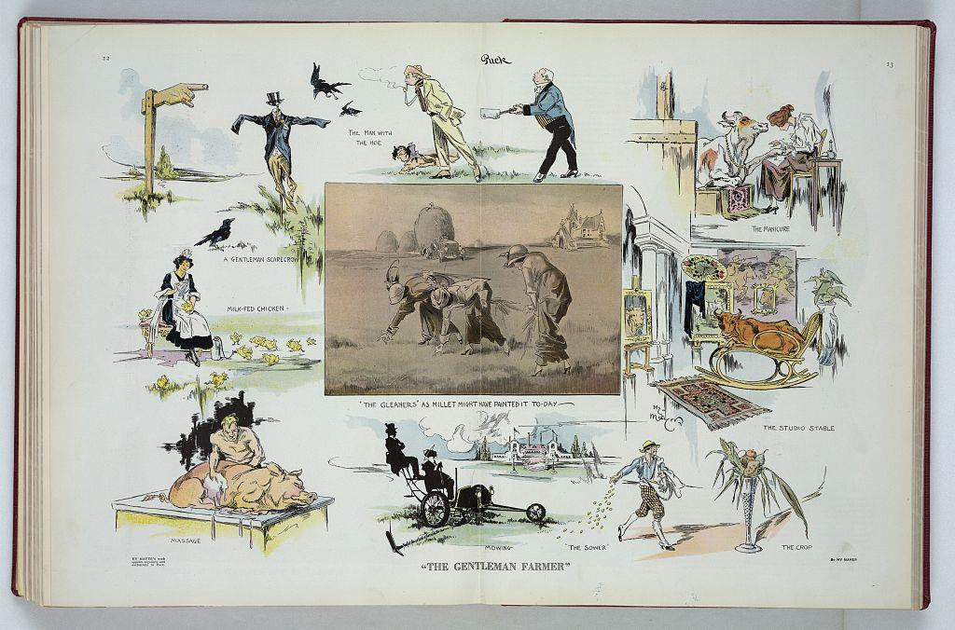

Citation: Mayer, H. (1914) "The gentleman farmer" / Hy Mayer ; by Hy Mayer. New York: Published by Puck Publishing Corporation, 295-309 Lafayette Street, June 6. [Image] Retrieved from the Library of Congress, https://www.loc.gov/item/2011649792.

Annotated Resources that relate specifically to the element
"Factors of Production - The Economic Lowdown Podcast ..." Federal Reserve Bank of St. Louis. N.p., n.d. Web. 14 Jan. 2017. < https://www.stlouisfed.org/education/economic-lowdown-podcast-series>.

SSEF1 Explain why limited productive resources and unlimited wants result in scarcity, opportunity costs, and tradeoffs for individuals, businesses, and governments., opportunity costs, and tradeoffs for individuals, businesses, and governments.
c. Explain the motivations that influence entrepreneurs to take risks (e.g., profit, job creation, innovation, and improving society).
Becoming an entrepreneur usually involves taking risks such as using one’s own financial resources to make a prototype of a product or buy the capital resources required to start the business. Some entrepreneurs may have to quit jobs from which they receive a relatively secure, predictable income in order to have enough time to invest in their new enterprise. In most cases, entrepreneurs begin new businesses because they believe the potential rewards of success outweigh the potential costs associated with the risks. The motivations of entrepreneurs include profit, job creation, innovation, and improving society. Traditionally, the field of economics sees the profit motive as the primary driver of

entrepreneurship. Those who start private firms believe they can operate the business in a way that the revenues (price times the quantity of goods/services sold) they receive will be greater than the costs (costs of production plus the income they gave up to start the business). In very basic terms, profit is
equal to a firm’s revenue minus its costs. Entrepreneurs may also be motivated by the opportunity to create a successful business that can provide jobs for people in the industry. According to a 2015 report by the Kauffman Foundation, new businesses accounted for ALL net new job creation and 20 percent of gross job creation. Innovation is another key motivation. Many successful entrepreneurs work as employee experts in their industry before venturing out on their own. During their time as employees, they often see ways companies could improve efficiency or production. They may apply their expertise to new products during their non-working hours. At some point, the desire to put their ideas to the test may become greater than their need for the security of a regular salary. Finally, some entrepreneurs start for-profit companies or non-profit organizations because they believe their product or service will improve society. For example, there are microfinance companies linking individual lenders to individual borrowers. This service provides financial resources to people who would be unlikely to qualify for traditional bank loans and a return to lenders who would like to see their money help grow the businesses of others.

Annotated Resources that relate specifically to the element
Entrepreneur Video Series (2015, October 13). Retrieved February 24, 2017, from http://www.econedlink.org/tool/357/Entrepreneur-VideoJackson, J. W. (2015, September 1). The Importance of Young Firms for Economic Growth. Retrieved February 24, 2017, from http://www.kauffman.org/what-we-do/resources/entrepreneurship-policy-digest/the-importance-of- young-firms-for-economic-growth
Williams, P., Kizer, S., Mares, L., & Barnes, E. (2015, September 01). Entrepreneurs – Dallas Fed. Retrieved February 24, 2017, from https://www.dallasfed.org/en/educate/everyday.aspx.
(Op en the Entrepreneurs PDF from this link) Federal Reserve Bank of Dallas. (n.d.). Retrieved April 29, 2017, from https://www.dallasfed.org/en/educate/everyday.aspx

SSEF1 Explain why limited productive resources and unlimited wants result in scarcity, opportunity costs, and tradeoffs for individuals, businesses, and governments., opportunity costs, and tradeoffs for individuals, businesses, and governments.
d. Define opportunity cost as the next best alternative given up when individuals, businesses, and governments confront scarcity by making choices.
The study of economics is all about the choices made by individuals, businesses, and governments. From an economist’s view, all choices involve both benefits and cost. The value of one’s next best alternative given up when a choice is made is called opportunity cost. Consider the following political cartoon. In the cartoon, Cuba faces a choice between accepting the terms of the Platt Amendment, which would seriously limit its sovereignty, but guarantee Cuban sugar exporters access to the U.S. market. Cuba could also pressure the United States to honor the Teller Amendment guaranteeing Cuban independence without limits to its sovereignty and face high import tariffs on Cuban sugar entering the United States. Cuba choose to incorporate the Platt Amendment terms into its constitution. Cuba gained the economic benefits associated with it sugar trade with the United States, but the opportunity cost

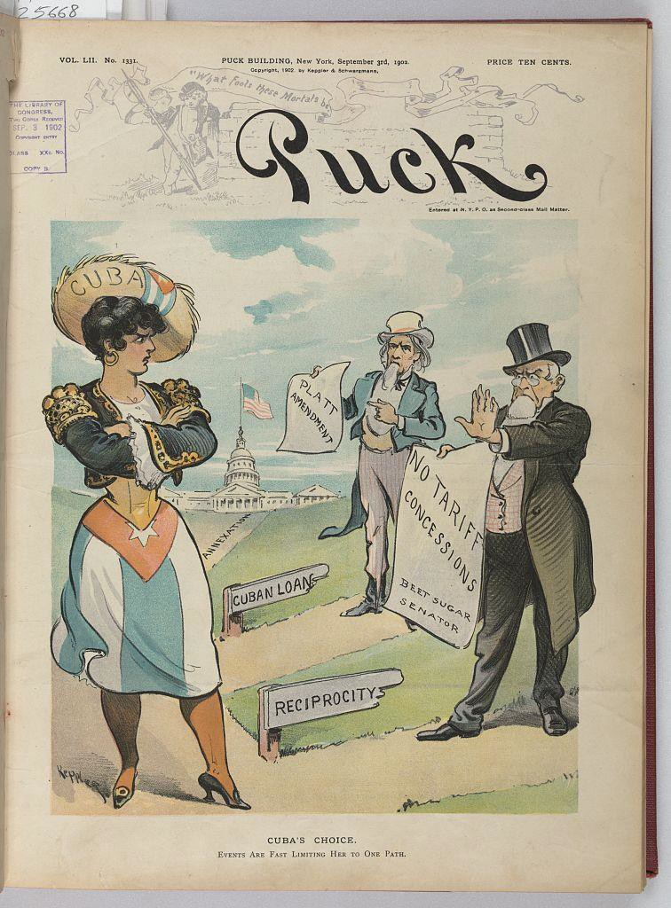
was loss of the right to enter into international treaties with other foreign powers and loss of control of parts of its territory.

Annotated Resources that relate specifically to the element
The United States, Cuba, and the Platt Amendment, 1901. (n.d.). Retrieved February 24, 2017, from https://history.state.gov/milestones/1899-1913/platt

Keppler, U. J. (1902) Cuba's choice / Keppler. N.Y.: J. Ottmann Lith. Co., Puck Bldg., September 3. [Image] Retrieved from the Library of Congress, https://www.loc.gov/item/2010652150/.
Wolla, S. (2013, January 1). Choices Are Everywhere: Why Can't We Just Have It All? (Page One Economics Classroom Edition). Retrieved February 24, 2017, from https://www.stlouisfed.org/education/page-one-economics-classroom-edition/choices-are-everywhere- why-cant-we-just-have-it-all
SSEF2 Give examples of how rational decision making entails comparing the marginal benefits and the marginal costs of an action.

The intent of this standard is to explain and give examples of rational decision making. The study of economics traditionally assumes that individuals, businesses, and governments behave rationally when faced with choices. A rational decision is based on comparing the marginal benefits and the marginal costs of a choice or action. Marginal in economics means incremental or small changes. The rational decision is the one in which the marginal benefit of the cost is greater than or equal to the marginal cost of the choice.
Resources: (if appropriate)
AP Microeconomics - Marginal Analysis. (n.d.). Retrieved February 24, 2017, from https://www.stlouisfed.org/education/ap-micro-marginal-analysis
Clifford, J. (2014, January 16). Retrieved February 24, 2017, from https://www.youtube.com/watch?v=0BAMv6lV2t4

SSEF2 Give examples of how rational decision making entails comparing the marginal benefits and the marginal costs of an action.
a. Define marginal cost and marginal benefit.
Marginal is defined in economics as small or incremental change. Marginal benefit refers to the additional positive value one receives from undertaking one more unit of an action. For example, the marginal benefit of running one more mile after running the previous two miles could be the additional calories burned. Marginal cost refers to the additional amount of effort, expense, or time one incurs from undertaking one more unit of an action. For example, the marginal cost of running one more mile after running the previous two miles could be ten minutes of time one could have devoted to another pursuit such as studying for an exam.

Annotated Resources that relate specifically to the element
Marginal Analysis. (n.d.). Retrieved April 29, 2017, from http://study.com/academy/lesson/marginal - analysis -in-economics -definition -formula -examples.html

SSEF2 Give examples of how rational decision making entails comparing the marginal benefits and the marginal costs of an action.
b. Explain that rational decisions occur when the marginal benefits of an action equal or exceed the marginal costs.
Rational actors in the economy will only select a choice if the marginal benefits of it are equal to or greater than the marginal costs of the action. In microeconomics, one benefit a firm receives from selling a product is the revenue (price times the quantity). One cost associated with producing a product is the cost of the human resources required to make the product. A rational firm wants to know how many workers it should hire to maximize its profit. Profit is revenue minus costs. An economist would tell the firm to hire the number of workers at which the marginal revenue generated by the human resource is equal to the marginal cost of hiring the human resource. Consider an example in which the wage for each worker you hire is $10.00 an hour and the price of your product is $2.50. In the table below, the marginal revenue (benefit) of each additional worker is equal to the marginal cost of each additional worker when the firm hires worker #3. A rational firm would not hire the 4th worker because the marginal cost of that worker is greater than the marginal benefit.

Number of Workers | Total Units Produced | Marginal Number of Units Produced | Price of Each Unit Produced | Total Revenue for the Units Produced | Marginal Revenue for Generated by Each Additional Worker | Marginal Cost of Hiring Each Additional Worker
0 | 0 |  | $2.50 | 0
1 | 6 | 6 | $2.50 | $15.00 | $15.00 | $10.00
2 | 11 | 5 | $2.50 | $27.50 | $12.50 | $10.00
3* | 15 | 4 | $2.50 | $37.50 | $10.00* | $10.00*
4 | 18 | 3 | $2.50 | $45.00 | $7.50 | $10.00
5 | 20 | 2 | $2.50 | $50.00 | $5.00 | $10.00
6 | 21 | 1 | $2.50 | $52.50 | $2.50 | $10.00

Annotated Resources that relate specifically to the element
Greeves, M. (n.d.). Marginal Analysis. Retrieved February 24, 2017, from http://study.com/academy/lesson/marginal-analysis-in-economics-definition-formula-examples.html

SSEF2 Give examples of how rational decision making entails comparing the marginal benefits and the marginal costs of an action.
c. Explain that people, businesses, and governments respond to positive and negative incentives in predictable ways.
In the study of economics, an incentive motivates individuals, businesses, and/or governments to undertake an action or avoid an action. Incentives are positive when these actors in the economy choose an option associated with a perceived benefit or gain. Incentives are negative, sometimes called disincentives, when actors in the economy avoid a particular option because they associate it with a cost that is too high. Traditionally, the field of economist believes individuals, businesses, and governments will respond predictably to positive and negative incentives. The chart below gives examples of both positive and negative incentives for individuals, businesses, and governments as well as the predicted response of the economic actor.

Economic Actor | Incentive | Is it positive or negative? | Predicted Response
Individuals | An income tax credit for purchasing a home. (A tax credit is money you receive from the government for undertaking an action the government views as desirable.) | Positive | Tax paying members of society are more likely to buy a home than they would be without the tax credit
Individuals | Individuals caught breaking traffic laws face fines or other penalties. | Negative | Drivers are less likely to break traffic laws if they face out of pocket costs for breaking the laws.
Businesses | A subsidy given to firms that develop new products which improve public health or safety. (A subsidy is a monetary transfer from a government to a business for undertaking a particular desirable action.) | Positive | Businesses will be more likely to invest in the capital goods and research for product or service if the government provides money to help offset the costs of the investment.
Businesses | A tax on the output of a good or service. Sometimes imposed by a government when the production of a good or service is deemed harmful to society or the environment. | Negative | Businesses faced with a tax on the good or service they produce may decrease production of the product due to the higher cost, thus reducing harm to society.
Governments | Low interest loans for economic development from international organizations like the World Bank. | Positive | When governments have low cost credit available for poverty alleviation projects, they are more likely to undertake those initiatives.
Governments | Rules tied funds from the Federal government to the state government for transportation. | Negative | State governments were once compelled to lower the speed limit on highways or lose Federal dollars associated with maintaining those highways.

Annotated Resources that relate specifically to the element
Price Signals - The Economic Lowdown Podcast Series, Episode 12. (n.d.). Retrieved March 06, 2017, from https://www.stlouisfed.org/education/economic-lowdown-podcast-series/episode-12-price- signals
You can bank on this! Positive & Negative Incentives. (n.d.). Retrieved March 06, 2017, from http://www.econedlink.org/tool/251/Positive-Negative-Incentives
Economic Incentives: Definition & Examples - Video & Lesson Transcript. (n.d.). Retrieved March 06, 2017, from http://study.com/academy/lesson/economic-incentives-definition-examples-quiz.html
SSEF3 Explain how specialization and voluntary exchange influence buyers and sellers.

The intent of this standard is to explain how specialization and voluntary exchange are beneficial to
individuals, businesses, and countries. Students should recognize that producing everything one’s self (being “self-sufficient”) severely limits access to goods and services. It also fails to use the individual’s special skills and talents efficiently. By focusing on the things we do at a lower opportunity cost than another individual or country, we can produce more and then trade our surplus to the other entity for the other good or service. This allows us to consume more of both goods or services. When we willingly exchange goods with someone else both parties benefit. This is why economists believe everyone benefits from free, voluntary trade.
Resources: (if appropriate)
Yetter, E., PhD. (2013, November 01). The Global Economy: It's a Small World After All (Page One Economics Classroom Edition). Retrieved March 06, 2017, from https://www.stlouisfed.org/education/page-one-economics-classroom-edition/the-global-economy-its- a-small-world-after-all
Trade, Exchange and Interdependence Video and Quiz. (n.d.). Retrieved March 06, 2017, from http://www.econedlink.org/tool/196/Trade-Exchange-Interdependence-Video-Quiz

SSEF3 Explain how specialization and voluntary exchange influence buyers and sellers.
a. Explain how and why individuals and businesses specialize, including division of labor.
Specialization is can be observed when individuals or businesses concentrate on a single activity or an area of expertise when producing a good or service. In economics, specialization is important because it boosts the overall productivity of a business or country. For example, a firm might use specialization by creating division of labor in the production of a good or service. An example of division of labor at a fast food restaurant might be when one employee takes drive-thru orders while another employee makes the food. Both employees get better at their tasks through repetition and can do the task more quickly with fewer errors. The fast food restaurant which has chosen to specialize in convenient, ready-made meals would probably not try to offer gourmet, fine dining at the same time and lets other restaurants specialize in this type of cuisine.
Specialization can also be observed when students choose to pursue a particular major in college. The farther into their college years, the more specialized their classes become. A business major may start out taking courses in economics, marketing, and management, but ultimately focus in the field of accounting and become an accountant. The student with specialized training in accounting will often be able to perform accounting tasks more quickly and with fewer errors than someone trained in another field. The accountant can then voluntarily exchange his or her labor for payment and use the money earned to purchase the goods and services produced by individuals and businesses specializing in other areas.
In the photograph below, we see one of the most famous examples of division of labor and specialization. This image was taken in 1928 and shows how workers in the Ford Factory had specific tasks as the cars moved through the factory. From 1908 to 1916, the Ford factory gradually increased the number of automobile components made under division of labor and assembly line production. The result was a drop in the price of a Model T Ford from $850 in 1908 to less than $300 by the 1920s.

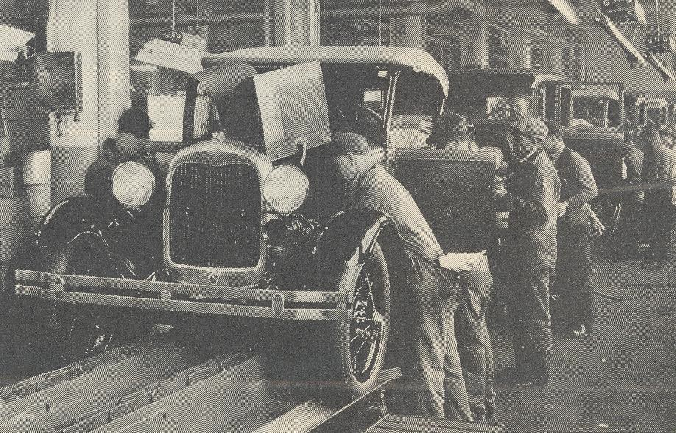

Ford Motor Company Assembly Line [Photograph found in Literary Digest]. (2007, August 09). Retrieved March 06, 2017, from https://commons.wikimedia.org/wiki/File:Ford_Motor_Company_assembly_line.jpg
(Originally photographed 1928, January 07)

Annotated Resources that relate specifically to the element
Productivity Video and Quiz. (n.d.). Retrieved March 06, 2017, from http://www.econedlink.org/tool/192/Productivity-Video-Quiz
Supplementary resources for college economics textbooks on Division of Labor and Specialization. (n.d.). Division of Labor and Specialization. Retrieved March 06, 2017, from http://www.econlib.org/library/Topics/College/divisionoflaborspecialization.html
SSEF3 Explain how specialization and voluntary exchange influence buyers and sellers.
b. Explain that both parties gain as a result of voluntary, non-fraudulent exchange.
Voluntary exchange occurs when two economic actors willingly trade one item for another because the value of the item they are receiving is greater at the time than the item they are giving up to receive it. While voluntary exchange can happen through barter, trading one good or service for another good or service, it is usually facilitated through money. Buyers can be household consumers, firms or governments while sellers can also be household consumers, firms or governments. The chart below gives some examples of gains from voluntary exchange.

Type of Voluntary Exchange | Party One | Party Two | Party One Gain | Party Two Gain
Exchanging an Apple for a Cookie at Lunch | Person with the Cookie | Person with the Apple | A healthier snack | A tasty dessert
Exchanging $5.00 for a Combo Meal at a restaurant | Buyer with $5.00 | Seller with the Combo Meal | The satisfaction of consuming a meal and no longer being hungry | The additional revenue the restaurant gains from selling the meal
Exchanging one hour of labor for  $8.00 of wages | Seller of one hour of labor | Buyer with $8.00 to pay for labor | Wages to use to pay for other goods and  services | A labor hour to help produce a good or service
Exchanging $8.58 million for an Abrams tank | Buyer (the U.S. government) with  $8.58 | Seller (Lima Army Tank Plant) with a tank | The U.S. gains a weapon for National Defense | The Lima Army Tank Plant receives revenue

SSEF4 Compare and contrast different economic systems and explain how they answer the three basic economic questions of what to produce, how to produce, and for whom to produce.

The term economic system refers to the way a country organizes economic activity. There are three economic systems, traditional, command, and market. Each economic system must answer a set of questions known as the three basic economic questions. The three basic economic questions are “What to produce?”, “How to produce?”, and “For whom to produce?”. In a traditional economic system, the three questions are answered based on how things have always been done in the past. In a command economic system, the questions are answered by a central authority or government. In a market economic system, the answers to the questions are determined by the interactions of buyers and sellers in the market.
Resources: (if appropriate)
Economic Systems Video and Quiz. (n.d.). Retrieved March 06, 2017, from http://www.econedlink.org/tool/187/Economic-Systems-Video-Quiz
Infographic for "Economic Systems: How Do Countries Organize Economic Activity?". (2015, September 01). Retrieved March 06, 2017, from https://www.frbatlanta.org/education/classroom- economist/infographics/economic-systems/full-view.aspx

SSEF4 Compare and contrast different economic systems and explain how they answer the three basic economic questions of what to produce, how to produce, and for whom to produce.
a. Compare traditional, command, market, and mixed economic systems with regard to private ownership, profit motive, consumer sovereignty, competition, and government regulation.
Economic systems are models economists use to explain how decision-makers in an economy are likely to view certain economic principles. While economists identify traditional, command, and market as the three distinct economic systems, real world economies are usually “mixed”. That is, real world economies have some characteristics of all three economic systems, but tend to lean toward one of the three. Before we examine how each economic system regards the economic principles in this element, let us define each.
Private ownership refers to the ability of individuals and businesses in an economy to buy, sell, and hold property as they wish without fear government interference or seizure. The profit motive incentivizes entrepreneurs to take the risk of starting a business. Profit is the amount of revenue (price times quantity sold) received by a business minus the costs of operating the business. If the revenue is greater than the cost of operation, the business will make a profit and the entrepreneur will receive the profit. This potential reward for the entrepreneur drives them to start businesses. Consumer sovereignty determines the goods and services an economy produces because businesses will only produce those products that consumers are willing to buy. Competition refers the characteristics and behavior firms in a particular market or industry.
Finally, government regulation refers to the extent to which a central authority has control over the production and consumption decisions in an economy. The chart below provides a comparison of these principles under each economic system.

Economic System | Private Ownership | Profit Motive | Consumer Sovereignty | Competition | Government Regulation
Traditional | Property rights are based on historical property rights and transfer of property would follow traditional rules of the culture | People who provide goods and services most likely provide the same good or service their ancestors provided. It would be difficult for someone to work in a field other than the one his or her ancestors had. | The production of goods and services is based on what has always been produced so changes in consumer taste for new goods and services would not change the goods and services produced in the economy | There may be more than one seller of a particular good or service, but the sellers are likely to continue operating the same way their ancestors operated so it is unlikely that competition will lead to lower prices or a more efficient use of resources. | Traditional leaders, like councils of elders or tribal chiefs, will typically be in charge of moderating disputes between members of the community.  They will make their decisions based on how the culture has decided in the  past.
Command | Property rights, if any, are insecure since central planners make all economic decisions.  Property seizures are common if the central planner thinks the property should be used in another capacity. | Little opportunity to pursue individual rewards since all economic decisions are made by a central planner. Small businesses, if allowed, will likely return a large percentage of profits to the central government. | Individual consumers have little say in what businesses or government producers offer as goods and services. They may be told how much of each good or service they are allowed to have. Even if consumers have money available to buy, there may be shortages of the more desirable goods because the central planners did not authorize the right level of  production. | Since the government is the producer of most goods and services, there is little or no competition among individual firms. This means there is little incentive to innovate, lower prices, increase quality, or use resources efficiently. | The government or central planner makes almost all decisions about the production of goods and services in the economy.
Market Economy | Property rights are strong. | The profit motive incentivizes | Firms produce only the goods and services | There is a high level of competition | Government regulation is minimal. If

 | Individuals | individuals to | they think | because firms can | regulation
 | and firms | start new | consumers are | freely open and | exists, the focus
 | own all the | businesses and | willing and able | close businesses. | is on protecting
 | factors of | to make their | to buy. Products | The entry of new | property rights,
 | production. | businesses | that do not sell | businesses in the | ensuring high
 | If a | efficient. Firm | will be | market for a | levels of
 | government | owners will be | discontinued | product | competition,
 | exists, its | able to keep | and firms will | incentivizes firms | and protecting
 | main role is | most or all of | increase the | to lower prices, | consumers from
 | to apply the | their business | quantity | increase quality, | harm.
 | rule of law | profits. | supplied of | and/or become
 | governing |  | products that | more efficient
 | property |  | are popular | with resources.
 | rights to all |  | with
 | property |  | consumers.
 | disputes in a
 | fair and
 | equal way.
Mixed | Individuals | Entrepreneurs | Businesses will | High levels of | The government
Economic | and firms | can freely start | usually produce | competition are | may require
Systems | can own | businesses, but | what | encouraged, but | licenses and
 | property | will usually be | consumers | government may | government
 | and the rule | required to pay a | want to buy. | allow certain | paperwork to
 | of law | certain | However, | monopolies to | start the
 | decides | percentage of | government | exist if there is a | business.
 | property | their profits in | may recognize | compelling | Businesses may
 | disputes. | taxes to the | that certain | reason to have | have to follow
 | Government | government. | public goods | one producer of | government
 | can also own |  | and services will | the good or | labor, consumer
 | property to |  | not be | service. | safety, and
 | provide |  | produced in |  | environmental
 | public goods |  | great enough |  | laws.
 | and services. |  | quantity by the
 | Government |  | private market
 | will |  | and will
 | sometime |  | produce the
 | seize |  | product as a
 | property |  | public good or
 | and pay the |  | service.
 | owner fair
 | market
 | value if the
 | property in
 | question is
 | to be used
 | for an
 | essential
 | public good
 | or service.

Annotated Resources that relate specifically to the element
Federal Reserve Bank of Atlanta (2015, August). Economic Systems [Infographic]. Retrieved March 18, 2017, from https://frbatlanta.org/education/classroom-economist/infographics/economic-systems.aspx
The Singing History Teachers. (2016, January 07). Retrieved March 18, 2017, from https://www.youtube.com/watch?v=Cpqq9HXYJPM (Silly, yet fun and accurate)

SSEF4 Compare and contrast different economic systems and explain how they answer the three basic economic questions of what to produce, how to produce, and for whom to produce.
b. Analyze how each type of system answers the three economic questions and meets the broad social and economic goals of freedom, security, equity, growth, efficiency, price stability, full employment, and sustainability.
Each economic system answers the three basic economic questions in a different way. The chart below organizes a comparison of each system’s answers
Economic System | What to produce? | How to produce? | For whom to produce?
Traditional | The economy will produce the goods and services it has produced for generations based on what the ancestors  produced. | The economy will pass the same production methods used in the past from generation to generation. | Goods and services are distributed using the methods used by past generations.
Command | The economy will produce what the government or central planner says it will produce. | The economy will produce using whatever methods the government or central planner says it will use. | The economy will distribute the goods and services to whomever the government or central planner says  should get it.
Market | Firms will produce what they believe consumers will want to buy. | Firms will produce goods and services using methods they believe will result in selling goods and services for  the most profit. | Individuals and firms in the society who are willing and able to pay the price of the good or service will obtain it.
Mixed | Many firms will produce what they believe consumers will want to buy, but government may restrict the production of certain goods or produce public goods. | Firms will try to produce goods and services using methods they believe will result in selling goods and services for the most profit, but the government may tax firm profits or mandate  production processes | Individuals and firms in the society who are willing and able to pay the price of the good or service will usually obtain it, but the government may restrict some people from  accessing certain goods

 |  | that minimize harm to the public. | or may decide to produce a public good  for specific people in the society.
Social Economic Goals
The social economic goals are the values underlying the economic system a country chooses and act as a guiding force as individual, businesses, and governments in the economy make economic choice.
Economic freedom refers to the ability of consumers, producers, and workers to make their own decisions about consumption, production, and distribution of goods and services. The more individuals and businesses make these decisions, the more economic freedom exists in the economy. Market economies tend to have a great deal of economic freedom while command economies may limit economic freedom in favor of more equal distribution of wealth.
Economic equity refers to fairness within the economy. There is a lot of debate in public policy about what is fair. Some people define fairness as equal access to jobs, goods, and services. Others define fairness based on outcomes. For example, if someone works hard to start a successful business, many believe that it is “fair” for that individual to keep the profit from that business. Market economies pursue this goal by ensuring competitive markets and protecting property rights. Command economies pursue this goal by redistributing wealth and ensuring everyone’s access to public goods.
Economic security has to do with protecting individuals and businesses from risk. In a market economy, individual workers and business owners are usually responsible for themselves during challenging economic circumstances. They protect themselves through insurance available in the private market or by saving money for the future. In command economies, the government provides security through government insurance programs, guaranteed jobs, and housing/food allowances.
Economic growth is increasing production of goods and services over time. This occurs through increases in factors of production or new technological innovations. Most countries measure growth through calculating the percentage change in real GDP from one period to the next. Real GDP is the total value of all final goods and services produced within a nation in a given time period adjusted for inflation. Although both command and market economies are capable of growth, command economies are capable of growing rapidly, using within targeted sectors, when guided by a central planner. Market economies may grow more slowly, but growth tends to be more sustainable through the organic forces of supply and demand within markets instead of arbitrary targets.
Economic efficiency when factors of production are allocated to their most productive use. The most efficient economies have fully employed resources, specialize in goods and services for which they have the lowest opportunity cost, and have high levels of competition in the market. Market economies tend to be very efficient due to competition and free trade. Supply and demand allows price to ration factors of production, goods, and services and allocate them to the most efficient uses. Command economies may be less efficient since there is no competition if government owns all the productive resources, everyone has to have a job, and no profit motive drives the people to reduce the costs of production.
Price stability refers to an economy making sure that increases in the overall price level of goods and services in the economy is predictable and protects the purchasing power of money in the economy over time. In the
  - economy, the Federal Reserve system uses monetary policy, tools to increase or decrease the quantity of money in circulation, to target a predictable inflation rate of 2%. In market economies, price levels can fluctuate with increases and decreases in the business cycle, rising significantly in expansionary times and

falling drastically in times of financial crisis. Command economies are more likely to have central authorities who take action against rising or falling price levels through fiscal or monetary policy.
The goal of full employment seeks to ensure that all those who are willing and able to work have the opportunity to do so. In the U.S., full employment is typically an unemployment rate between 4% and 6% depending on economic conditions. The unemployment rate is never zero because of people moving from one job to another or people graduating from an educational program and looking for a job. Market economies can achieve full employment during strong expansions, but will often suffer high levels of unemployment during contractions. Command economies will try to ensure full employment, but will often employ resources in less efficient uses and pay income much lower than that found in a market economy.
Economic sustainability usually refers to the goal of individual countries to maintain an upward trend of real Gross Domestic Product growth in the long-run. For highly developed countries, the goal for long-run real GDP growth trend desired may be 2-3% while it may be much higher for developing countries. To achieve these targets, countries must make decisions and create conditions benefitting the economy for the long term as well as the short term. There are many viewpoints about sustainability, but some of the considerations in building a sustainable economy could include food systems, environmental protection, new business creation, technological development, and the health of the overall financial system. In market
economies, sustainability is a goal if firms believe it is in the firm’s self-interest to pursue sustainability. In command economies, the government or central planner will determine the type of sustainability to pursue.
The cartoon below is part of the Opper Project’s Great Depression cartoons. The cartoon published in 1931 by the Chicago Tribune illustrates the lack of economic security in the U.S. financial system prior to the Great Depression. The man experiences financial ruin because of a bank failure. In response to the bank failures of the 1930s, the United States established the Federal Deposit Insurance Corporation. This program now insures depositors for deposits up to $250,000 if their bank were to fail.
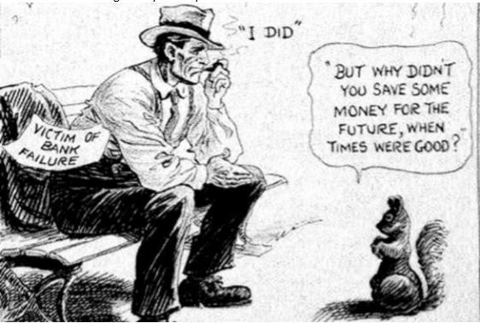
McCutcheon , J. (1931). A Wise Economist Asks a Question [Cartoon]. The Chicago Tribune.

Annotated Resources that relate specifically to the element
Federal Reserve Bank of Atlanta (2015, August). Economic Systems [Infographic]. Retrieved March 18, 2017, from https://frbatlanta.org/education/classroom-economist/infographics/economic-systems.aspx
Growing a Sustainable Economy. (n.d.). Retrieved March 18, 2017, from http://www.sustainable.org/economy

SSEF4 Compare and contrast different economic systems and explain how they answer the three basic economic questions of what to produce, how to produce, and for whom to produce.
c. Compare and contrast strategies for allocating scarce resources, such as by price, majority rule, contests, force, sharing, lottery, authority, first-come-first-served, and personal characteristics.
The third basic economic question all societies must answer is for whom to produce. Allocation strategies are the methods available to societies as they seek to answer this question. First, it is important to describe each of the strategies and then compare the benefits and costs of using one over another.
- Price: This refers to allowing the forces of supply and demand to determine a market price. Supply is the amount of a good, service, or factor of production a seller is willing and able to sell at each price. Demand is the amount of a good, service, or factor of production that a buyer is willing and able to purchase at each price. The price at which the quantity demanded by the buyer is equal to the quantity supplied by the seller is the market price. This allocation strategy allows rationing of a resource based on who can afford the price set by the market. The more desirable and relatively scarce the item, generally, the higher the price. This method is efficient because one can easily tell whether he or she can obtain the good, service, or factor of production based on his or her willingness and ability to pay the price. However, this method will exclude people from markets if they lack the money to pay the price.
United States Example: If one would like to obtain a banana, one must pay the price per pound indicated by the grocery store. If one has no money, one gets no banana.
- Authority: This strategy is based on the decisions of a power person or group of people who make most of the decisions about who gets to obtain a good, service, or factor of production. This allocation strategy allows for quick action because a person or a group of people in power can make and implement the decisions quickly.
United States Example: Elected representatives have the authority to pass legislation requiring workers to pay a tax on the income they earn.
- Force: When allocating by force, goods, services, and factors of production are given or taken away under using threats. In countries where the government makes and carries out decisions by force, economic changes can happen quickly because the government decides how to distribute all items and enforces the decision through military/police power.
United States Example: In the United States, most people are free to choose the work they would like to do. However, when the United States had a military draft during the Vietnam War, the United States arrested those who did not report for military duty.
- Lottery: This allocation strategy, also known as random selection, gives everyone who wants the good, service, or factor of production equal odds of obtaining it. This strategy can be inefficient because it may allocate the resource to a purpose or person who does not need it or who will not put it to a productive use. If the government randomly selects individuals to receive farmland, the land may go to someone who has no knowledge of farming techniques and the land resource may be underutilized.
United States Example: In the case of conscripted military service, force was not the only allocation strategy employed. The photograph below shows the lottery held in 1940 to select the first group of

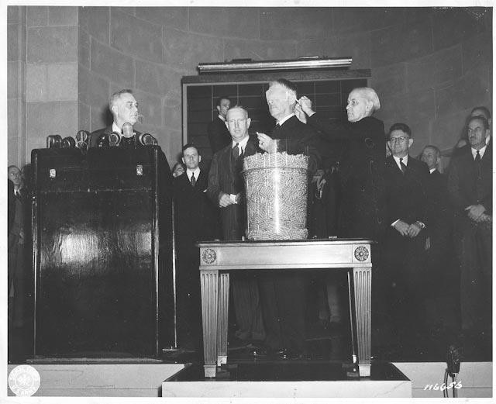
Selective Service registrants for the newly initiated draft. Secretary of War, Henry Stimson, chose the first number from the bowl and it was 158. Nationally, 6,175 men held the number 158. All of them had to report to their local draft board for assessment of their military service fitness.
Zebrowski, C. (2007, December). Your Number's Up! Retrieved March 24, 2017, from http://www.americainwwii.com/articles/your-numbers-up/
October, 1940. (2011, October). Retrieved March 24, 2017, from http://www.fdrlibrary.marist.edu/daybyday/resource/october-1940/
- First Come, First Served: This allocation strategy allows people to receive a good, service, or factor of production if they get to it first or are one of the people close enough to the front of the line to receive the good, service, or factor of production before there are none remaining. This can be an inefficient strategy since the time spent waiting in a physical or virtual line took time away from more productive activities.
United States Example: At one time, a teenager who wanted to take the driver’s license road test had to arrive early and get in line for the opportunity to take the test. The aspiring driver might wait in line all day for the test. Now, the Georgia Department of Driver’s Services allows potential drivers to schedule a road test for a specific date and time, eliminating the first come, first served strategy and improving efficiency.

- Majority Rule: This strategy occurs when a group of people who have control over a good, service, or factor of production vote to decide how it will be distributed. In the best case, the vote will have a significant majority in favor of the decision and the decision will be in society’s best interest. However, if the majority has a small margin, many people may be unhappy with the decision. If the majority is corrupt or makes the decision based on favoritism or fear, the good, service, or factor of production allocation may not be efficient.
United States Example: National, state, and local governments sometimes vote to establish public parks and greenspace. In some cases, there are citizens who would rather the land be used for commercial production. When the majority of elected representatives vote for the public land use, those who favor private ownership of the land are unable to access the factor of production.
- Personal Characteristic: This allocation strategy allows resources to be distributed based on need or merit. Ideally, the person who gets the good, service, or factor of production is the one who will put it to the best use. However, personal characteristics can be barriers to keep certain individuals from receiving the allocation.
United States Example: The Committee to Defend Martin Luther King advertised in the New York Times to generate awareness and support for the civil rights movement in 1960. The advertisement shares several examples of how the personal characteristic of having brown skin was excluding people from a variety of goods and services. The citation below has a link to a transcript of the advertisement.

Annotated Resources that relate specifically to the element
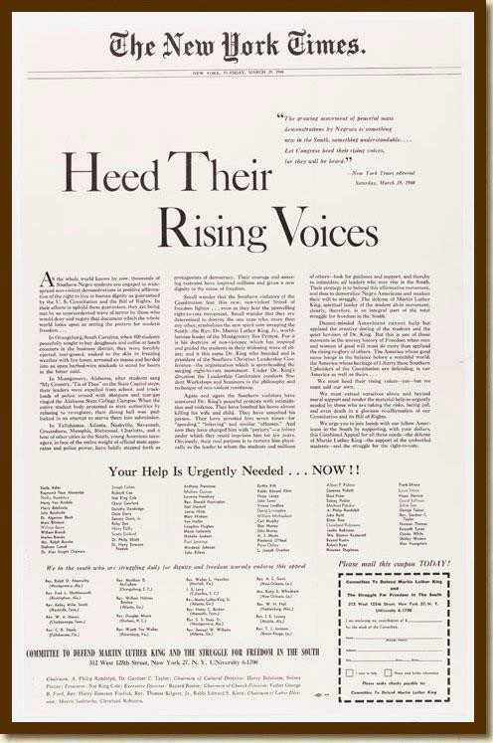
Federal Reserve Bank of Atlanta. (2017, March 23). Allocation Strategies, Rational Decision Making, and Social Economic Goals. Retrieved March 24, 2017, from https://www.frbatlanta.org/education/publications/extra- credit/2017/spring/lessons-and-activities/high-school/basic-economic-concepts/allocation-strategies.aspx

Committee to Defend Martin Luther King. (n.d.). Heed Their Rising Voices. Retrieved March 24, 2017, from https://www.archives.gov/exhibits/documented-rights/exhibit/section4/detail/heed-rising-voices- transcript.html
Heed Their Rising Voices [Advertisement]. (1960, March 29). New York Times.
- Contest: This allocation strategy can distribute the resource to the person who wins. The “winning” could be based on running a race (who is fastest), in academics (valedictorian has the highest GPA), or in a test of knowledge/skill (Jeopardy contestant or chess champion). This strategy can be inefficient on a day to day basis. You don’t want to run a race to see who gets the last slice of pizza in the cafeteria. It would take too long.

SSEF5 Describe the roles of government in the United States economy.
Although the United States leans toward a market economic system, our federal, state, and local governments are involved in the economy in many ways. Over its history, the extent of government intervention in the economy in the United States has risen and fallen. The reasons for this ebb and flow are varied. For example, a period of low government intervention in the economy may result in damage to public health from pollution and citizens demand government regulation of the polluting industries. During a period when the United States is at war, the government may have to redirect the use of resources to military production or limit the choice of career for young people of fighting age. This standard explore the variety of ways our government is involved in the U.S. economy.
Resources: (if appropriate)
Role of government in a market economy. (n.d.). Retrieved April 28, 2017, from http://www.econmentor.com/hs-advanced/microeconomics/role-of-the-government/role-of-government- in-a-market-economy/text/1059.html#Role of government in a market economy
SSEF5 Describe the roles of government in the United States economy.
a. Explain why government provides public goods and services, redistributes income, protects property rights, and resolves market failures.
Federal, state, and local governments in the United States are involved in the economy. Invention includes providing public goods and services, redistributing income, protecting property rights, and resolving market failures.
Governments in the United States usually produce public goods and services only when there is a reason that the private market is unable to provide the good or service at a level considered beneficial to society. The most common way to pay for public goods are through the collection of tax dollars.
There are two main characteristics of purely public goods. They include “shared consumption” goods also known as “non-rival” good. This means the consumption of the good by one person does not diminish the satisfaction enjoyed by another consumer who consumes the exact same good. For example, public interstate highways are used by one driver without decreasing the benefits enjoyed by another driver. A non-example is a piece of gum. We are unlikely to get the same benefit as someone else by chewing the same piece of gum. In fact, we are unable to chew the same piece of gum as someone else at the same time. The other characteristic is non-exclusion. Non-exclusion means that it is difficult or impossible to keep a person who is unwilling to pay from enjoying the benefits of the public

good. For example, the federal government provides national defense to everyone who resides in the United States regardless of whether they pay for protection. (They become in economic terms, a “free- rider”. A free rider enjoys the benefit of a good without incurring the cost of paying for it.) In the case of a piece of gum, a non-example, I cannot have it unless I pay for it at the store. However, one can drive on most United States interstate highways even if one does not pay any taxes.
The chart below shows examples of public goods or services for each level of government in the United States.
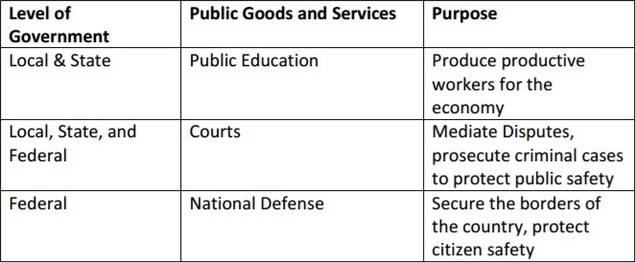

When pursuing the social economic goal of equity, governments in the United States may choose to redistribute income. This involves taking tax money from one group of individuals or firms and giving it to other individuals and firms. These transfer payments include things like social welfare payments to low income citizens, unemployment compensation to those laid-off during a recession, or Social Security payments made to retirees. These payments subsidize the income of recipients to allow the consumption of necessities. In some cases, there may be redistribution to higher income people such a tax credits for buying electric vehicles.
In a market economy, the protection of private property rights is essential. If consumers and businesses are uncertain of their ability to retain property, they are less likely to purchase goods or invest in and expand their businesses. Property rights are protected by intellectual property laws such as copyrights and patents, legal documents like deeds for real estate or titles for cars, and business licenses or corporate charter recognize the legal owner of a business. In an economy that protects private property rights, the court system is available to hear property dispute and settles them based on an impartial
“rule of law”.
Market Failures occur when the private market is unable to produce goods and services in a way that the marginal benefit to society from the production of the good is equal to or greater than the marginal cost to society for producing the good. Market failures include externalities and market power.
Externalities can be both positive and negative. They occur when a third party other than the consumer or producer of a good is hurt or benefits from the production or consumption of that good. For example, some industries cause air pollution while producing a product. If this pollution causes a local resident to get sick there is a negative externality. If your new roommate at college plays their iPod full of all your favorite singers/bands you get to enjoy it even though you did not purchase the songs, this is a positive externality. In the United States, government attempts to correct negative externalities like pollution through increasing taxes or regulations on the polluting industry. This makes it more expensive to

produce the good and reduces the amount of production. In the case of a positive externality producing industry like colleges and universities, the government will provide subsidies to the institutions and to their students so there is an increase in amount supplied to the market.
Market power refers to a market failure resulting from the formation of monopoly and oligopoly market structures. Monopoly market structures are markets controlled primarily by one seller of a good or service, an oligopoly market is one controlled by several large firms. Under anti-trust laws in the United States, monopolies, and oligopoly firms who work together to fix prices or restrain competitors, may be prosecuted by the government and, in some cases, broken up into smaller companies. Economists are divided over the dangers of market power. Many believe that market power is fine as long as prices are reasonable and new competitors are not barred from entry into the market by unfair practices.

Annotated Resources that relate specifically to the element
Externalities - The Economic Lowdown Podcast Series, Episode 11. (n.d.). Retrieved March 24, 2017, from https://www.stlouisfed.org/education/economic-lowdown-podcast-series/episode-11-externalities
Market Failures Video & Quiz. (n.d.). Retrieved March 24, 2017, from http://www.econedlink.org/tool/215/Market-Failures-Video-Quiz
Public Goods - The Economic Lowdown Podcast Series, Episode 17. (n.d.). Retrieved March 24, 2017, from https://www.stlouisfed.org/education/economic-lowdown-podcast-series/episode-17-public-goods

SSEF5 Describe the roles of government in the United States economy.
b. Explain the effects on consumers and producers caused by government regulation and deregulation.
Government regulation takes many forms. Overall, the goal of the government is to provide for the health and safety of its citizens and its businesses. Some regulations protect citizens from corporate abuse. Other government regulations help businesses recover from external problems by offering money to help offset an unforeseen disaster.
Examples of Increased Regulation:
The Sarbanes–Oxley Act of 2002 was a response to major problems with the accounting practices of large public companies. In the wake of corporate bankruptcies like Enron, Tyco, and WorldCom, Congress passed the act to regulate the way public companies handle their accounting. The purpose of the act was to increase the responsibility of the corporate board of directors for published financial records and to protect investors from financial loss due deceptive accounting practices.
On the consumer side, government may pass laws regulating the information companies must provide to consumers. As obesity has become more of a problem in the United States, some states now require certain restaurants to publish nutritional information so consumers can make better choices. Credit card companies must publish information about how long it will take customers to pay off debt.
Example of Decreased Regulation:
The Banking Act of 1933 or Glass-Steagall included many provisions connected with the U.S. banking system. Many believe, although there are those who disagree, that Glass-Steagall did not permit commercial banks to be involved in investment banking activities. In 1999, Congress repealed the parts of Glass-Steagall that many believed prevented commercial banks from acting as investment banks. This increased competition among financial institutions in the investment banking industry. However, some believe this increased risk-taking contributed to the Subprime Mortgage Crisis and Great Recession of the late 2000s.

Annotated Resources that relate specifically to the element
Financial Regulation: A Primer on the Dodd-Frank Act (Page One Economics). (n.d.). Retrieved March 24, 2017, from https://www.stlouisfed.org/education/page-one-economics-classroom-edition/financial- regulation-a-primer-on-the-doddfrank-act
SSEF6 Explain how productivity, economic growth, and future standards of living are influenced by investment in factories, machinery, new technology, and the health, education, and training of people.

Individuals, businesses, and countries want their economy to grow. There are many ways to measure how well an economy is doing. Three factors to consider are changes in productivity, changes in real Gross Domestic Product (GDP), and changes in real GDP per capita. Productivity is the ratio of inputs to outputs. For example, a company may ask, how many minutes does it take to produce one unit of a good? If the number of inputs (minutes) decreases while the unit of output (the good) remains the same, productivity increases. Inputs include the factors of production (land, labor, capital, and entrepreneurship) as well as

intermediate goods (goods used to produce final goods). Gross Domestic Product (GDP) is the value of all final goods and services produced within a country’s borders within a given time period. Real GDP refers to GDP adjusted for changes in a country’s price level. If there is a change in the value of real GDP, a country knows the change was due to an increase in production and not due to an increase in the prices of goods and services. A change in real GDP from one period to the next indicates economic growth for a country. Real GDP per capita is the total real GDP of a country divided by its population. It indicates whether the output per person in the country has also increased. When the real GDP per capita of a country rises, many economists believe that the standard of living (the amount of goods and services each person can consume) will also rise. Most economists believe economic growth (an increase in real GDP) happens through increased investment in capital goods, human capital, and technology. When firms in a country invest in physical capital (factories and machinery), there are more machines and tools to produce goods and services. Investment in human capital (the health, education, and training of people) makes workers capable of producing more goods and services. Finally, investment in new production technology can increase the amount of output firms produce. Think about the following questions. How did agricultural output change when farmers moved from animal powered plows to modern tractors? How much more productive are you when you feel great versus when you are sick with a fever? How much did output and efficiency increase when workers changed from producing documents using a typewriter to using a computer? In each case, the amount of output possible increased dramatically.
Resources: (if appropriate)
Economic Growth Video & Quiz. (n.d.). Retrieved April 28, 2017, from http://www.econedlink.org/tool/201/Economic -Growth -Video -Quiz

SSEF6 Explain how productivity, economic growth, and future standards of living are influenced by
investment in factories, machinery, new technology, and the health, education, and training of people.
a. Define productivity as the relationship of inputs to outputs..
Productivity looks at the relationship between inputs and outputs. An input is something that goes into making a good or service. For example, to make a cookie, a bakery must have ingredients like flour and sugar that come from natural resources like wheat and sugar cane. The baker must have capital resources like ovens and mixers to process the cookie dough. The baker needs labor resources to run the machines and serve the customers. The labor resources must have the appropriate human capital such as the ability to read the recipe, make decisions about when the baking of the cookies is complete, and how to package the cookies for sale to customers. If the baker is the owner of the bakery, he or she is the entrepreneurial resource who must choose to take a risk and decide how best to run the business. An output is the amount of a good or service produced. In the case of the baker described above, the cookie is the output. The baker wants to produce the right amount of output at the right price so he can make a profit. Increases in productivity occur when producers can produce more output with fewer inputs. This could occur because an entrepreneur finds ways to use his inputs more efficiently. For example, productivity might increase by using a recipe that requires less sugar, rearranging the production line to be more efficient, training labor resources to specialize in specific jobs, reducing the amount of inputs that are wasted in the production process, adding new, more efficient machinery or technology, or finding ways to motivate labor resources to produce more quickly.

Productivity Using Conventional Oven | Productivity After Introducing High Tech, Large Capacity Oven
Productivity = Number of Cookies Baked  Number of Minutes to Bake Cookies  Productivity = 24 cookies = 2 cookies per  12 minutes minute | Productivity = Number of Cookies Baked  Number of Minutes to Bake Cookies  Productivity = 48 cookies = 8 cookies per  6 minutes minute
The investment in the high tech, large capacity oven increased productivity from 2 cookies per minute baked to 8 cookies per minute baked. This is a 400% increase in productivity.

Annotated Resources that relate specifically to the element
Productivity Video and Quiz. (n.d.). Retrieved April 28, 2017, from http://www.econedlink.org/tool/192/Productivity-Video-Quiz

SSEF6 Explain how productivity, economic growth, and future standards of living are influenced by
investment in factories, machinery, new technology, and the health, education, and training of people.
b. Explain how investment in equipment and technology can lead to economic growth.
For the purposes of this element, investment refers to the introduction of machines and equipment, the building of new factories, and/or the purchasing and implementation of new production technology.
Both firms and government entities invest in equipment and technology leading to economic growth. Consider again the example of the bakery from the last element. The productivity increase from the new oven applied only to the bakery. Imagine the effect on the economy if many firms made similar investments leading to large increases in productivity. Consider a scenario in which governments also invest in equipment and technology, increasing productivity in public goods and services. If this increased productivity across the economy happens while keeping prices of goods and services relatively stable, there will be economic growth. Remember, we measure economic growth by the change in the real GDP from one period to the next. If the total value of final goods and services produced within the
country’s borders and adjusted for changes in the price level increases from one period to the next, there is economic growth in the country.

Annotated Resources that relate specifically to the element
The Production Possibilities Frontier - The Economic Lowdown Video Series, Episode 8. (n.d.). Retrieved April 29, 2017, from https://www.stlouisfed.org/education/economic -lowdown-video - series/episode -8-production -possibilities -frontier

SSEF6 Explain how productivity, economic growth, and future standards of living are influenced by
investment in factories, machinery, new technology, and the health, education, and training of people.
c. Explain how investments in human capital (e.g., education, job training, and healthcare) can lead to a higher standard of living.
Standard of living refers to the material well-being people in an economy enjoy. Usually, the higher the real GDP per capita a country has, the higher the standard of living of the people in that country will be.
Remember, real GDP per capita is the value of final goods and services produced per person in an economy in a particular time period. As the output per person in the country increases, an economist would expect the amount of goods and service each person can consume to increase. In market leaning economies, the benefits of increases in real GDP per capita, are unequally distributed among the population of the country. The change in the standard of living for individuals in the economy will often depend upon the amount of human capital the individual members of the economy possess. Healthy, skilled, and well-educated participants in the economy are likely to enjoy a greater share of any increases in standard of living. For example, the chart below shows the relationship between educational attainment, weekly median wages, and unemployment. In most cases, the higher the education level, the higher the wage and lower the likelihood of unemployment. Since wages play a large role in determining the amount of goods and services individuals can consume, it is clear that more education means a better material well-being.
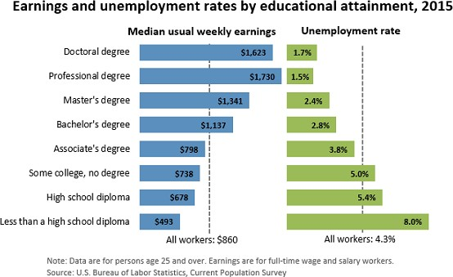

Bureau of Labor Statistics. (2016, March 15). Earnings & Unemployment Rates by Educational Attainment, 2015 [Digital image]. Retrieved April 10, 2017, from https://www.bls.gov/emp/ep_chart_001.htm

Annotated Resources that relate specifically to the element
College: Learning the Skills To Pay the Bills? (Page One Economics). (n.d.). Retrieved April 28, 2017, from https://www.stlouisfed.org/education/page-one-economics-classroom-edition/college-learning-the- skills-to-pay-the-bills
Lessons: Teaching Human Capital and the Importance of Postsecondary Education. (n.d.). Retrieved April 28, 2017, from https://www.frbatlanta.org/education/publications/extra-credit/2016/spring/lessons- and-activities/high-school/personal-finance/teaching-human-capital.aspx?d=1&s=fre

SSEF6 Explain how productivity, economic growth, and future standards of living are influenced by
investment in factories, machinery, new technology, and the health, education, and training of people.
d. Analyze, by means of a production possibilities curve: trade-offs, opportunity cost, growth, and efficiency.
A production possibilities curve is an economic model used by economists to illustrate all possible combinations of efficient production available to an individual, firm, or country given the resources available to produce the two goods or services shown on the graph. The model shows the amount of one good or service sacrificed to produce additional units of the other good or service. The model also shows the production combinations that are inefficient or impossible given current resources. The example below demonstrates the analysis required.
Figure A
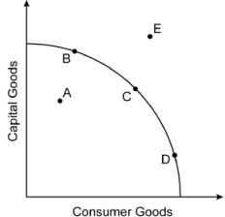
    - On Figure A, points B, C, and D indicate examples of efficient production combinations of capital goods and consumer goods. Any point on the curve falls into this category.
    - On Figure A, point A is an example of an inefficient production combination of capital and consumer goods. This point also represents unemployed resources and/or recession in the economy. This combination is possible, but undesirable given underutilized resources.
    - On Figure A, point E is an example of an unattainable production combination of capital and consumer goods because
Figure B there are not enough factors of production to produce at this point.
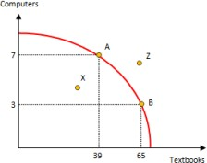
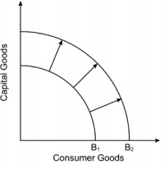
    - Figure B shows the opportunity cost of choosing a particular combination of textbooks and computers over another possible combination. The opportunity cost of choosing point A over point B is 26 textbooks. The marginal benefit of moving from point B to point A is 4 computers.

Figure C
    - Figure C illustrates economic growth on the production possibilities model. Curve B1 shows the economy’s original efficient combinations of capital and consumer goods production. Curve B2 shows the production possibilities curve for the economy following investment in physical capital and technology. For example, the U.S.
economy experienced a shift outward like this after the construction of the interstate highway system in the 1950s. The interstate system was a government investment in physical capital that allowed more production of other capital goods and consumer goods. This happened because interstates made the transportation of inputs and outputs

cheaper and faster for firms in the economy. Large-scale adoption of computers by industry in the 1990s would be another example of investment in physical capital and technology leading to economic growth.

Annotated Resources that relate specifically to the element
Trade: Why Do Nations Trade? (n.d.). Retrieved April 28, 2017, from https://frbatlanta.org/education/classroom -economist/infographics/trade.aspx?d=1&s=fre

TEACHER NOTES
Economics – Microeconomics Domain
SSEMI1 Describe how households and businesses are interdependent and interact through flows of goods,
services, resources, and money.
Within an economy, there are sectors that have specific roles to play in economic activity. These sectors depend upon each other to play each role effectively. The two main sectors are households and businesses (firms). Households need businesses to purchase resources from them in exchange for income and to make goods and services for the households to purchases. Businesses need households to sell their resources to firms so they will have the inputs required to make goods and services.
Business need households to purchase the goods and service they produce so the business can take in revenue (price times the quantity sold) and return a profit to the entrepreneur(s) who own the business. Businesses use money to pay households for their resources and households use the money they earned as income to purchase goods and services.
Resources: (if appropriate)
C ircular flow of income and expenditures. (n.d.). R etrieved April 28, 2017, from https://www.khanacademy.org/economics -finance -domain/macroecon omics/gdp -topic/circular -econ - gdp-tutorial/v/circular -flow-of-income -and-expenditures
C ircular Flow - The Economic Lowdown Video S eries, Episode 6. (n.d.). Retrieved April 28, 2017, from https://www.stlouisfed.org/education/economic -lowdown-video -series/episode -6-circular -flow

SSEMI1 Describe how households and businesses are interdependent and interact through flows of goods,
services, resources, and money.
a. Illustrate a circular flow diagram that includes the product market, the resource (factor) market, households, and firms.
The Circular Flow Diagram is a model economists use to show the characteristics of and relationships that exist between households and businesses in the economy.
Households, in the Resource Market (factor market), are the owners of the productive resources (factors of production) in the circular flow model. They sell their land, labor, capital, and entrepreneurship to businesses (firms) in the Resources Market in exchange for income payments.
Households, in the Product Market, are consumers of goods and services in the circular flow model. They buy goods and services from businesses. They spend the income they earned in the Resource Market to buy these goods and services. Consumer “expenditures” is a fancy word for spending.
Businesses (firms) in the Resource Market are the consumers of the productive resources (factors of production) in the circular flow model. They purchase the use of land, labor, capital, and entrepreneurship from households in the Resource Market (Factor Market) using the revenue they earned in the product market.
Businesses (firms) in the Product Market are producers of goods and services in the circular flow model. They sell goods and services to households. They earn revenue in exchange for their goods and services.

Annotated Resources that relate specifically to the element
C ircular flow of income and expenditures. (n.d.). Retrieved April 28, 2017, from https://www.khanacademy.org/economics -finance -domain/macroeconomics/gdp -topic/circular -econ - gdp-tutorial/v/circular -flow-of-income -and-expenditures
C ircular Flow - The Economic Lowdown Video S eries, Episode 6. (n.d.). Retrieved April 28, 2017, from https://www.stlouisfed.org/education/economic -lowdown-video -series/episode -6-circular -flow
High School Economic Webinar. (n.d.). Retrieved April 28, 2017, from http://www.econedlink.org/tool/390/Webinar-High-School-Economics-3rd-Edition

SSEMI1 Describe how households and businesses are interdependent and interact through flows of goods,
services, resources, and money.
b. Explain the real flow of goods, services, resources, and money between and among households and firms.
In the circular flow diagram below, businesses and households are the sectors of the economy located across from each other on the diagram. The resource and product markets are also located opposite from each other on the diagram. In between the sectors and markets, there are flows of goods and services, resources, and money payments.

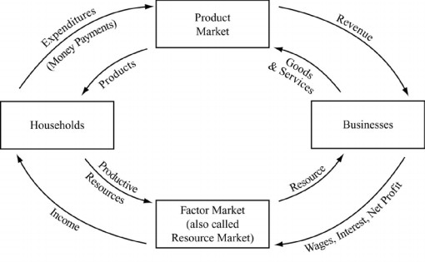

Businesses need productive resources in order to produce goods and services. They go to the resource market to buy productive resources from households. Wages, interest, rent, and profit flow from businesses to the resource market, becoming the flow of income from the resource market to the households. Land, labor, capital, and entrepreneurship flow from households through the resource market to the businesses.
On the other side of the diagram, households use their income for spending or “expenditures” in the product market. Spending flows from households to the product market becoming the revenue that flows from the product market to the businesses. Goods and services flow in the opposite direction from businesses to households through the product market.
It is important to note that the arrows on the inside of the diagram all flow in the same direction, making a circle. This is true for the arrows on the outside too which flow in the opposite direction from those on the inside. On the example diagram shown, notice that the inside circle flows are goods, services, or resources and the outside circle flows are all money payments.

Annotated Resources that relate specifically to the element
Circular flow of income and expenditures. (n.d.). Retrieved April 28, 2017, from https://www.khanacademy.org/economics-finance-domain/macroeconomics/gdp-topic/circular-econ- gdp-tutorial/v/circular-flow-of-income-and-expenditures
Circular Flow - The Economic Lowdown Video Series, Episode 6. (n.d.). Retrieved April 28, 2017, from https://www.stlouisfed.org/education/economic-lowdown-video-series/episode-6-circular-flow

SSEMI2 Explain how the law of demand, the law of supply, and prices work to determine production and distribution in a market economy.

In a market economy, consumers decide what to produce, firms decide how to produce, and the price system decides who will get the items produced. Consumers of goods, services, and resources behave according to the law of demand. Demand is the quantity a consumer is willing and able to purchase at each price. The law of demand says that as the price of a good rises the quantity of the good consumers are willing and able to buy will decrease. Supply is the quantity a seller is willing and able to sell at each price. The law of supply says that as price rises the quantity a seller is willing and able to sell will

increase. A market or equilibrium price is one where the quantity of a good that buyers are willing and able to buy matches the quantity of a good that producers are willing and able to sell. As the market/equilibrium price in the market changes, it sends signals to buyers and sellers about much they should be willing and able to buy and sell.
Resources: (if appropriate)
S hifting C u rves: Demand and Supply S hifts in the Gasoline Market. (n.d.). Retrieved April 29, 2017, from https://www.stlouisfed.org/education/shiftin g-curves -demand -and-supply -shifts -in-the-gasoline - market/
S upply & Demand: How Do Markets Determine Prices? (n.d.). Retrieved April 29, 2017, from https://frbatlanta.org/education/classroom -economist/infographics/supply -and- demand.aspx?d=1&s=fre
SSEMI2 Explain how the law of demand, the law of supply, and prices work to determine production and
distribution in a market economy.
a. Define the law of supply and the law of demand.
The law of demand says that as the price of a good rises the quantity of the good consumers are willing and able to buy will decrease. The graph below illustrates this law.
Price
P2
As price rises from P1 to P2, the quantity of the
good consumers are willing and able to buy falls from Q1 to Q2. This is the law of demand.
P1
Demand
Q2
Q1
Quantity

The law of supply says that as price rises the quantity a seller is willing and able to sell will increase. The graph below illustrates this law.
Price
P2
Supply
P1
As price rises from P1 to P2, the quantity of the
good sellers are willing and able to sell rises from Q1 to Q2. This is the law of demand.
Q1
Q2
Quantity

Annotated Resources that relate specifically to the element

S hifting C urves: Demand and Supply S hifts in the Gasoline Market. (n.d.). Retrieved April 29, 2017, from https://www.stlouisfed.org/education/shifting -curves -demand -and-supply -shifts -in-the-gasoline - market/
S upply & Demand: How Do Markets Determine Prices? (n.d.). Retrieved April 29, 2017, from https://frbatlanta.org/education/classroom -economist/infographics/supply -and- demand.aspx?d=1&s=fre

SSEMI2 Explain how the law of demand, the law of supply, and prices work to determine production and
distribution in a market economy.
b. Distinguish between supply and quantity supplied, and demand and quantity demanded.
The market supply curve refers to all the quantities of a good, service, or resource sellers are willing and able to sell at each price. The quantity supplied is the amount of a good, service, or resource sellers are willing and able to sell at one specific price. In the graph below, the quantity supplied at a price of $1 is 100 units of the good. The market supply includes the quantities supplied at $1, $2, $3, and all other prices found along the curve. The table in the example below is the Supply Schedule and provides the data you use to create a supply curve.
Price
$3
Supply
$2

$1
100 150 200 Quantity

Price | Quantity Supplied
$1 | 100
$2 | 150
$3 | 200

The market demand curve refers to all the quantities of a good, service, or resource buyers are willing and able to buy at each price. The quantity demanded is the amount of a good, service, or resource buyers are willing and able to buy at one specific price. In the graph below, the quantity demanded at a price of $1 is 200 units of the good. The market demand includes the quantities demanded at $1, $2, $3, and all other prices found along the curve. The table in the example below is the Demand Schedule and provides the data you use to create a demand curve.

Price | Quantity Demanded
$1 | 200
$2 | 150
$3 | 100

Price
$3
$2

$1
Demand

100 150 200 Quantity

Annotated Resources that relate specifically to the element
S upply & Demand: How Do Markets Determine Prices? (n.d.). Retrieved April 29, 2017, from https://frbatlanta.org/education/classroom -economist/infographics/supply -and- demand.aspx?d=1&s=fre

SSEMI2 Explain how the law of demand, the law of supply, and prices work to determine production and
distribution in a market economy.
c. Describe the role of buyers and sellers in determining market clearing price (i.e. equilibrium).
The market clearing or equilibrium price is the point of intersection between the market demand curve and market supply curve. This is also the point at which the quantity demanded by consumers is equal to the quantity supplied by producers. Buyers help determine this price by buying a smaller quantity of a good when they view the price charged by sellers as too high. Sellers respond by lowering the price.
When buyers perceive a price as lower than equilibrium price, they will buy all of the available items as quickly as possible. Sellers will notice they are having trouble keeping the item in stock or lack the capacity to provide as many services as consumers want. Sellers will raise the price of the product.
Through these interactions between buyers and sellers, price will work its way toward equilibrium.

Annotated Resources that relate specifically to the element
S hifting C urves: Demand and Supply S hifts in the Gasoline Market. (n.d.). Retrieved April 29, 2017, from https://www.stlouisfed.org/education/shifting -curves -demand -and-supply -shifts -in-the-gasoline - market/
S upply & Demand: How Do Markets Determine Prices? (n.d.). Retrieved April 29, 2017, from https://frbatlanta.org/education/classroom -economist/infographics/supply -and- demand.aspx?d=1&s=fre

SSEMI2 Explain how the law of demand, the law of supply, and prices work to determine production and
distribution in a market economy.
d. Illustrate on a graph how supply and demand determine equilibrium price and quantity.
To illustrate how supply and demand determine equilibrium price and quantity, start with a market graph. Draw a horizontal x-axis line and label it “Quantity”. On the left end of your x-axis, draw a vertical line upward to create a y-axis and label it “Price”. Create the demand curve by drawing a downward sloping 45-degree line from the top of the y-axis diagonally toward the right side of the x-axis. Label this curve “Demand”. Create the supply curve by
drawing an upward sloping 45-degree line from the bottom of the y-axis diagonally upward away from the origin of your graph. Label this curve “Supply”. Find the place at which the demand curve crosses the supply curve. Draw a dotted horizontal line from the point of intersection to the left until it hits the y-axis. Label this y-axis value as “Pe”. Return to the intersection of the supply and demand curve. Draw a dotted vertical line downward to the x-axis and label this x-axis value as “Qe”. “Pe” is the equilibrium price in the market. “Qe” is the equilibrium quantity in the market as well as the quantity at which the quantity demanded is equal to the quantity supplied. The graph below illustrates the equilibrium in the market.
Price
Supply
Pe
Pe is the equilibrium price in the
market. Qe is the equilibrium quantity in the market. At a price of Pe, the quantity supplied in the market is equal to the quantity demanded.
Demand
Qe
Quantity

Annotated Resources that relate specifically to the element
S hifting C urves: Demand and Supply S hifts in the Gasoline Market. (n.d.). Retrieved April 29, 2017, from https://www.stlouisfed.org/educat ion/shifting -curves -demand -and-supply -shifts -in-the-gasoline - market/
S upply & Demand: How Do Markets Determine Prices? (n.d.). Retrieved April 29, 2017, from https://frbatlanta.org/education/classroom -economist/infographics/supply -and- demand.aspx?d=1&s=fre
SSEMI2 Explain how the law of demand, the law of supply, and prices work to determine
production and distribution in a market economy.
e. Identify the determinants (shifters) of supply (e.g., changes in costs of productive resources, government regulations, number of sellers, producer expectations, technology, and education) and illustrate the effects on a supply and demand graph.
The determinants of supply describe the types of changes in a market that will cause the entire supply curve to move to the right or to the left. In other words, all sellers of a good, service, or productive resource will be willing and able to supply more or less of their product at all prices in the market. The shift will cause a change in the equilibrium price and equilibrium quantity in the market. The table below shows the effects of these changes on a supply and demand graph.

Change in the costs of productive resources | Effects of a Change in Supply on a Supply and Demand Graph
Decrease in costs - If the resources needed to produce a product become more less expensive, sellers will produce more and supply will increase and shift to the right.  Example: If the cost of electricity used to power an automotive factories falls, the supply of cars in the market increases.  Increase in Supply Equilibrium Price Decreases  Equilibrium Quantity increases | Price  Pe1 Pe2 | Qe1 | Supply 1 Supply 2  Demand  Qe2 Quantity
Increase in costs – If the resources needed to produce a product become more expensive, sellers can produce less and supply will decrease and shift to the right.  Example: If the price of peanuts rises, then the cost of making peanut butter will increase causing the supply of peanut butter to decrease.  Decrease in Supply Equilibrium Price Increase  Equilibrium Quantity Decreases | Price  Pe2 Pe1 | Qe2 | Supply 2 Supply 1  Demand  Qe1 Quantity
Change in Government Regulations | Effects of a Change in Supply on a Supply and Demand Graph
Decrease in Regulations - If the government decreases the regulations on sellers in a market, sellers will produce more of the product and supply will shift to the right.  Example: When the U.S. stopped controlling the fares and routes for air travel in 1978, airlines made decisions based on market factors, increasing the supply of flights and the price of air travel fell.  Increase in Supply Equilibrium Price Decreases  Equilibrium Quantity increases | Price  Pe1 Pe2 | Qe1 | Supply 1  Supply 2  Demand  Qe2 Quantity

Increase in Regulations - If the government increases the regulations on sellers in a market, sellers will produce less of the product and supply will shift to the left.  Example: If the government requires factories to reduce pollution, complying will initially increase costs of production in the market and reduce supply.  Decrease in Supply Equilibrium Price Increase  Equilibrium Quantity Decreases | Price  Pe2 Pe1 | Qe2 | Supply 2 Supply 1  Demand  Qe1 Quantity
Change in Number of Sellers | Effects of a Change in Supply on a Supply and Demand Graph
Increase in the Number of Sellers - If the number of sellers in the market increases, there will be more producers of the product, supply will increase and shift to the right.  Example: The demand for pecans from people in China has increased which has increased the market price for pecans. This increased market price has attracted more farmers into the pecan market. As trees become productive, the supply of pecans will increase.  Increase in Supply Equilibrium Price Decreases  Equilibrium Quantity increases | Price  Pe1 Pe2 | Qe1 | Supply 1 Supply 2  Demand  Qe2 Quantity

Decrease in the Number of Sellers - If the number of sellers in the market decreases, there will be fewer producers of the product, supply will decrease and shift to the left.  Example: As the demand for DVDs decreased due to consumer preference for streaming movies, the market price for DVDs fell. This lower market price caused sellers to leave the DVD market and supply decreased.  Decrease in Supply Equilibrium Price Increase  Equilibrium Quantity Decreases | Price  Pe2 Pe1 | Qe2 | Supply 2 Supply 1  Demand  Qe1 Quantity
Change in Producer Expectations | Effects of a Change in Supply on a Supply and Demand Graph
Producers expect the price of their product to fall in the future - If producers expect the price of their product to fall in the future, they will supply more in the present while the market price is higher. This will cause supply to increase and shift to the right.  Example: If airlines expect prices for airline tickets to fall in September when families are less likely to travel due the school calendar, they will supply more during the summer months when they can charge higher fares.  Increase in Supply Equilibrium Price Decreases  Equilibrium Quantity increases | Price  Pe1 Pe2 | Qe1 | Supply 1 Supply 2  Demand  Qe2 Quantity

Producers expect the price of their product to rise in the future - If producers expect the price of their product to rise in the future, they will supply less in the present and wait for the price to rise. This will cause supply to decrease and shift to the left.  Example: If producers expect consumers to be willing to pay a higher price for candy during holidays like Halloween, they will supply less now and put their efforts into producing for the period preceding the holiday when the price is higher.  Decrease in Supply Equilibrium Price Increase  Equilibrium Quantity Decreases | Supply 2 Supply 1  Price  Pe2 Pe1  Demand Qe2 Qe1 Quantity

Change in Technology | Effects of a Change in Supply on a Supply and Demand Graph
Production Technology used to produce a product improves - If producers implement new, more efficient technology in the production process, supply will increase and shift to the right.  Examples: When auto manufacturer were able to implement robotics on the production line, automobiles were produced more quickly and at a smaller cost per unit. This allowed the industry to supply more cars.  Increase in Supply Equilibrium Price Decreases  Equilibrium Quantity increases | Price  Pe1 Pe2 | Qe1 | Supply 1 Supply 2  Demand  Qe2 Quantity
Production Technology, used to produce a product, declines – This scenario is unusual. This could occur if a natural or cyber disaster destroyed access to production technology for a large number of the market’s producers at one time or if a defect in production technology affects many producers all at one time. If producers lose the benefits of production technology, supply decreases and shifts to the left.  Example: If a cyberattack interfered with the GPS on which farmers rely to monitor and service their fields for a significant amount of time.  Decrease in Supply Equilibrium Price Increase  Equilibrium Quantity Decreases | Price  Pe2 Pe1 | Qe2 | Supply 2 Supply 1  Demand  Qe1 Quantity

Change in Education | Effects of a Change in Supply on a Supply and Demand Graph
Education of the workers in a market improves - If many workers in a market improve their education, knowledge, and skills related to the production process, their labor productivity will increase. As a result supply will increase and shift to the right.  Example: Workers train on a new software package that will increase productivity in the market and allow supply to increase.  Increase in Supply Equilibrium Price Decreases  Equilibrium Quantity increases | Supply 1 Supply 2  Price  Pe1 Pe2  Demand Qe1 Qe2 Quantity
Education of the workers in a market declines - If the education, knowledge, and skills of many workers in a market declines, their labor productivity will decrease. As a result supply will decrease and shift to the left.  Example: An economic boom allows skilled workers to move from fast food jobs into white collar office administration jobs. Fast food producers are forced to hire less skilled workers and supply of fast food decreases.  Decrease in Supply Equilibrium Price Increase  Equilibrium Quantity Decreases | Supply 2 Supply 1  Price  Pe2 Pe1  Demand Qe2 Qe1 Quantity

Annotated Resources that relate specifically to the element
S hifting C urves: Demand and Supply S hifts in the Gasoline Market. (n.d.). Retrieved April 29, 2017, from https://www.stlouisfed.org/education/shift ing -curves -demand -and-supply -shifts -in-the-gasoline - market/
S upply - The Economic Lowdown Video S eries, Episode 1. (n.d.). Retrieved April 29, 2017, from https://www.stlouisfed.org/education/economic -lowdown-video -series/episode -1-supply
S upply & Demand: How Do Markets Determine Prices? (n.d.). Retrieved April 29, 2017, from https://frbatlanta.org/education/classroom -economist/infographics/supply -and- demand.aspx?d=1&s=fre

SSEMI2 Explain how the law of demand, the law of supply, and prices work to determine
production and distribution in a market economy.
f. Identify the determinants (shifters) of demand (e.g., changes in related goods, income, consumer expectations, preferences/tastes, and number of consumers) and illustrate the effects on a supply and demand graph.
The determinants of demand describe the types of changes in a market that will cause the entire demand curve to move to the right or to the left. In other words, all consumers of a good, service, or productive resource will be willing and able to purchase more or less of a product at all prices in the market. The shift will cause a change in the equilibrium price and equilibrium quantity in the market. The table below shows the effects of these changes on a supply and demand graph.
Change in Price of Related Goods | Effects of a Change in Demand on a Supply and Demand Graph
Decrease in the Price of a Complementary Good - If the price of a good, service, or resource that is consumed with the product in this market falls, then the demand for the product in this market will rise and shift to the right.  Example: When the price of cream cheese falls, the demand for bagels will increase.  Increase in Demand Equilibrium Price Increases Equilibrium Quantity increases | Supply  Price  Pe2 Pe1  Demand 2  Demand 1  Qe1 Qe2 Quantity
Decrease in the Price of a Complementary Good - If the price of a good, service, or resource that is consumed with the product in this market rises, then the demand for the product in this market will fall and shift to the left.  Example: When the price of peanut butter increases, the demand for jelly will decrease.  Decrease in Demand Equilibrium Price Decreases Equilibrium Quantity Decreases | Supply  Price  Pe1 Pe2  Demand 1  Demand 2  Qe2 Qe1 Quantity

Change in Price of Related Goods | Effects of a Change in Demand on a Supply and Demand Graph
Increase in the Price of a Substitute Good - If the price of a good, service, or resource that is consumed in place of the product in this market rises, then the demand for the product in this market will rise and shift to the right.  Example: When the price of black bean veggie burgers rises, the demand for tofu veggie burgers will increase.  Increase in Demand Equilibrium Price Increases Equilibrium Quantity increases | Supply  Price  Pe2 Pe1  Demand 2  Demand 1  Qe1 Qe2 Quantity
Decrease in the Price of a Substitute Good - If the price of a good, service, or resource that is consumed in place of the product in this market decreases, then the demand for the product in this market will fall and shift to the left.  Example: When the price of coffee falls, the demand for tea will decrease.  Decrease in Demand Equilibrium Price Decreases Equilibrium Quantity Decreases | Supply  Price  Pe1 Pe2  Demand 1  Demand 2  Qe2 Qe1 Quantity

Change Consumer Income | Effects of a Change in Demand on a Supply and Demand Graph
Increase in Consumer Income – If consumers in a market for a normal good have an increase in income, then the demand for the product in this market will rise and shift to the right.  Example: If the government decides to lower income tax rates, consumers will have more disposable income to spend on goods and services and demand will increase.  Increase in Demand Equilibrium Price Increases Equilibrium Quantity increases | Supply  Price  Pe2 Pe1  Demand 2  Demand 1  Qe1 Qe2 Quantity
Decrease in Consumer Income - If the income of consumers in the market for a normal good falls, then the demand for the product in this market will fall and shift to the left.  Example: During an economic recession, workers may take pay cuts or lose their from a job loss. If a worker’s income falls, he or she will have less to spend on goods and services. The demand for the product will decrease.  Decrease in Demand Equilibrium Price Decreases Equilibrium Quantity Decreases | Supply  Price  Pe1 Pe2  Demand 1  Demand 2  Qe2 Qe1 Quantity

Change Consumer Expectations | Effects of a Change in Demand on a Supply and Demand Graph
Consumers expect the price of a product to rise in the future - If consumers expect the price of a product to rise in the future, they will demand more in the present before the price rises. This will cause demand to increase and shift to the right.  Example: If consumers expect producers to charge higher prices for candy during holidays like Halloween, some consumers will purchase candy early before prices rise for the holiday.  Increase in Demand Equilibrium Price Increase Equilibrium Quantity Increases | Supply  Price  Pe2 Pe1  Demand 2  Demand 1  Qe1 Qe2 Quantity
Consumers expect the price of a product to fall in the future - If consumers expect the price of a product to fall in the future, they will demand less in the present while the market price is higher. This will cause demand to decrease and shift to the left.  Example: If consumers expect prices for airline tickets to fall in September when families are less likely to travel due the school calendar, consumers who can travel any time will demand fewer tickets during the summer months when prices are high.  Decrease in Demand Equilibrium Price Decreases Equilibrium Quantity Decreases | Supply  Price  Pe1 Pe2  Demand 1  Demand 2  Qe2 Qe1 Quantity

Change Consumer Tastes/Preferences | Effects of a Change in Demand on a Supply and Demand Graph
Increase in Consumer Taste for a Product – If consumers in a market for a good or service have an increase in their taste for that product, then the demand for the product in this market will rise and shift to the right.  Example: If researchers publish a study concluding that eating a grapefruit every day causes people to lose weight, there will be an increase in taste for grapefruit and demand will increase.  Increase in Demand Equilibrium Price Increases Equilibrium Quantity increases | Supply  Price  Pe2 Pe1  Demand 2  Demand 1  Qe1 Qe2 Quantity
Decrease in Consumer Taste for a Product – If consumers in a market for a good or service have a decrease taste for a product, then the demand for the product in this market will rise and shift to the right.  Example: A series of airplane crashes will decrease consumer taste for air travel and demand will decrease.  Decrease in Demand Equilibrium Price Decreases Equilibrium Quantity Decreases | Supply  Price  Pe1 Pe2  Demand 1  Demand 2  Qe2 Qe1 Quantity

Change in Number of Consumers in the Market | Effects of a Change in Demand on a Supply and Demand Graph
Increase in Consumers in the Market  – If more consumers enter the market for a product, then the demand for the product in this market will rise and shift to the right.  Example: As the number of Americans connected to the internet has risen, the number of consumers in the market for online retail has increased and demand has increased.  Increase in Demand Equilibrium Price Increases Equilibrium Quantity increases | Supply  Price  Pe2 Pe1  Demand 2  Demand 1  Qe1 Qe2 Quantity
Decrease in Consumers in the Market – If consumers leave the market for a product, then the demand for the product in this market will fall and shift to the left.  Example: As ride and room sharing apps have expanded, the number of consumers in the traditional taxi and hotel markets has decreased, decreasing demand for these services.  Decrease in Demand Equilibrium Price Decreases Equilibrium Quantity Decreases | Supply  Price  Pe1 Pe2  Demand 1  Demand 2  Qe2 Qe1 Quantity

Annotated Resources that relate specifically to the element
Demand - The Economic Lowdown Video Series, Episode 2. (n.d.). Retrieved April 29, 2017, from https://www.stlouisfed.org/education/economic -lowdown-video -series/episode -2-demand
S hifting C urves: Demand and Supply S hifts in the Gasoline Market. (n.d.). Retrieved April 29, 2017, from https://www.stlouisfed.org/education/shifting -curves -demand -and-supply -shifts -in-the-gasoline - market/
S upp ly & Demand: How Do Markets Determine Prices? (n.d.). Retrieved April 29, 2017, from https://frbatlanta.org/education/classroom -economist/inf ographics/supply -and- demand.aspx?d=1&s=fre

SSEMI2 Explain how the law of demand, the law of supply, and prices work to determine
production and distribution in a market economy.
g. Explain and illustrate on a graph how prices set too high (e.g., price floors) create surpluses, and prices set too low (e.g., price ceilings) create shortages.
In some limited circumstances, governments or producers will choose to set a market price rather than allow the forces of supply and demand to determine the market price. A price set above equilibrium price is a Price Floor. A price set below equilibrium price is a Price Ceiling. Since these set prices are above or below equilibrium, the quantity supplied will not equal the quantity demanded in the market. Since price floors are above equilibrium, there will be a larger quantity supplied than there is a quantity demanded. When quantity supplied is greater than the quantity demanded, there is a surplus of the product in the market. Since price ceilings are below equilibrium, there will be a larger quantity demanded than there is a quantity supplied. When quantity supplied is less than the quantity demanded, there is a shortage of the product in the market. In the example below, the demand and supply schedule table shows that equilibrium price is $2.00. This price is the one at which the quantity demanded is equal to the quantity supplied. If price is legally set at $1.00, this is a price ceiling. Under this condition, the quantity demanded is greater than the quantity supplied and there is a 100-unit shortage in the market. If price is legally set at $3.00, this is a price floor. Under this condition, the quantity demanded is less than the quantity supplied and there is a 100-unit surplus in the market.
Price | Quantity Demanded | Quantity Supplied | Condition in the Market
$1 | 200 | 100 | 100-unit Shortage
$2 | 150 | 150 | Equilibrium
$3 | 100 | 200 | 100-unit Surplus

Price
Supply
$3

$2

$1
Demand

100 150 200 Quantity

Annotated Resources that relate specifically to the element
Price C ontrols. (n.d.). Retrieved April 29, 2017, from http://www.econedlink.org/tool/217/Price - C eilings -Floors -Video -Quiz

SSEMI3 Explain the organization and role of business and analyze the four types of market structures in the U.S. economy.
In the U.S. economy, businesses have a variety forms under which they establish themselves. The form
of business organization a firm uses affects who owns the business, the liability the business owners have for debts of the business, the life of the business, its decision-making process and the type of taxation it experiences. The role of businesses in the U.S. economy includes producing goods and services for consumers, buying productive resources from households, paying income to households in exchange for their resources, borrowing money in the financial markets, making charitable contributions to community organizations, and paying taxes to local, state, and/or federal governments.

The four types of market structures are economic models describing the nature of competition among firms in an industry and include perfect (pure) competition, monopolistic competition, oligopoly, and monopoly. When analyzing the markets in which firms compete, economists consider the following factors: the number of sellers in the market, the conditions restricting new firms from entering the market (barriers to entry), the amount of control individual firms have over the price of their product, and the likelihood of individual firms allocating funds to marketing their product.

Resources: (if appropriate)
C ompetition and Market Structure. (n.d.). Retrieved April 29, 2017, from http://www.econedlink.org/tool/208/C ompetition -Market-S tructure -Video -Quiz
(Open the Entrepreneurs PDF from this link) Federal Reserve Bank of Dallas. (n.d.). Retriev ed April 29, 2017, from https://www.dallasfed.org/en/educate/everyday.aspx

SSEMI3 Explain the organization and role of business and analyze the four types of
market structures in the U.S. economy.
a. Compare and contrast three forms of business organization—sole proprietorship, partnership, and corporation with regards to number of owners, liability, lifespan,
decisionmaking, and taxation.
Sole proprietorships are firms legally owned by only one person. Partnerships are firms legally owned by two or more people. Corporations are firms legally owned by stockholders who have purchased “shares” of the company in the hope that the value of their shares will increase over time and pay dividends. Dividends are money payments distributing some of a firm’s profit to shareholders on a quarterly basis. While sole proprietorship, partnerships, and corporations are the three main ways to organize a business in the U.S., students should understand that there are many variations of these forms in real life with complex rules. The following chart
provides a comparison of the three basic types of business organization. Liability refers to responsibility for paying the debts of the business. Unlimited liability means that if a business is unable to meet its financial obligations, the owner(s) of the business are personally responsible to pay those debts. This means the owner(s) could be required to liquidate personal assets such as their home to pay the debts of the company. Limited liability is when responsibility for the debts of the business are restricted to the ownership stake (shares of stock) the business owner owns. The personal assets of the shareholder are not in jeopardy. Lifespan of the business refers to what happens to the business when an owner leaves or dies. Limited life means the business closing or reorganizing a business under the new owner(s) when the previous owner(s) leave the business. Unlimited life means the business passes to new owners through the sale of shares without ending the business. Decisionmaking refers to

the entity responsible for the day-to-day operating decisions of the business. The way a business is organized affects taxation on the profits of the business. Sole proprietorships and partnerships face a single tax on their business profits as income. The amount of income they earn from their business will determine the income tax rate charged. Corporations must also pay corporate income tax on profits. The profit income distributed to shareholders in the form dividends is also taxed. This is double taxation.
Type of Business  Organization | How many owners are  there? | What type of liability do  owners have? | What is the lifespan of the  business? | Who makes the operating  decisions? | What type of taxation do  owners have?
Sole Proprietorship | One | Unlimited | Limited | Owner | Single
Partnership | Two or more | Unlimited | Limited | Owners | Single
Corporation | Determined by who owns shares of the corporation’s  stock | Limited | Unlimited | Board of Directors elected by shareholders; Professional Managers and Employees | Double

Although not expressly required by this element, you may want to categorize these characteristics of the types of business organization into advantages and disadvantages. The following chart accomplishes this task and includes some other key comparisons.
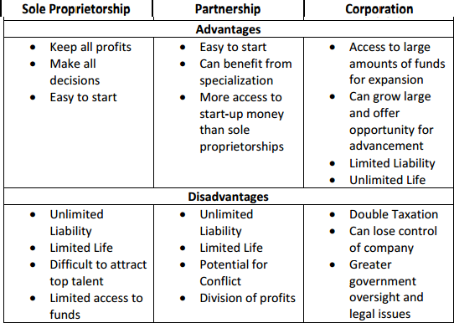

Annotated Resources that relate specifically to the element
(Open the Entrepreneurs PDF from this link) Federal Reserve Bank of Dallas. (n.d.). Retrieved April 29, 2017, from https://www.dallasfed.org/en/educate/everyday.aspx

SSEMI3 Explain the organization and role of business and analyze the four types of
market structures in the U.S. economy.
b. Identify the basic characteristics of monopoly, oligopoly, monopolistic competition, and pure (perfect) competition with regards to number of sellers, barriers to entry, price
control, and product differentiation.

Pure (Perfect) Competition is a market structure characterized by a large number of buyer and sellers of an identical product. (Example: commodities like crude oil) Monopolistic Competition refers to a market structure characterized by a large number of buyers and sellers of products that are similar to one another be can be differentiated by brand, quality, etc. (Example: restaurants and retail clothing sellers) An oligopoly is a market structure characterized by only a few sellers of a product who dominate the market. (Example: breakfast cereals and natural gas) A Monopoly is a market structure characterized by only one seller of a product dominating the market. (Example: electrical power companies and cable television companies) The following characteristics are usually important when distinguishing between the four market structures:

Number of Sellers: Are there many, few, or one seller(s) of the product? The more sellers there are the more competitive the market is.
Barriers to Entry: Are there any obstacles that prevent other firms from entering the market for the good? If barriers are weak or absent from the market, the market will be more competitive.
Price Control: Can the individual firms in the market for a product exercise any control over the price they charge? The weaker the control over price, the more competitive the market.
Product Differentiation: Is there any difference between the products sold by the sellers in the market for the good? If the products sold by the firms in the market are identical, there is no reason for sellers to engage in non-price competition which refers to methods other than price used to attract customers.

The chart below identifies the characteristics associated with each of the four market structures.
Type of Market  Structure | Number of Sellers | Barriers to Entry | Price Control | Product  Differentiation
Pure (Perfect) Competition | Many | Low or No Barriers | None – price taker - must take the market price | None – products are identical
Monopolistic Competition | Many | Low or No Barriers | Some | Yes - firms must engage in non-price competition to distinguish their products from those of competitors
Oligopoly | Few | High Barriers | Yes –price leadership  – when one firm increases or  decreases price, the others will follow to maintain market share | Varies – Oligopoly markets may sell identical or differentiated products – those with differentiated products will use non-price competition
Monopoly | One | High Barriers | Strong Control over Price | Not Applicable – there is only one seller’s product

Annotated Resources that relate specifically to the element
C ompetition and Market Structure. (n.d.). Retrieved April 29, 2017, from http://www.econedlink.org/tool/208/C ompetition -Market-S tructure -Video -Quiz

TEACHER NOTES
Economics – Macroeconomics Domain
SSEMA1 Illustrate the means by which economic activity is measured.
Economic activity derives from the sectors of the economy we explored in the fundamentals and microeconomics domains. Individuals, businesses, markets, and governments all interact to create a country’s economy. The degree of strength or weakness of all economic activity in an economy will affect the individual components of that economy. For this reason, public and private entities constantly measure specific types of economic activity and synthesize the data to create a picture of the economy’s health. The pictures drawn by the data inform policy makers who may choose to intervene in the economy to meet economic goals.
Resources: (if appropriate)
C lassroom Economist - Economic Indicators. (n.d.). Retrieved April 29, 2017, from https://frbatlanta.org/education/classroom -economist.aspx?panel=2

SSEMA1 Illustrate the means by which economic activity is measured.
a. Identify and describe the macroeconomic goals of steady economic growth, stable prices, and full employment.
The teacher notes for Standard SSEF4, element b, explained the social economic goal of growth and that most countries measure this by using changes in real gross domestic product over time. Countries want steady economic growth because it means the economy is moving in the right direction. Steady economic growth is usually associated with things like entrepreneurs starting new businesses, firms becoming more productive by adding capital or new technology, workers becoming more productive through increases in knowledge and skills, and productive resources being available in greater quantities for the economy. Standard SSEF6, element d, showed how to illustrate economic growth on a production possibilities curve indicating a growing economy.

The teacher notes for Standard SSEF4, element b, explained the social economic goal of price stability. Price stability refers to minimizing increases in the price level over time so that a country’s money will retain its purchasing power over time. Countries have many ways to measure changes in the price level in the economy. For the purposes of this course in economics, students need only know one of these measures of price level, the Consumer Price Index. Countries want stable prices so individual, firms, and governments can correctly predict how much the money they have now will buy in the future. Our predictions, about changes in the purchasing power of our money over time, affects how we save, how much we save, and when we decide to spend our savings.

The teacher notes for Standard SSEF4, element b, explained the social economic goal of full employment. Full employment refers to the state of the economy when virtually all who are willing and able to work have the opportunity to do so. Countries have many ways to measure full employment.
For the purposes of this course in economics, students need only know one of these measures, the unemployment rate as well as the four types of unemployment people in the labor force may encounter. Countries want full employment because of the circular flow of the economy studied in standard SSMI1, element a. The income people receive from working affects their ability to buy products and pay taxes. If consumers become unemployed, they will have less income to spend, firms will receive less revenue, and entrepreneurs will earn less profit. Businesses may close because they cannot cover

their costs, causing increased numbers of workers to become unemployed. If workers and entrepreneurs are earning lower incomes, they will pay less to the government in taxes, reducing the amount of public goods and services available. If governments cannot maintain roads or fund schools, the infrastructure needed to support economic activity will decline and the economy will contract.

Annotated Resources that relate specifically to the element
Broad S ocial Economic Goals. (n.d.). Retrieved April 29, 2017, from http://www.econedlink.org/teacher -lesson/1327/Broad -S ocial -Goals -Economy

SSEMA1 Illustrate the means by which economic activity is measured.
b. Define Gross Domestic Product (GDP) as the sum of Consumer Spending, Investment, Government Spending, and Net Exports (output expenditure model).
Gross Domestic Product (GDP) is the sum of consumer spending, investment spending, government spending, and net exports. Consumer spending refers to the monetary value of what households spend on final goods and services in the product market in a given time period. Investment includes the monetary value of final capital goods businesses purchase in a given time period, the value of inventories produced by businesses, but not yet sold, by the end of the measurement time period, and the value of new home construction produced in the given time period. Government spending is the monetary value of any spending on final goods and services by a local, state, or national government in a given time period. Net exports refers to the monetary value of all final goods and services produced in one country but sold outside the country’s borders minus the monetary value of all final goods and services produced outside the country’s borders but sold within the country in a given time period. In
other words, the value of a country’s exports minus the value of a country’s imports in a given time period. This method of calculating a country’s GDP is the Output Expenditure Model.

Annotated Resources that relate specifically to the element
GDP: Measuring national income. (n.d.). Retrieved April 28, 2017, from https://www.khanacademy.org/economics-finance-domain/macroeconomics/gdp-topic
Infographic for GDP. (n.d.). Retrieved April 28, 2017, from https://frbatlanta.org/education/classroom- economist/infographics/gross-domestic-product/full-view.aspx?d=1&s=fre

SSEMA1 Illustrate the means by which economic activity is measured.
c. Define unemployment rate, Consumer Price Index (CPI), inflation, real GDP, aggregate supply and aggregate demand and explain how each is used to evaluate the macroeconomic goals
from SSEMA1a
The unemployment rate is a statistic reported by the Federal Department of Labor’s Bureau of Labor Statistics (BLS). The BLS calculates the unemployment rate from data derived from a sample of 60,000 households as part of the Census Bureau’s Current Population Survey. The BLS reports the statistic monthly. To calculate the unemployment rate, take the number of unemployed people in the country divided by the number of people in the labor force and multiplying the quotient by 100. The result is the percentage of people in the labor force who are unemployed. Since some types of unemployment always exist, such as those graduating from college who start looking for a job, full employment does not mean zero percent unemployment. Economists usually indicate full employment is attained when the unemployment rate is somewhere between 4% and 6%. Those counted as unemployed meet several

criteria. The person must be at least 16 years old, they cannot be in prison or a mental institution, they cannot have worked for pay in the measurement time-period, and they must be actively seeking a job. Calculate the labor force by adding all unemployed people in a country to all the employed people.
Those considered employed are 16 years old, not a member of the armed forces, and worked for pay in the time-period measured.

The Consumer Price Index (CPI) is also a statistic reported monthly by the BLS. The statistic measures the change in value of a basket of goods and services purchased by the average urban consumer. To calculate CPI, take the current value of the market basket, divide it by the value of the market basket in the base year, and multiply the quotient by 100 to get the index number. The base year is simply the year the BLS has chosen to be the year of comparison. As of the writing of this document, the BLS uses the value of the basket in 1982-1984. Statisticians use the resulting CPI number to calculate the inflation rate in the country.

Inflation is a sustained increase in the price level in an economy over time. One way to measure whether there is inflation in the economy is to calculate the inflation rate. The inflation rate is equal to the percent change in a price index number such as the CPI. Percent change in CPI is equal to the new CPI minus the old CPI divided by the old CPI times 100. If the result of this calculation is positive then the price level is rising. Most economists do not want the inflation rate to be zero percent and agree that some inflation will occur when an economy is growing. Increases in the price level become a concern when they happen too quickly, when they make it difficult for households and firms to plan for the future, when they occur because of shocks in markets for productive resources, or when they are a result of inappropriate public policy decisions.

Real GDP is the value of current gross domestic product adjusted for inflation. This is a more accurate view of a country’s productivity than just the current dollar value of the output expenditure model discussed in SSEMA1b. Before adjusting for inflation, an increase in GDP could be due to an increase in the prices of the final goods and service produced rather than an increase in the quantity of goods and services produced. To calculate real GDP, take the value of the output expenditure model from SSEMA1b, divide it by a price index number such as CPI, and multiply the quotient times 100. The result is GDP adjusted for changes in the price level. Most countries measure economic growth through calculating the percentage change in real GDP from one period to the next.
Aggregate Demand refers to the total quantity of all goods and services consumers are willing and able to purchase at each price level in a given period of time. The aggregate demand curve (AD) is downward-sloping showing an inverse relationship between price level and real GDP. Three effects explain the downward-sloping Aggregate Demand curve: the interest rate effect, the wealth effect (real balances), and the foreign purchases effect (net exports effect). The interest rate effect causes the downward slope of the aggregate demand curve because as price level rises, interest rates (the price of borrowing money) rises resulting in consumers and businesses spending less on interest sensitive purchases like cars, new homes, and physical capital. The wealth effect occurs when a rising price level reduces the purchasing power of consumers thus lowering the amount of consumption spending due to higher prices. Finally, the foreign purchases effect occurs when a higher price level in a country makes the relative price of the country’s exports higher, reducing demand for the country’s exports in other countries.

Aggregate Supply is the total quantity of final goods and services producers in an economy are willing and able to supply at each price level. Aggregate supply has both a short-run and a long-run curve. Aggregate supply in the short-run is typically an upward-sloping curve. This illustrates a direct or positive relationship between price level and the quantity of real GDP output supplied in the economy. It is upward-sloping in the short-run because wages and prices are slow to change due to contracts. Economists called this “sticky” wages and prices. In the long-run, economists generally view wages and prices as completely flexible.
Therefore, the long-run aggregate supply curve is vertical at the full employment level of real GDP (real output or real national income). The long-run curve illustrates that, in the long-run, changes in price level have no effect on the long-run quantity of final goods and services the economy can produce.
Although it is beyond the scope of this element, graphing the aggregate demand and supply curves can help students visualize the effect of a change in the curves on the macroeconomic goals specified in SSEMA1a.
Change in Aggregate Demand | Effects of a Change in Aggregate Demand
Increase in Aggregate Demand – Increases in aggregate demand can occur when changes in the economy lead households, businesses, governments, or foreign consumers of domestic exports to purchase a greater number of final goods and services at all price levels.  Real GDP increases – The change from Y1 to Y2 means more employment in the short-run. This change indicates economic growth only if the percent change in Real GDP is greater than the percent change in price level.  Price Level Increases – Price level increased from PL1 to PL2. This indicates an increase in the inflation rate. The amount of the increase would determine how well the  country’s is meeting its price stability goals. | Price Level  PL2 PL1 | Y1 |  | Y2 |  | Short-run Aggregate Supply  Aggregate Demand 2  Aggregate Demand 1 Real GDP
Decrease in Aggregate Demand – Decreases in aggregate demand can occur when changes in the economy lead households, businesses, governments, or foreign consumers of domestic exports to purchase a smaller number of final goods and services at price levels.  Real GDP decreases – The change from Y1 to Y2 means less employment in the short-run. This change indicates the economy is  contracting rather than growing. | Price Level  PL1 PL2 |  | Y2 |  | Y1 | Aggregate Supply  Aggregate Demand 1  Aggregate Demand 2 Real GDP

Price Level decreases – Price level decreased from PL1 to PL2. This indicates a decrease in the price level or deflation. Deflation is generally not desirable when it occurs because of a decrease in economic activity. When the price level falls, businesses are unable to sell their products at a price high enough to cover costs they have already incurred, putting producers at
risk of failure.

Change in Aggregate Supply | Effects of a Change in Aggregate Supply on an Economy
Increase in Aggregate Supply – Increases in aggregate supply can occur when changes in the economy reduce the costs of production or increase productivity for industries throughout the country, allowing producers to supply a greater number of final goods and services at all price levels.  Real GDP increases – The change from Y1 to Y2 means more employment in the short-run. This change indicates economic growth in the short-run because the price level is lower.  Price Level decreases – Price level decreased from PL1 to PL2. A price level decrease caused by decreased production costs or increased productivity do not usually cause the problems associated with deflation from demand shifts since producers  have a lower cost of production. | Price Level  PL1 PL2 | Y1 | Y2 | Aggregate Supply 1  Aggregate Supply 2  Aggregate Demand  Real GDP
Decrease in Aggregate Supply – Decreases in aggregate supply can occur when changes in the economy increase the costs of production or decrease productivity for industries throughout the country, forcing producers to supply a fewer number of final goods and services at all price levels.  Real GDP decrease – The change from Y1 to Y2 means more less | Price Level  PL2 PL1 | Y2 | Y1 | Aggregate Supply 2  Aggregate Supply 1  Aggregate Demand Real GDP

employment in the short-run. This change indicates the economy is contracting in the short-run.

Price Level increases – Price level increased from PL1 to PL2. This economic condition when an increase in the price level occurs with a decrease in Real GDP and employment is stagflation. It is difficult to recover because prices are high at the same time as incomes are falling. There is little incentive to
spend and high incentive to save.

Annotated Resources that relate specifically to the element
Aggregate demand and aggregate supply. (n.d.). Retrieved April 28, 2017, from https://www.khanacademy.org/economics -finance -domain/macroeconomics/aggregate -supply - demand -topic
CPI index. (n.d.). Retrieved April 28, 2017, from https://www.khanacademy.org/economics-finance- domain/core-finance/inflation-tutorial/inflation-basics-tutorial/v/cpi-index

SSEMA1 Illustrate the means by which economic activity is measured.
d. Give examples of who benefits and who loses from unanticipated inflation.
One of the reasons price stability is good for an economy is that it allows households, firms, governments, and the financial sector to make decisions in the present with confidence about the price level in the future. Two groups with an eye on changes in the price level are borrowers and lenders. Households, firms, governments, and financial institutions act as borrowers in the economy. Households take loans for major purchases like cars, college, and homes. Firms borrow to cover expenses in difficult times and to expand operations when the future looks bright. Governments borrow to fund shortfalls in tax revenue needed to provide public goods and services to citizens. Even financial institutions borrow overnight funds to cover their reserve requirements and take longer-term loans to fund expansion projects. All of the sectors act as lenders too. Anyone who holds a bond has lent funds to one of these sectors. Households, businesses, and banks lend to government when they buy Treasury or Municipal bonds. They lend to businesses when they buy corporate bonds. The price of borrowing money is the interest charged over the life of the loan. When lenders make a loan, they agree to a price for the loan. When making loans at fixed rates, an unanticipated rise in price level by more than the lender anticipated hurts the lender since the money repaid will have less purchasing power. Unanticipated inflation hurts lenders who lend at fixed rates. Borrowers who borrow at fixed rates will benefit from unanticipated inflation. Their interest rates remain stable as price rise and they pay back their loan with money that has less purchasing power than the money they borrowed.
Resources: (if appropriate)
Anticipated and Unanticipated Inflation. (2014, August 11). Retrieved April 28, 2017, from http://econtutorials.com/blog/anticipated-and-unanticipated-inflation/

SSEMA1 Illustrate the means by which economic activity is measured.
e. Identify seasonal, structural, cyclical, and frictional unemployment.
Full employment does not mean the country’s unemployment rate is zero percent. Certain types of unemployment always exist even during the best economic times. There are four main types of unemployment. Three out of the four types are long-run unemployment because the rate of unemployment for these types are relatively stable over time. The fourth type is short-run because in good economic times it may be close to zero. It is the short-run type of unemployment that most often targeted by economic stabilization policies. SSEMA2 and SSEMA3 discuss these policies. The chart below describes the four types of unemployment.
Type of Unemployment | Description | Short or Long Run | Example
Cyclical | The cyclically unemployed are unemployed due to a downturn in overall economic activity. If the economy expanded again, these workers would be able to go  back to work. | Short-run | Thousands of restaurant workers lose their jobs because a recession has reduced the number of consumers who can afford to eat out.
Frictional | The frictionally unemployed are unemployed because they are graduating from high school or college, looking for better working conditions, or seeking a  higher wage. | Long-run | In May, thousands of college graduates enter the labor market looking for their first professional job. This happens every May, year after year.
Structural | Structurally unemployed people are unemployed because their human capital does not match the needs of employers hiring in the labor  market. | Long-run | Thousands of high school students graduate without the literacy and math skills needed by the labor market. This happens  every year.
Seasonal  (Sub category of structural unemployment) | Seasonally unemployed people are unemployed because employers need their type of human capital during only one part of the  year. | Long-run | Agricultural workers seek new jobs when the harvest season is finished.

Annotated Resources that relate specifically to the element
Types of Unemployment Online Course for Teachers and Students. (n.d.). Retrieved April 28, 2017, from https://www.stlouisfed.org/education/types-of-unemployment-online-course-for-teachers-and- students
SSEMA1 Illustrate the means by which economic activity is measured.
f. Define the stages of the business cycle, including: peak, contraction, trough, recovery/expansion as well as recession and depression.
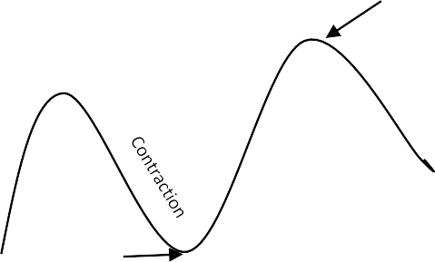
The business cycle is an economic model illustrating how economic activity fluctuates over time. The y-axis in the model is Real GDP and the x-axis is Time. The x-axis values are usually months, quarters, or years. The business cycle graph looks a graph of waves from the field of Physics. The graph shows a period of rising Real GDP reaching a high point and then falling until reaching a low. After the lowest point, Real GDP recovers and begins to rise again. The whole cycle repeats itself. The graph below shows the business cycle model. The graph that follows the model shows real data about the U.S. economy.
Peak
Real GDP
Trough

Time
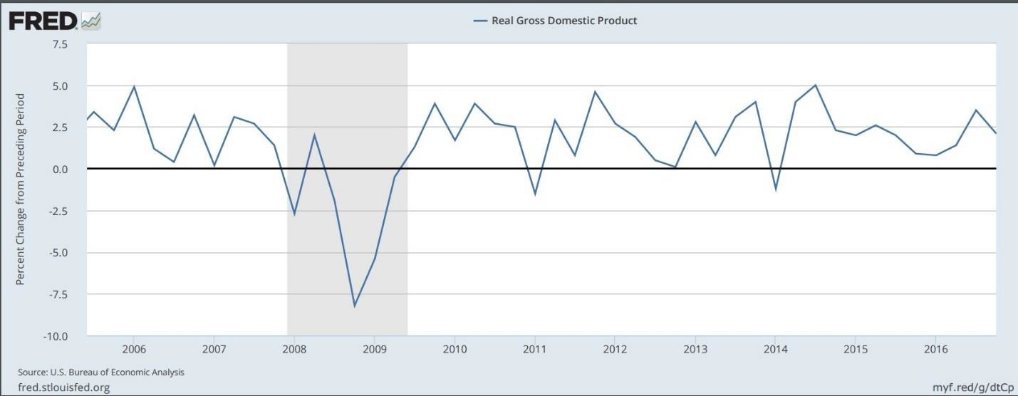
https://fred.stlouisfed.org/series/A191RL1Q225SBEA

Annotated Resources that relate specifically to the element
- (2012, June 28). The Business Cycle. Retrieved April 28, 2017, from https://www.youtube.com/watch?v=yOpsT4hqpME&feature=player_embedded%3Fd&s=fre

SSEMA2 Explain the role and functions of the Federal Reserve System.
The Federal Reserve System is the central bank for the United States. Congress created the Federal Reserve in 1913 to provide stability for the U.S. financial system after the country experienced a series of severe financial crises. The Federal Reserve’s role in the economy includes conducting monetary policy, maintaining the stability of the financial system, supervising and regulating financial institutions, fostering a safe and efficient payments system, and promoting consumer protection and community development. Study of the Federal Reserve in this course includes: explaining the role and function of money, describing the organization of the Federal Reserve System, defining monetary policy and its tools, and describing how the Federal Reserve uses monetary policy to promote its dual mandate of price stability and full employment.
Resources: (if appropriate)
Board of Governors of the Federal Reserve System. (n.d.). Retrieved April 29, 2017, from https://www.federalreserve.gov/aboutthefed/pf.htm
Exploring the Distinctions between Monetary and Fiscal Policy. (n.d.). Retrieved April 29, 2017, from https://www.richmondfed.org/~/media/richmondfedorg/publications/education/5e_educator/2013/pd f/5e_educator_springsummer_2013.pdf
Infographic for Fiscal and Monetary Policy. (n.d.). Retrieved April 29, 2017, from https://frbatlanta.org/education/classroom-economist/infographics/fiscal-and-monetary-policy/full- view.aspx?d=1&s=fre
Infographic for "The Fed Explained". (n.d.). Retrieved April 29, 2017, from https://www.frbatlanta.org/about/fed- explained/infographic.aspx

SSEMA2 Explain the role and functions of the Federal Reserve System.
a. Explain the roles/functions of money as a medium of exchange, store of value, and unit of account/standard of value.
Throughout history, money has taken many forms. We have used items like shells, animal skins, and precious metals as money. Money is what money does. Any item that serves the three main functions of money efficiently is good money. In most economies today, we use a type of money called fiat money. Fiat money is the official money issued by the government of a country. In most cases today, a country’s money works because of trust in the good faith and credit of the country’s government. As long as people are willing to accept a country’s money as a method of payment, the money functions effectively. Maintaining confidence in the U.S. monetary system is an important role of the Federal Reserve. For money to have value, people must believe it has value and it must serve the following three functions: medium of exchange, store of
value, and unit of account (standard of value). Money used as a medium of exchange facilitates transactions between individuals, businesses, financial institutions, and governments in an economy. When a household wants to purchase groceries, it will use money to facilitate the transaction. The household could use cash, write a check, or swipe a debit card linked to a checking account. All of these methods of payment involve using money as a medium of exchange. The money payment people earn is income. Many people today receive this money payment through direct deposit into a checking account. After receiving their money payment, most people will designate some of the money for spending and some of the money for saving.
When people hold money as savings for purchases sometime in the future, money functions as a store of value. People avoid holding savings if they fear a loss of purchasing power in the future. The belief that money saved today will purchase a similar amount of goods and services in the future is the function store of

value. Money also functions as a guide. In the United States, the dollar is our unit of currency. When we look at our bank account balance or shop for goods and services, we see an amount expressed in dollars. This allows us to compare prices and determine whether we have enough in our account to make a particular purchase. This function of money is unit of account (or standard of value).

Annotated Resources that relate specifically to the element
(Open the Money PDF from this link) Federal Reserve Bank of Dallas. (n.d.). Retrieved April 29, 2017, from https://www.dallasfed.org/en/educate/everyday.aspx
Money Video and Quiz. (n.d.). Retrieved April 29, 2017, from http://www.econedlink.org/tool/189/Money-Video-Quiz

SSEMA2 Explain the role and functions of the Federal Reserve System.
b. Describe the organization of the Federal Reserve System (12 Districts, Federal Open Market Committee (FOMC), and Board of Governors).
The Federal Reserve System is unique among the world’s central banks for its decentralized structure and its public/private nature. In the Federal Reserve Act of 1913, Congress called for a decentralized structure with a maximum of 12 district banks located throughout the country. The district banks are the private part of the system and the Board of Governors is the public part. District banks operate under the direction of a private board representing banking, business and community organizations throughout the district. A selection committee of non-banker board members select the president of the district banks. The president and his or her professional staff are employees of the district and run the day-to-day operations of the district banks.
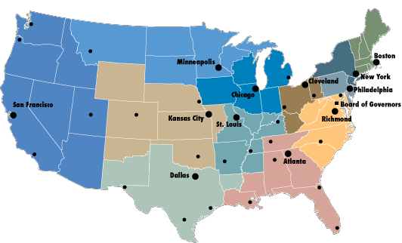
The President of the United States nominates members of the Board of Governors and the U.S. Senate confirms them. They are the public part of the system. The Federal Open Market Committee (FOMC) is the monetary policy making body of the Federal Reserve System. When fully staffed, the FOMC includes the seven members of the Board of Governors and the 12 district bank presidents. Only five of the twelve district bank presidents are voting members of the FOMC at any one time. The New York District president always votes. The other four voting spots rotate among the remaining eleven district presidents. The image below shows the geographic location of the districts and Board of Governors.
https://www.federalreserveeducation.org/about-the-fed/structure-and-functions/districts
The following image shows the composition of the Federal Open Market Committee.

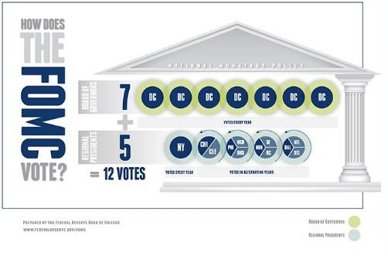
https://www.chicagofed.org/education/fomc-infographic

Annotated Resources that relate specifically to the element
Board of Governors of the Federal Reserve System. (n.d.). Retrieved April 29, 2017, from https://www.federalreserve.gov/aboutthefed/pf.htm

SSEMA2 Explain the role and functions of the Federal Reserve System.
c. Define monetary policy
According to the Federal Reserve’s 2016 edition of Purposes and Functions, “monetary policy is the Federal Reserve’s actions, as a central bank, to achieve three goals specified by Congress: maximum employment, stable prices, and moderate long-term interest rates in the United States.”

Annotated Resources that relate specifically to the element
Board of Governors of the Federal Reserve System. (n.d.). Retrieved April 29, 2017, from https://www.federalreserve.gov/aboutthefed/pf.htm
Infographic for Fiscal and Monetary Policy. (n.d.). Retrieved April 29, 2017, from https://frbatlanta.org/education/classroom-economist/infographics/fiscal-and-monetary-policy/full- view.aspx?d=1&s=fre

SSEMA2 Explain the role and functions of the Federal Reserve System.
d. Define the tools of monetary policy including reserve requirement, discount rate, open market operations, and interest on reserves.
According to the Federal Reserve Board of Governors, there are currently seven tools of monetary policy available to the Federal Open Market Committee. For the purposes of this course in economics, students must define four of these tools.
Reserve Requirement: The Federal Reserve requires most financial institutions to keep a percentage of customer deposits in vault cash or as a deposit in their account with the Federal Reserve. Banks cannot lend these reserves. In theory, if the Federal Reserve raised or lowered the reserve requirement, it would change the supply of money in the economy. However, the Federal Reserve rarely uses this tool.
Interest on Required and Excess Reserves: On October 1, 2008, Congress authorized the Federal Reserve to begin paying interest on the required and excess reserves of financial institutions. Prior to this change, financial institutions gained no return on their required reserves, acting as an implicit tax. Now, they earn a return on required reserves as well as any excess reserves they want to hold with the Federal Reserve.
Financial institutions weigh the choice between earning interest on excess reserves from the Fed with the option to earn interest by loaning excess reserves to customers. If the Federal Reserve changes the interest rate on excess reserves, it changes the incentive financial institutions have to keep their reserves with the Fed, increasing or decreasing the money supply.
Discount Rate: One role the Federal Reserve plays in the economy is the “lender of last resort.” If financial institutions cannot borrow from each other, they may need to borrow from the Federal Reserve. The interest rate charged by the Fed, when lending to a financial institution, is the Discount Rate. When the Fed raises or lowers the discount rate, it is sending a signal to financial institutions telling them to increase or decrease their lending activity, affecting the money supply.
Open Market Operations: At each Federal Open Market Committee meeting, members vote to raise, lower, or maintain their target for an interest rate called the Federal Funds Rate (FFR). The FFR is the rate financial institutions charge each in the overnight lending market. The Fed targets the rate by buying or selling government bonds through primary dealers in the open market. As the FFR rises or falls, the incentives for financial institutions to borrow from each other changes, affecting the money supply.

Annotated Resources that relate specifically to the element
Board of Governors of the Federal Reserve System. (n.d.). Retrieved April 29, 2017, from https://www.federalreserve.gov/aboutthefed/pf.htm
Infographic for Fiscal and Monetary Policy. (n.d.). Retrieved April 29, 2017, from https://frbatlanta.org/education/classroom-economist/infographics/fiscal-and-monetary-policy/full- view.aspx?d=1&s=fre

SSEMA2 Explain the role and functions of the Federal Reserve System.
e. Describe how the Federal Reserve uses the tools of monetary policy to promote its dual mandate of price stability and full employment, and how those affect economic growth.
The Federal Reserve uses monetary policy to achieve its congressionally mandated goals of price stability and full employment. The following chart shows how each of the four policy tools discussed in SSEMA2d are used to achieve these economic goals and how economic growth is likely to be affected.

Tool | Action | When is the Fed most likely to use it? | Effect the Money Supply | Effect on Price Level, Real GDP, & Unemployment
Reserve Requirement | Increase the reserve requirement | When concerned about inflation  (Price Stability) | Money supply would decrease | Price Level falls Real GDP falls Unemployment  rises
 | Decrease the reserve requirement | When concerned about contraction or recession  (Full Employment) | Money supply would increase | Price Level rises Real GDP rises  Unemployment decreases
Interest on Required & Excess Reserves | Increase the interest rate on reserves | When concerned about inflation  (Price Stability) | Money supply would decrease | Price Level falls  Real GDP falls  Unemployment rises
 | Decrease the interest rate on reserves | When concerned about contraction or recession  (Full Employment) | Money supply would increase | Price Level rises Real GDP rises Unemployment  decreases
Discount Rate | Increase the discount rate | When concerned about inflation  (Price Stability) | Money supply would decrease | Price Level falls Real GDP falls  Unemployment rises
 | Decrease the discount rate | When concerned about contraction or recession  (Full Employment) | Money supply would increase | Price Level rises Real GDP rises Unemployment  decreases
Open Market Operations | Sell government securities on the open market | When concerned about inflation  (Price Stability) | Money supply would decrease | Price Level falls Real GDP falls  Unemployment rises
 | Buy government securities on the open market | When concerned about contraction or recession  (Full Employment) | Money supply would increase | Price Level rises Real GDP rises Unemployment  decreases

Annotated Resources that relate specifically to the element
Board of Governors of the Federal Reserve System. (n.d.). Retrieved April 29, 2017, from https://www.federalreserve.gov/aboutthefed/pf.htm
Guided Reading Questions for Notes from the Vault's "Interest on Reserves". (n.d.). Retrieved April 29, 2017, from https://frbatlanta.org/education/publications/extra-credit/2017/spring/lessons-and-activities/high- school/macroeconomics/guided-reading-questions-for-interest-on-reserves.aspx?d=1&s=fre
Infographic for Fiscal and Monetary Policy. (n.d.). Retrieved April 29, 2017, from https://frbatlanta.org/education/classroom-economist/infographics/fiscal-and-monetary-policy/full- view.aspx?d=1&s=fre
SSEMA3 Explain how the government uses fiscal policy to promote price stability, full employment, and economic growth.

Many individuals and businesses expect government to provide the foundation for a healthy economy and take policy action to stabilize the economy in difficult times. In the United States, government uses fiscal policy to promote price stability during times of inflation and full employment during times of contraction. The fiscal policy tools available to government are changes in government spending and changes in taxes.
Resources: (if appropriate)
Exploring the Distinctions between Monetary and Fiscal Policy. (n.d.). Retrieved April 29, 2017, from https://www.richmondfed.org/~/media/richmondfedorg/publications/education/5e_educator/2013/pd f/5e_educator_springsummer_2013.pdf
Fiscal Policy Online Course for Teachers and Students. (n.d.). Retrieved April 29, 2017, from https://www.stlouisfed.org/education/fiscal-policy-online-course-for-teachers-and-students Fiscal Policy Video and Quiz. (n.d.). Retrieved April 29, 2017, from http://www.econedli nk.org/tool/203/Fiscal -Policy -Video -Quiz
Infographic for Fiscal and Monetary Policy. (n.d.). Retrieved April 29, 2017, from https://frbatlanta.org/education/classroom-economist/infographics/fiscal-and-monetary-policy/full- view.aspx?d=1&s=fre

SSEMA3 Explain how the government uses fiscal policy to promote price stability, full
employment, and economic growth.
a. Define fiscal policy.
The term fiscal policy at the federal level refers to legislation, passed by Congress and signed into law by the President, changing levels of taxation and/or government spending to stabilize the economy. By changing the amount of taxes people pay or the amount of spending by the government, fiscal policy influences economic activity in the circular flow of the economy. State and local governments also use changes in taxes or spending to influence economic activity.

Annotated Resources that relate specifically to the element Fiscal Policy Video and Quiz. (n.d.). Retrieved April 29, 2017, from http://www.econedlink.org/tool/203/Fiscal-Policy-Video-Quiz
Infographic for Fiscal and Monetary Policy. (n.d.). Retrieved April 29, 2017, from https://frbatlanta.org/education/classroom-economist/infographics/fiscal-and-monetary-policy/full- view.aspx?d=1&s=fre
SSEMA3 Explain how the government uses fiscal policy to promote price stability, full
employment, and economic growth.
b. Explain the effect on the economy of the government’s taxing and spending decisions in promoting price stability, full employment, and economic growth.
Changes in taxation and spending may promote price stability, full employment, and economic growth. During a time of increasing price level, the government may decide to pursue contractionary fiscal policy to curb inflation. The fiscal policy tools used to combat inflation include lowering government spending or increasing taxes. Reducing government spending, fewer firms and workers are earning money from government contracts and jobs. This lowers consumption and investment spending in the economy putting downward pressure on prices and eventually reducing inflation.
When the government wishes to promote full employment and economic growth at a time when price level is not a concern, it will use fiscal policy tools designed to increase consumption and investment spending in the economy. By lowering taxes, government allows people to keep more of their income for spending on goods and services. By increasing government spending, more firms and workers can earn money from government contracts and jobs. Households spend some of this additional income on goods and services, increasing other economic activity.

The chart below illustrates how changes in government spending and taxes should affect the economy.
Tool | Action | When is the government most likely to use it? | Effect on Economic Activity | Effect on Price Level, Real GDP, & Unemployment
Change in Taxes | Increase taxes | When concerned about inflation  (Price Stability) | Economic activity would fall | Price Level falls Real GDP falls  Unemployment rises
 | Decrease taxes | When concerned about contraction or recession  (Full Employment) | Economic activity would increase | Price Level rises Real GDP rises  Unemployment  decreases
Change in Government Spending | Decrease spending | When concerned about inflation  (Price Stability) | Economic activity would fall | Price Level falls Real GDP falls Unemployment  rises
 | Increase Spending | When concerned about contraction or recession  (Full Employment) | Economic activity would increase | Price Level rises  Real GDP rises  Unemployment decreases

Annotated Resources that relate specifically to the element
Fiscal Policy Video and Quiz. (n.d.). Retrieved April 29, 2017, from http://www.econedlink.org/tool/203/Fiscal -Policy -V ideo-Quiz
Government S pending: Measuring Federal Expenditures. (n.d.). Retrieved April 29, 2017, from http://www.frbsf.org/education/teacher -reso urces/datapost/macroeconomics/government -spending/

SSEMA3 Explain how the government uses fiscal policy to promote price stability, full
employment, and economic growth.
c. Explain how government budget deficits or surpluses impact national debt.
All budgets include sources of income and a list of expenses. Income for a government usually comes from two sources: taxes and fees. Expenses include all the public goods and services provided by the government as well as the interest payments the government pay on its debt. The total amount of income the government receives minus the total amount of expenses it pays determines whether a government’s budget runs a surplus or a deficit. A surplus exists when the amount of income received exceeds the amount of expenses paid. A deficit exists when the amount of income received falls short of the amount of expenses paid. Governments running a deficit must borrow funds to pay expenses. Anyone who owns a government bond is a lender to that government and is paid interest by the government for the use of their money. Each year, any deficit in the federal government’s budget adds to the country’s national debt. If interest rates remain the same or increase as the national debt increases, it costs the federal government more each year to pay the interest payments on the debt. If a government runs a surplus in its budget, it can pay down its debt with the surplus funds to reduce the national debt.

Annotated Resources that relate specifically to the element
Budget Deficits and Public Debt Video and Quiz. (n.d.). Retrieved April 29, 2017, from http://www.econedlink.org/tool/199/Budget-Deficits-Public-Debt-Video-Quiz
Government Budgets Online Course for Teachers and Students. (n.d.). Retrieved April 29, 2017, from https://www.stlouisfed.org/education/government-budgets-online-course-for-teachers-and-students

TEACHER NOTES
Economics – International Domain
SSEIN1 Explain why individuals, businesses, and governments trade goods and services.
Trade refers to the exchange of goods, services, and/or productive resources among individuals, businesses, and/or governments. Trade refers to exchange among people within a country as well as international trade among people from many countries. Economic models suggest domestic and international trade improve a country’s economy. However, some individuals, firms, and/or industries experience difficulties as trading relationships evolve over time. As with all choices, costs and benefits exist.
Resources: (if appropriate)
(Open the International Trade PDF from this link) Federal Reserve Bank of Dallas. (n.d.). Retrieved April 29, 2017, from https://www.dallasfed.org/en/educate/everyday.aspx

SSEIN1 Explain why individuals, businesses, and governments trade goods and services.
a. Define and distinguish between absolute advantage and comparative advantage.
Absolute advantage refers to an individual, firm, or country using the fewest inputs to produce the same amount of output or the individual, firm, or country producing the largest number of units of output given the same productive resources.
For example, imagine two countries, Jasminia and Lauraland, both producing MP3 players and Tablet Computers. In the example below, the problem presented is an INPUT problem because the numbers represent the labor hours used to produce one unit of each good. Since Jasminia only takes 10 hours to produce a unit of MP3 players while Lauraland takes 15 hours, Jasminia has the absolute advantage. In the case of the tablet computer, both countries take the same number of hours so neither has the absolute advantage.
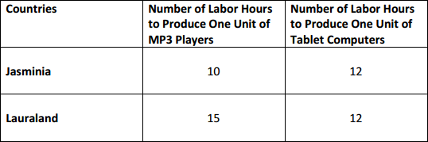
Now, imagine that Matthewtopia and Damianland are both producing MP3 players and Tablet Computers. However, the problem presented below is an OUTPUT problem because the numbers represent the number of units of each good they can produce given a fixed resource, in this case one hour of time. Since Damianland produces 9 MP3 players while Matthewtopia produces only 4 MP3 players, Damianland has the absolute advantage. In fact, Damianland has the absolute advantage in both good because it produces more of both per hour.

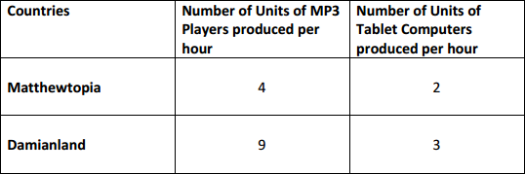

While large, more technologically advanced countries will probably have an absolute advantage in production over smaller countries, both countries can still benefit each other through specialization and trade.
The economic model explaining the how two entities can benefit from trade is the law of comparative advantage. Comparative advantage in production of a good or service exists when one individual, firm, or country has the lowest opportunity cost for producing the good or service.
To illustrate comparative advantage, let us look again at the example using Jasminia and Lauraland. Remember, this is an INPUT problem because the numbers represent the labor hours used to produce one unit of each good. Use the labor hours to find out how many units of tablet computers each country must give up to produce MP3 players. For input problems, we have to express opportunity cost as the
ratio of “what we are producing” divided by “what we are giving up”. The ratios in each box below
represent the opportunity cost of producing each good. When reading this information, say it the following way:
“When Jasminia produces MP3 players, it gives up .833 of a tablet computer. When Lauraland produces MP3 players, it gives up 1.67 tablet computers.”
Since Jasminia gives up less to produce MP3 players, it has the comparative advantage in production. It should specialize in this product.
“When Jasminia produces Tablet Computer, it gives up 1.2 MP3 players. When Lauraland produces Tablet Computer, it gives up .6 of an MP3 player.”
Since Lauraland gives up less to produce Tablet Computers, it has the comparative advantage in production. It should specialize in this product. Jasminia should trade its MP3 players to Lauraland in exchange for Lauraland’s tablet computers. By specializing and trading, both countries will be able to consume more goods than they could when they produced both goods.
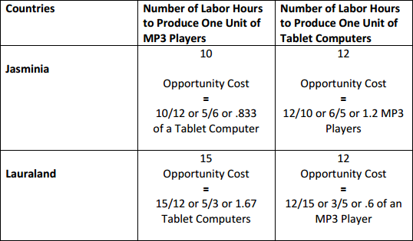

To illustrate comparative advantage using the OUTPUT method, let us look again at the example using Matthewtopia and Damianland. The problem presented is an OUTPUT problem because the numbers represent the number of units of each good produced given the same amount of resources. Use the number of units to find out how much of one good each country must give up to produce the other good. For output problems, we have to express opportunity cost as the ratio of “what we are giving up” divided by “what we are producing”. The ratios in each box below represent the opportunity cost of producing the other good. When reading this information, say it the following way:
“When Matthewtopia produces MP3 players, it gives up .5 of a tablet computer. When Damianland
produces MP3 players, it gives up .33 of a tablet computer.”
Since Damianland gives up less to produce MP3 players, it has the comparative advantage in production. It should specialize in this product.
When Matthewtopia produces Tablet Computers, it gives up 2 MP3 players. When Damianland produces Tablet Computer, it gives up 3 MP3 players. Since Matthewtopia gives up less to produce Tablet Computers, it has the comparative advantage in production. It should specialize in this product. Damianland should trade its MP3 players to Matthewtopia in exchange for Matthewtopia’s tablet computers. By specializing and trading, both countries will be able to consume more goods than they could when they produced both goods.
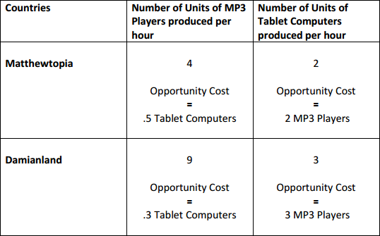

Annotated Resources that relate specifically to the element
C omparative Advantage Online C ourse for Teachers and S tudents. (n.d.). Retrieved April 29, 2017, from https://www.stlouisfed.org/education/comparative -advantage -online -course -for-teachers -and- students Trade: Why Do Nations Trade? (n.d.). Retriev ed April 28, 2017, from https://frbatlanta.org/education/classroom -economist/infographics/trade.aspx?d=1&s=fre

SSEIN1 Explain why individuals, businesses, and governments trade goods and services.
b. Explain that most trade takes place because of comparative advantage in the production of a good or service.
Based on the examples used in SSEIN1a, the country with the lowest opportunity cost for producing a good or service should specialize in that good and then trade with another country for the other good. By producing those goods for which it has the lowest opportunity cost, countries can consume beyond

the production possibilities of their own country. Specialization allows countries to allocate resources to their best possible use and creates greater economic efficiency.

Annotated Resources that relate specifically to the element
C omparative Advantage Online C ourse for Teachers and S tudents. (n.d.). Retrieved April 29, 2017, from https://www.st louisfed.org/education/comparative -advantage -online -course -for-teachers -and- students
SSEIN1 Explain why individuals, businesses, and governments trade goods and services.
c. Define balance of trade, trade surplus, and trade deficit.
A country’s balance of trade refers to the value of its exports minus the value of its imports for measurable during a specific time. Remember, this is the calculation used to determine the value of the Net Exports component of GDP. If the value of a country’s exports exceeds the value of its imports, the country enjoys a trade surplus. If the value of a country’s exports fall short of the value of its imports, the country has a trade deficit.

Annotated Resources that relate specifically to the element
Wolla, S. A. (n.d.). International Trade. Retrieved April 29, 2017, from https://research.stlouisfed.org/publications/page1-econ/2016/11/01/international-trade/
SSEIN2 Explain why countries sometimes erect trade barriers and sometimes advocate free trade.

Trade Barriers limit the flow of goods, services, and productive resources between countries. Free trade refers to the unrestricted flow of goods, services, and productive resources between countries. While the field of economics generally regards free trade as positive for countries, specific political, ideological, and economic factors affecting a country may incentivize the erection of trade barriers.
Resources: (if appropriate)
Analysis Trade Barriers. (n.d.). Retrieved April 29, 2017, from https://www.sophia.org/tutorials/analysis -trade -barriers -2

SSEIN2 Explain why countries sometimes erect trade barriers and sometimes advocate free trade.
a. Define trade barriers such as tariffs, quotas, embargoes, standards, and subsidies.
Trade Barriers are laws passed or actions taken by the government of a country with the intention of restricting the flow of goods and services between itself and another country or countries. Except for embargoes, the motivation for trade barriers is protection of a domestic industry or domestic jobs. The most common trade barriers are tariffs, quotas, embargoes, standards, and subsidies. A tariff is a tax placed on goods imported into a country. A quota limits the quantity of a good imported into a country. Embargoes completely ban trade with a country usually due to political disputes. Standards are requirements a good must meet before it can enter the country as an import. Subsidies are government payments transferred exporting companies allowing the companies to compete with other nations at

the international market price without having to incur the costs associated with selling at the lower price.

Annotated Resources that relate specifically to the element
Trade: Why Do Nations Trade? (n.d. ). Retrieved April 28, 2017, from https://frbatlanta.org/education/classroom -economist/infographics/trade.aspx?d=1&s=fre

SSEIN2 Explain why countries sometimes erect trade barriers and sometimes advocate free trade.
b. Identify costs and benefits of trade barriers to consumers and producers over time.
When a country imposes trade barriers, some people benefit and others incur costs. A general concern about using any trade barrier is the possible retaliation of the other country. If a country decides to use a tariff, the benefits include providing revenue to the importing country’s government as it collects the tax and protecting the domestic producers of the good by effectively increasing the price of imported goods. Costs of tariffs include higher prices for consumers and inefficiently producing goods for which the country does not have a comparative advantage.
Quotas benefit domestic producers by limiting the number of foreign goods with which they must compete. The cost is that consumers who want the imported good cannot get it once the quota is met no matter how high a price they are willing to pay. The country’s resources are allocated toward goods for which it does not have a comparative advantage. Embargoes are politically motivated.
An embargo could successfully influence another country to behave according to the embargoing country’s wishes, benefitting the embargoing country. However, the individuals and firms in the embargoing country can no longer enjoy the goods the embargoed country produces and may encounter higher prices from less competition in the market. The individuals and firms in the embargoed country will incur significant costs without the economic activity with customers in the embargoing country.
By placing standards on a good, a country can exclude the goods of foreign producers who are unable to meet the importing country’s requirements. When used appropriately, standards can benefit domestic consumers by protecting them from substandard or dangerous products. Some countries impose unattainable standards for foreign producers simply to force them out of the domestic market despite the products not posing any threat to domestic consumers. This hurts domestic consumers by increasing prices and hurts the foreign producer who has lost a market for the product.
Subsidies benefit domestic producers by allowing them to compete at the lower market price established by their foreign competition. This keeps prices low for domestic and foreign consumers, protects domestic jobs, and helps firms stay profitable. Subsidies damage industries and workers in other countries that would have a comparative advantage in production if the subsidy were not in place.

Annotated Resources that relate specifically to the element
Trade: Why Do Nations Trade? (n.d.). Retrieved April 28, 2017, from https ://frbatlanta.org/education/classroom -economist/infographics/trade.aspx?d=1&s=fre

SSEIN2 Explain why countries sometimes erect trade barriers and sometimes advocate free trade.
c. Describe the purpose of trading blocs such as the EU, NAFTA, and ASEAN.
Trading blocs refer to free trade agreements among countries in a region. The goals for trading blocs may include reducing or eliminating trade barriers, increasing specialization and efficiency in production, allowing free movements of workers within the bloc, establishing a common currency, and/or coordinating infrastructure projects to facilitate efficient trade among members. Three examples of trading blocs are the EU, NAFTA, and ASEAN. As of May 1, 2017, the European Union (EU) had 28 member countries. Of the 28, 19 use the common currency the Euro and 26 enjoy the border-free movement of goods and people from country to country. Currently, the United Kingdom intends to leave the European Union within about two years. The North American Free Trade Agreement (NAFTA) is an agreement among the United States, Canada, and Mexico. This agreement allows for the free trade of many goods among the countries, encourages efficiency and specialization in production, and involves coordination among countries. NAFTA countries do not share a common currency or border- free movement of goods and people. The Association of Southeast Asian Nations (ASEAN) is a trade bloc of 10 Southeast Asian countries. Like the NAFTA countries, the ASEAN countries promote free trade, specialization, and coordination among members, but do not have a common currency or border-free travel.
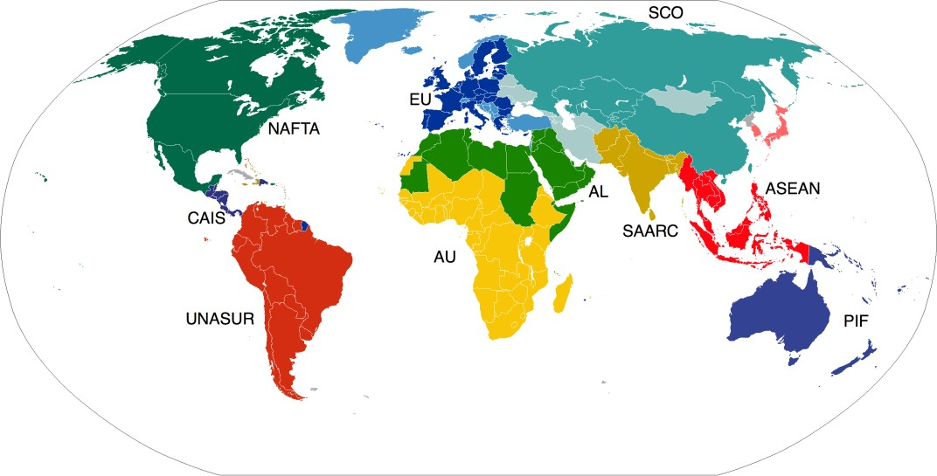
https://upload.wikimedia.org/wikipedia/commons/4/43/ActiveBlocs.PNG

Annotated Resources that relate specifically to the element
Trading Blocs and Regional Trade Agreements (RTAs) | tutor2u Economics. (n.d.). Retrieved April 29, 2017, from https://www.tutor2u.net/economics/reference/trading -blocs -and-regional -trade - agreements -rtas
World Trade. (n.d.). Retrieved April 29, 2017, from http://www.econedlink.org/tool/381/World -Trade - after-World-War-II-E U -NAFTA -WTO -Lesson -Demo

SSEIN2 Explain why countries sometimes erect trade barriers and sometimes advocate free trade.
d. Evaluate arguments for and against free trade.
The main arguments against free trade include:
  - Protecting infant industries – markets in need of time to develop before competing against foreign rivals
  - Protecting national security
  - Protecting domestic employment
  - Protecting workers in developing countries from unfair labor practices
  - Protecting the environment in developing countries
The infant industries argument supports the use of trade barriers when a new industry is in the early stages of development. Unless the industry can grow and establish economies of scale (high output with low cost per unit), it will be unlikely to survive in competition with established industries in other countries. Opponents of this argument cite the difficulty in accurately predicting which industries are
likely to “grow up” and be competitive as well as the potential for retaliation by other countries.
The national security argument cites the importance of maintaining industries critical to the country’s national security even when the industry cannot efficiently compete at the international level. National security is also the argument behind an embargo. Opponents to this argument cite the potential for abuse because at some level many industries can argue their importance to national security.
The domestic employment argument seeks to protect workers of a country from becoming unemployed due to competition from products made by workers in developing countries who usually work for much lower wages and benefits. Opponents of this argument emphasize the increased consumer prices caused by the protectionism. Free trade and efficient production usually lead to new industries and jobs within those new industries. Finally, if workers in developing countries produce goods for which they have a comparative advantage, these workers will become richer and will become consumers of international goods as well as producers.
The protecting workers in developing countries from unfair labor practices argument is the basis for limiting the purchase of those goods by people in the developed country. By developed world standards, working conditions in developing nations are often very bad relatively speaking. However, opponents of this argument emphasize that workers in developing countries would lack jobs entirely if their countries were unable to produce and sell goods abroad. In the long-run, as industries in developing countries
become more established and worker’s wealth increases, the workers will demand better working
conditions.
The protection of the environment argument supports restrictions on trade with countries that have lax environmental standards. Opponents argue that developing nations must have the ability to produce goods without the same environmental standards as developed nations because they would be uncompetitive otherwise. Economic research shows that as a country becomes richer, the people of the country demand higher environmental standards. If countries increase growth, some economists believe an cleaner environment will follow.

Annotated Resources that relate specifically to the element
Trade: Why Do Nations Trade? (n.d.). Retrieved April 28, 2017, from https://frbatlanta.org/education/classroom -economist/infographics/trade.aspx?d=1&s=fre
SSEIN3 Explain how changes in exchange rates can have an impact on the purchasing power of groups in the United States and in other countries.

An Exchange Rate refers to the price of one country’s currency express in terms of another country’s currency. Anyone buying products from another country, selling products to people in other countries, traveling to other countries, or depending on travelers from other countries cares about changes in the exchange rate. For people to do business with people in other countries, they must acquire the currency accepted by people in those countries. As the price of a currency rises and falls relative to another currency, people who buy, sell, and earn in that currency will experience a change in how much of the other country’s currency they can buy.
Resources: (if appropriate)
(Open the Globalization PDF from this link) Federal Reserve Bank of Dallas. (n.d.). Retrieved April 29, 2017, from https://www.dallasfed.org/en/educate/everyday.aspx
Solman, P. (n.d.). Dollar's Weakness Inspires Modern-day Gold Rush. Retrieved April 29, 2017, from http://www.econedlink.org/tool/56/Making-Sen$e-with-Paul-Solman-Dollar-s-Weakness-Inspires- Modern-day-Gold-Rush

SSEIN3 Explain how changes in exchange rates can have an impact on the purchasing power of
groups in the United States and in other countries.
a. Define exchange rate as the price of one nation’s currency in terms of another nation’s
currency.
An Exchange Rate refers to the price of one country’s currency express in terms of another country’s
currency. For example, on April 27, 2017, the price of one dollar expressed in euros was .92 euros.

Annotated Resources that relate specifically to the element
C urrency C rusaders Online C ourse for Teachers and S tudents. (n.d.). Retrieved April 29, 2017, from https://www.stlouisfed.org/education/currency -crusaders -online -course -for-teachers -and-students C urrency exchange introduction. (n.d.). Retrieved April 29, 2017, from https://www.khanacademy.org/economics -finance -domain/core -finance/money -and- banking/ currency -tutorial/v/currency -exchange -introduction

SSEIN3 Explain how changes in exchange rates can have an impact on the purchasing power of
groups in the United States and in other countries.
b. Interpret changes in exchange rates, in regards to appreciation and depreciation of currency.
Most exchange rates between currencies fluctuate based on supply and demand. The terms appreciation and depreciation describe changes in the value of one currency in terms of another. Appreciation refers to an increase in the value of a currency relative to another. Depreciation refers to a decrease in value of one currency relative to the other. In the table below shows the price of the U.S. dollar expressed in terms of other currencies for Year 1 and Year 2. In Year 1, a dollar cost .49 pounds. In Year 2, a dollar cost .52 pounds. Since the dollar was more expensive for people holding British pounds in Year 2 than in Year 1, the dollar appreciated against the pound. In Year 1, a dollar cost 5.17 Danish krone. In Year 2, a dollar cost 4.83 krone. Since the dollar cost less for people holding Danish krone in Year 2 than in Year 1, the dollar depreciated against the krone.
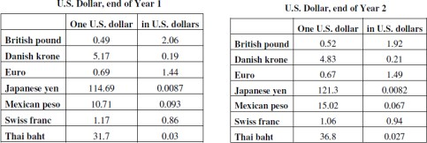

Annotated Resources that relate specifically to the element
C urrency C rusaders Online C ourse for Teachers and S tudents. (n.d.). Retrieved April 29, 2017, from https://www.stlouisfed.org/education/currency -crusaders -online -course -for-teac hers -and-students Currency exchange introduction. (n.d.). Retrieved April 29, 2017, from https://www.khanacademy.org/economics-finance-domain/core-finance/money-and-banking/currency- tutorial/v/currency-exchange-introduction

SSEIN3 Explain how changes in exchange rates can have an impact on the purchasing power of
groups in the United States and in other countries.
c. Explain why some groups benefit and others lose when exchange rates change.
When a country’s currency appreciates against another currency, it means those who hold the
appreciated currency can buy more of the other country’s currency. If a country’s depreciates, those who hold the depreciated currency can buy less of the other country’s currency. For example, assume
the United States and Japan are trading partners. Due to the popularity of Japanese Anime in the United States, people in the U.S. demand for yen because they need Japanese currency to buy Japanese goods. As the demand for yen rises, the yen appreciates in the foreign exchange market. The higher price of yen will make Japanese goods more expensive for U.S. consumers and Japanese exports to the United States will decrease. However, the higher value of the yen will allow people in Japan to import more goods, more cheaply from the United States. Therefore, while the appreciation of the yen hurts Japanese exporters, U.S. exporters to Japan benefit from the increased Japanese consumption of U.S.

goods. U.S. tourists visiting Japan are harmed by the increased price of the yen, but Japanese tourists coming to the U.S. are helped because they can buy more.

Annotated Resources that relate specifically to the element
C urrency C rusaders Online C ourse for Teachers and S tudents. (n.d.). Retrieved April 29, 2017, from https://www.stlouisfed.org/education/currency -crusaders -online -course -for-teachers -and-students Currency exchange introduction. (n.d.). Retrieved April 29, 2017, from https://www.khanacademy.org/economics-finance-domain/core-finance/money-and-banking/currency- tutorial/v/currency-exchange-introduction

TEACHER NOTES
Economics – Personal Finance Domain
SSEPF1 Apply rational decision making to personal spending and saving choices.
A rational decision making model refers to a process individuals, firms, and governments use to evaluate the costs and benefits associated various options when making a choice. The model consists of the possible options evaluated against a set of desirable criteria identified by the decision maker who chooses the option most closely aligned to the criteria. Two life choices demanding a rational decision making model include major spending decisions and major saving decisions.
Resources: (if appropriate)
Decision Matrix. (n.d.). Retrieved April 29, 2017, from http://asq.org/learn-about-quality/decision- making-tools/overview/decision-matrix.html
SSEPF1 Apply rational decision making to personal spending and saving choices.
a. Use a rational decision making model to evaluate the costs and benefits of post-high school life choices (i.e., college, technical school, military enlistment, workforce participation, or other option).
All high school students choose a post-high school path. Using a rational decision making model makes the costs and benefits of this choice easier to evaluate. The example provided below used a free downloadable excel file from the website Launch Excel. In the example, the hypothetical student chose his or her own criteria and assigned a score based on his or her own research. The student also chose the weights for the criteria according to his or her own values and priorities. While this example identified a formal union apprenticeship program as the best choice for life after high school, the results will vary greatly from student to student. For instance, the student creating the example believed they could stay near family for college and technical school. If this were a student in a rural area, the score on “closeness to family” could be much lower. Similarly, a genius might score “easiness of path” for college a 4 or 5.

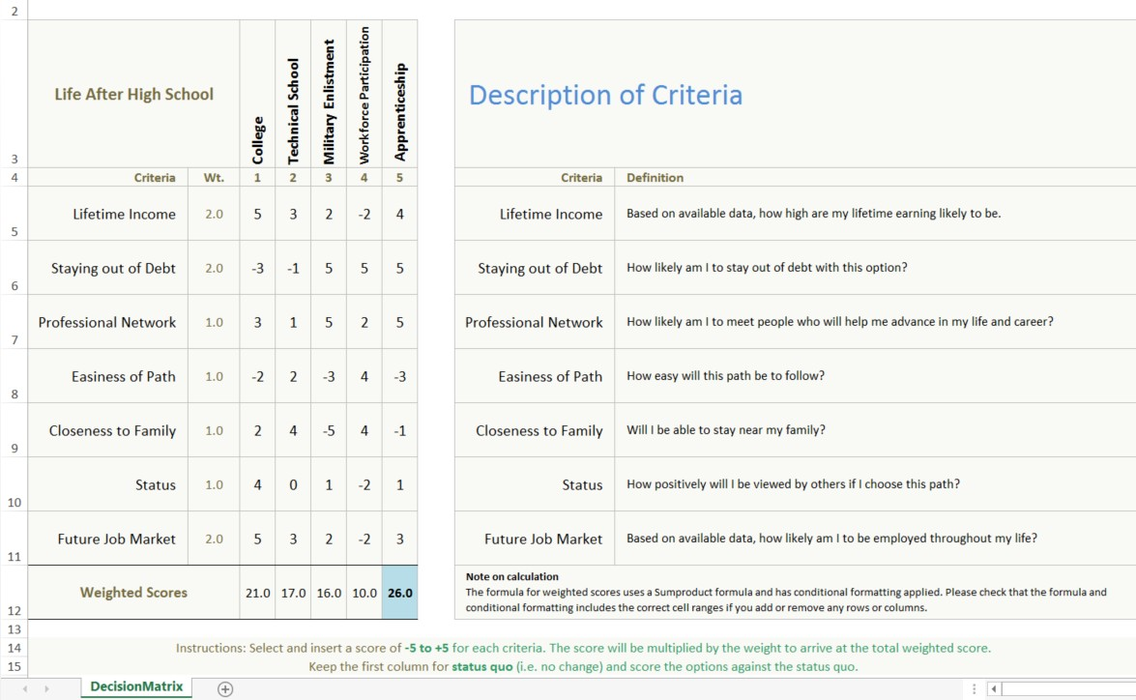

Annotated Resources that relate specifically to the element
Decision Matrix. (n.d.). Retrieved April 29, 2017, from http://asq.org/learn-about-quality/decision- making-tools/overview/decision-matrix.html
Decision Matrix Download Page. (2013, October 07). Retrieved April 28, 2017, from http://www.launchexcel.com/resources/decision-matrix/decision-matrix-download-page/

SSEPF1 Apply rational decision making to personal spending and saving choices.
b. Create a budget that includes a savings or financial investment plan for a future goal.
A budget is a document listing all the income a person makes each monthly and the expenses a person must pay each month. A budget allows people to make a plan for the money they earn, keep track of their spending, and plan for future expenses. The example below used a free, online excel budget template from Smartsheet. The original template contained additional categories and was modified to reflect the expenses of a hypothetical college student. As you can see the student has budgeted 10 percent of income for general savings to use in case of unexpected expenses and has a specific savings goal category, his or her spring break trip.

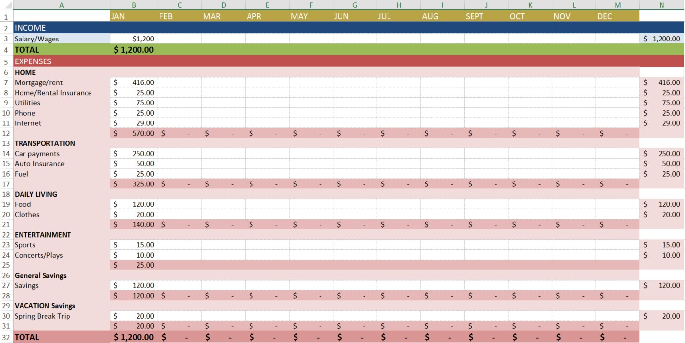

Annotated Resources that relate specifically to the element
Budgeting 101 Online C ourse for C onsumers. (n.d.). Retrieved A pril 28, 2017, from https://www.stlouisfed.org/education/budgeting -101 -online -course -for-consumers Infographic: Budgeting - Katrina's Classroom. (n.d.). Retrieved April 28, 2017, from https://www.frbatlanta.org/education/katrinas-classroom/lesson4/budgeting.aspx Top Excel Budget Templates. (2016, October 31). Retrieved April 28, 2017, from https://www.smartsheet.com/top-excel-budget-templates
SSEPF2 Explain that banks and other financial institutions are businesses that channel funds from savers to investors.

Banks and other financial institutions are businesses. Like other businesses, banks must be profitable to operate. While banks collect revenue from a variety of activities, their traditional source of revenue comes from their role as a financial intermediary. This means taking the deposits from one group of customers and loaning a portion of deposits to other customers. Banks make revenue by charging borrowers a higher rate of interest than they are paying to depositors. This is called the “spread”.
Resources: (if appropriate)
Infographic: Where Do You Bank? - Katrina's C lassroom. (n.d.). Retrieved April 28, 2017, from https://frbatlanta.org/education/katrinas -classroom/lesson2/infographic.aspx?d=1&s=fre

SSEPF2 Explain that banks and other financial institutions are businesses that channel
funds from savers to investors.
a. Compare services offered by different financial institutions, including banks, credit unions, payday lenders, and title pawn lenders.
There are many types of financial institutions and they offer a variety of services. Potential customers must compare services to determine which option fits their needs. The financial institutions detailed in this course include banks, credit unions, payday lenders, and title pawn lenders.
Bank—For most consumers, banks provide a safe means to store earnings. Typically, banks also offer direct deposit (where a person’s paycheck goes directly into his or her account), check-writing services, debit and credit cards, loans of all sorts (personal, home equity, business), and a host of other services.
Credit Union—Credit unions provide services similar to a bank; the main difference is that a credit union only provides these services to its members. Members own and control the institution. Credit unions often offer higher interest rates on deposits and lower interest rates on loans than banks.
Payday Loan Company—Suppose you need $50 on Wednesday but won’t get paid by your job until Friday. To solve this temporary problem, a payday loan company will give out small loans in return for a portion of the upcoming paycheck. This means the person will get $50 on Wednesday, but come Friday,
$55 of his or her paycheck will go to the payday loan company. Payday loan companies generally charge much higher interest on loans than other institutions.
Title Pawn Lender – Title pawn lenders provide short-term loans to individuals facing a gap between their income and expenses. Usually, those accessing loans through title pawn lenders lack access to other types of short-term loans like credit cards. Title pawn lenders make loans based on an individual’s collateral. Collateral is an item of value one owns like a car. Lenders can sell the collateral to cover the value of an outstanding loan if the borrower cannot repay. Like payday loans, the fees associated with title pawn loans are usually much higher than those a bank would charge. In the case of title pawn loans, the inability to repay the loan could result in the loss of the vehicle put up as collateral.

Annotated Resources that relate specifically to the element
(2014, J une 03). Types Of Financial Institutions And Their Roles. Retrieved April 29, 2017, from http://www.investopedia.com/walkthrough/corporate -finance/1/financial -institutions.aspx Infographic: Where Do You Bank? - Katrina's C lassroom. (n.d.). Retrieved April 29, 2017, from https://frbatlanta.org/education/katrinas -classroom/lesson2/infographic.aspx?d=1&s=fre

SSEPF2 Explain that banks and other financial institutions are businesses that channel
funds from savers to investors.
b. Explain reasons for the spread between interest charged and interest earned.
Commercial banks, and other financial institutions offering loans, are businesses. They must make a profit if they expect to continue operating. One primary way banks make profits is by taking the money deposited by bank customers and loaning out a portion to people who want to borrow. By charging interest on the loans, banks make money. The more money on deposit, the more loans they can make, which is why some banks offer very generous checking account services. The interest on the loans is always more than the interest paid out to depositors. If banks did not have this “spread” between interest earned and interest charged, they would go out of business very quickly. NOTE: As provisions of

the Glass-Steagall Act have eroded, commercial banks have increasingly added very lucrative investment banking services to the traditional role of taking deposits and making loans. Banks also earn interest on required and excess reserves they deposit with the Federal Reserve.

Annotated Resources that relate specifically to the element
Interest Rates for Beginners. (2008, December 30). Retrieved April 29, 2017, from https://baselinescenario.com/2008/12/27/interest -rates -for-beginners/
Infographic: Where Do You Bank? - Katrina's C lassroom. (n.d.). Retrieved April 29, 2017, from https://frbatlanta.org/education/katrinas -classroom/lesson2/in fographic.aspx?d=1&s=fre

SSEPF2 Explain that banks and other financial institutions are businesses that channel
funds from savers to investors.
c. Give examples of the direct relationship between risk and return.
The relationship between risk and return is that the higher the potential return offered by a savings or investment opportunity, the more risky the savings or investment usually is. Therefore, if someone offers a 20% return and no risk, the person is most likely not being very honest. The options below give an idea of the relationship between risk and return:

Annotated Resources that relate specifically to the element
Interest Rates for Beginners. (2008, December 30). Retrieved April 29, 2017, from https://baselinescenario.com/2008/12/27/interest -rates -for-beginners/

SSEPF2 Explain that banks and other financial institutions are businesses that channel
funds from savers to investors.
d. Evaluate the risk and return of a variety of savings and investment options, including: savings accounts, certificates of deposit, retirement accounts, stocks, bonds, and mutual funds.
Savings Accounts - Savings accounts are bank accounts in which people put savings to which they need easy access. The Federal Deposit Insurance Corporation (FDIC) most types of bank deposits up to
$250,000. There is virtually no risk that the depositor will lose his or her money. The only risk comes from inflation risk. This means that the interest earned on the savings is less than the rate of inflation. Therefore, money held in a very low interest savings account is likely to erode in value over time. Since savings accounts are very low risk, the rate of return is very low as well. Most bank pay less than 1% interest on savings.
Certificates of Deposit – Certificates of Deposit (CDs) are products offered by banks. Buying a CD means you will earn a higher rate of return than on a regular savings account. The higher rate of return results from the saver agreeing to keep the funds in the CD for a specified period, usually between 1 months to 10 years. The longer the period, the higher the interest rate. People who save in CDs and need to withdraw their funds early will pay a fee for early withdrawal.
Retirement Accounts – Saving for retirement is a key goal for many people in the United States. Very few employers offer traditional defined benefit pensions and most retirees will need to live off their savings to maintain their standard of living. There are a number of retirement account options for

workers. The most common account is a 401K. This is provided through an employer which will sometimes offer a percentage of matching funds. Individuals can also establish their own Individual Retirement Accounts through an investment bank. They usually have a choice between a Roth IRA and a traditional IRA. Roth IRAs allow contributors to pay taxes today and withdraw the funds they contributed tax-free in the future. The contributor will still have to pay taxes on any “gaines” they withdraw from their account in retirement. A traditional IRA allows contributors to put money away before taxes are paid. The taxes are paid on the money when it is withdrawn during retirement. All of these retirement account options offer portfolios with mixed investment options. People can chose high risk, high return stock funds or low risk, low return bond funds. Finally, the U.S. government has a program called MyRA for workers whose employers do not have a 401K. It allows workers to contribute up to $15,000 before having to roll it over into an account with an investment bank. The funds can be withdrawn as needed without penalty and are guaranteed by the U.S. government, causing the return to be small.
U.S. Treasury Bonds – Purchasing a U.S. Treasury Bond means you have loaned the U.S. government money. The government pays you a guaranteed rate of return. Since the U.S. government repays its debts, the rate of return is low. For example, the interest rate on a 5-year treasury bond on April 27, 2017 was 1.822%. The interest rate on 10-year treasury bonds was 2.3%. Bonds are safe but also carry an inflation risk if interest paid is not higher than the inflation rate.
Stock Mutual Funds – While individual company stock is relatively risky, many people choose to play the stock market by purchasing mutual funds. Mutual funds provide more protection against loss because the investment is spread across many different companies rather than just one company. You may also select funds that reflect specific levels of risk or your values. Long term investing tends to give a greater return in the stock market than short-term investing. Over a 20-year period, the stock market returns on average 7-8%. However, when holding stocks for only 5 to 10 years, the average rate of return drops to 1- 2%.
Stock – Purchasing stock of individual companies is one of the more risky ways to invest. When purchasing stock in large stable companies (blue chip stocks), your investment could be safer, but your rate of return is likely to be lower. If you invest in companies with a shorter history or a brand new product, the potential return is generally high if the company succeeds, but you are much more likely to lose your investment because of the high rate of new business failures.

Annotated Resources that relate specifically to the element
Financial Markets Video and Quiz. (n.d.). Retrieved April 29, 2017, from http://www.econedlink.org/tool/229/Financial -Markets -Video -Quiz
Interest Rates for Beginners. (2008, December 30). Retrieved April 29, 2017, from https://baselinescenario.com/2008/12/27/interest -rates -for-beginners/

SSEPF3 Explain how changes in taxation can have an impact on an individual’s spending and saving choices.
Government assesses taxes on individuals and firms in an economy to pay for public goods and services. Some common taxes paid by individuals include income, property, and sales tax. When the government increases taxes, individuals will have less of their income to save and spend. When government decreases taxes, individuals will have more income to save and spend.
Resources: (if appropriate)
Taxes: Who pays and how much? (n.d.). Retrieved April 29, 2017, from https://www.stlouisfed.org/publications/inside-the-vault/spring-2006/lesson-plan

SSEPF3 Explain how changes in taxation can have an impact on an individual’s spending and saving
choices.
a. Define progressive, regressive, and proportional taxes.
Taxes can fall into three categories: progressive, regressive, and proportional. The category into which a tax falls determines how it will affect people who make higher or lower incomes.
A Progressive tax rate increases as income increases, meaning the wealthy pay a higher percentage of their earnings than people less financially well-off. The U.S. federal income tax is a progressive tax. For example, a progressive tax might have a tax rate of 1% for every $10,000 earned annually, with a maximum tax rate of 50%. This system would lead to the following example.

Progressive Income Tax Example
Income | Tax Rate | Calculation | Total Tax
$10,000 | 1% | $10,000 X .01 | $100
$30,000 | 3% | $30,000 X .03 | $900
$200,000 | 20% | $200,000 X .20 | $40,000
$500,000 | 50% | $500,000 X .50 | $250,000
In the example, people earning $30,000, or three times as much as those earning $10,000, would have to pay nine times the amount in taxes ($900 compared to $100). Those earning $200,000, more than six times as much as those earning $30,000, would have to pay more than forty-four times as much in taxes. While this may seem excessive, the rationale is that a progressive tax takes more money from those who can afford to pay it. Opponents of progressive taxes argue that higher tax rates for high income earners is a disincentive to engage in productive activity.
A Regressive tax is a tax rate that decreases as income increases. Consider a tax that imposes a flat rate of $1,000 annually regardless of income. For someone earning only $3,000 a year, this tax would be huge, accounting for one-third of all earnings. To someone earning $50,000 a year, the tax rate is not as large, accounting for only 2% of annual income. Most sales taxes are regressive because lower income people tend to spend a greater proportion of their income on sales taxed items than higher income people.

A Proportional tax, also known as a flat tax, does not change with respect to changes in income. If the proportional tax rate is 15%, then everyone pays 15%, regardless of whether he or she makes $10,000 or
$570,000. The FICA tax workers pay to fund Social Security and Medicare is proportional. Everyone pays the same percentage of their income to this tax up to a specified income cap.

Annotated Resources that relate specifically to the element
Horton, M. (2016, October 19). What are the differences between regressi ve, proportional and progressive taxes? Retrieved April 29, 2017, from
http://www.investopedia.com/ask/answers/042 415/what -are -differences -between -regressive - proportional -and-progressive -taxes.asp
Income Tax: Facts and Filings (Page One Economics, Focus on Finance). (n.d.). Retrieved April 29, 2017, from https://www.stlouisfed.org/education/page-one-economics-classroom-edition/income-tax-facts- filings

SSEPF3 Explain how changes in taxation can have an impact on an individual’s spending and saving
choices.
b. Explain how an increase in sales tax affects different income groups.
Sales tax refers to a consumption tax levied on people when they make certain kinds of purchases, such as buying a book or eating out at a restaurant. Not all goods and services are subject to a sales tax; doctor visits, for example, are free of taxes. Like the different types of income taxes, a change to the sales tax affects different income groups in different ways. Since all consumers purchase essential goods like food, a high sales tax on food would affect poor people more than wealthy people because both groups will be paying the same tax rate for the same good. For this reason, economists usually classify sales tax as a regressive tax because it takes a greater percentage of income from a low-income person than from a high-income person. This is one reason why food is often not subject to a sales tax.
However, food served at a restaurant typically is subject to a sales tax, since eating out is a luxury.

Annotated Resources that relate specifically to the element
Sales & Use Tax. (n.d.). Retrieved April 29, 2017, from https://dor.georgia.gov/sales-use-tax
SSEPF3 Explain how changes in taxation can have an impact on an individual’s spending and saving
choices.
c. Explain the impact of property taxes on individuals and communities.
Property tax refers to a tax on real estate people own. The tax, levied by local governments like counties or cities, is on the value of the real estate. Periodic appraisals of a property’s value indicate whether the tax on the property will rise or fall. Increases in property value are cause for celebration by those ready to sell their property. However, for those who wish to remain in their homes, increased property values translate to increases in property taxes. If property taxes increase drastically, lower income people may no longer be able to afford the taxes on their homes. Delinquent taxes accrue interest and fees increasing the total bill owed. Various entities can use the delinquent tax bill to start the foreclosure process even properties fully owned with no mortgage. For this reason, owners of previously low value properties can lose their homes as property values rise and they are unable to afford the tax bill. This is

gentrification. Gentrification occurs when high-income property owners replace low-income property owners in an area. Since taxes assessed on the property’s value are without regard for the income of the owner, these taxes are regressive.

Annotated Resources that relate specifically to the element
Property Tax - Real and Personal Property. (n.d.). Retrieved April 29, 2017, from https://dor.georgia.gov/property -tax -real-and-personal -property
SSEPF4 Evaluate the costs and benefits of using credit.

Credit refers to borrowing money. People borrow money for a variety of reasons. When considering a loan, borrowers identify the benefits and the cost of using credit. If the benefits of using credit outweigh the costs, taking a loan is rational. If the costs of borrowing outweigh the benefits, the loan should be avoided.
Resources: (if appropriate)
C osts of C redit. (n.d.). Retrieved April 29, 2017, from http://www.econedlink.org/teacher - lesson/175/Costs -C redit
SSEPF4 Evaluate the costs and benefits of using credit.
a. Describe factors that affect credit worthiness and the ability to receive favorable interest rates including character (credit score), collateral, and capacity to pay.
As a rule, we should spend only what we earn and avoid borrowing. However, some purchases are very difficult to make without the use of credit and the benefits of making those purchases using credit may outweigh the costs in the long-run.
For example, if someone cannot go to college without a student loan, the higher future income potential and lower risk of unemployment may make the student loan a wise idea. If someone lacks a reliable car to get them to a great job, the benefits of a low-interest car loan may outweigh the costs because of the higher income earned at the new job.
The key is to be wise in borrowing. Do not borrow more than you need and make sure the payments are affordable given your income. If you want to secure a loan from a financial institution like a bank, your credit rating must be good. Credit worthiness is a measure of a variety of factors used to determine whether a person will repay a loan. While there is no guarantee a person making $400,000 annually will pay a $2,000 loan, evaluation of their credit worthiness indicates they have the income required to handle the loan. Annual earned income is a major factor in determining credit worthiness. If income is high, lenders believe the borrower can use some of that income for debt repayment. However, the amount of current debt is another big factor affecting credit worthiness. Making $400,000 a year is less attractive to lenders if you already owe $500,000.
The “Three C’s of Credit” are character, capacity, and collateral. Since most lenders do not know
potential borrowers personally, they evaluate a potential borrower’s character using the information on the borrower’s credit report. A credit report is available through three main private companies: Transunion, Equifax, and Experian. It details a person’s borrowing and repayment history for the last

seven years reported to the company’s by a person’s previous and current lenders. Potential lenders request credit reports on potential borrowers to assess the borrower’s character and capacity.
A potential borrower who has “paid as agreed” on all credit accounts has good credit character. The credit report also shows some aspects of capacity. While income is one factor in assessing capacity, the amount it takes to service current debt is also a concern. If debt to income ratio is high, the borrower may not be able to handle additional debt payments.
Finally, collateral is something of value a borrower can use to back the loan if the borrower can no longer pay the scheduled payments. For example, a home mortgage is available to people with lower incomes because the bank can seize the home if the mortgage is not paid.
Many people obtain a credit card to start building a positive credit history. To get low interest rates for borrowing and sometimes even to get a job, people need a good credit report and good credit score. In some cases, no credit history affects people negatively just as a poor credit history does. A credit score is a number calculated by the credit reporting companies based on a variety of factors. While the exact calculation is proprietary, the companies release general guidelines about how the score is calculated.
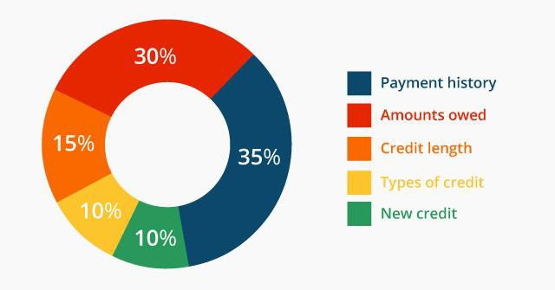
Payment history, amount of open credit used, and the number of open credit accounts are some of the factors determining a credit score. By making small purchases and paying the entire amount each month, a potential borrower shows a lender how they use credit wisely. The image below shows a general breakdown of a credit score.
https://www.flickr.com/photos/cafecredit/29132289382

Using credit wisely and sparingly is essential to a healthy financial life. Some people find they are unable to make wise credit use decisions. Using credit cards impulsively, some find they are unable to pay the entire amount owed month and begin to accrue high amounts of interest on the unpaid balance. As the balance owed increases, it takes years to pay the loan for a small purchase. If borrowers have late payments, interest rates skyrocket and lenders charge late fees. Current law requires credit card companies to show borrowers the difference in total payments they will make if they pay only the minimum payment due versus paying the debt within three years. The image below shows an example as it looks on a credit card statement. This borrower will save $204 by paying the bill in three years and far more if paying the balance in full.

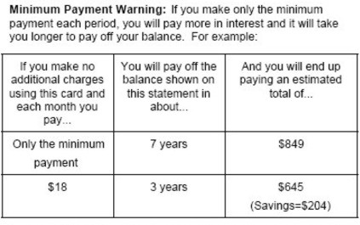

http://www.keywordsuggests.com/S917OVYzI*c*si91FqCXCl9h9WlqZKCv7JXZ*kZ2QCo/

Annotated Resources that relate specifically to the element
5E Navigator: C redit Reports. (n.d.). Retrieved April 29, 2017, from https://www.richmondfed.org/publ ications/education/5e_navigator/credit_reports
Infographic: Why Is Good Credit Important? - Katrina's Classroom. (n.d.). Retrieved April 29, 2017, from https://frbatlanta.org/education/katrinas-classroom/lesson3/infographic.aspx?d=1&s=fre

SSEPF4 Evaluate the costs and benefits of using credit.
b. Compare interest rates on loans and credit cards from different institutions.
Wise potential borrowers shop for the best interest rates on loans. While the exact rate offered to a
borrower will vary with the borrower’s character, capacity, and collateral, the internet allows borrowers to compare the best rates offered by different financial institutions. The table below looks at a snapshot of rates for a variety of loan products available from different lenders in April 2017.
Lender | 30-year Fixed Rate Mortgage | 5-year Fixed Rate Auto Loan | Home Equity Lump Sum Fixed Rate Loan | Credit Card (no annual fee)
Institution A | 4.0%  4.081% APR | 3.24% | 4.79% | 13.74% – 23.74%  variable annual percentage rate
Institution B | 4.125%  4.2182% APR | 2.49% | 4.49% | 11.99% - 21.99%  variable annual  percentage rate
Institution C | 4.125%,  4.186% APR | 3.12% | 4.75% | 17.90% - 26.74%  variable annual percentage rate
Assuming the borrower qualified for the best rates available, a wise decision would be Lender A for the mortgage and Lender B for the three remaining products.

Annotated Resources that relate specifically to the element
Infographic: Why Is Good Credit Important? - Katrina's Classroom. (n.d.). Retrieved April 29, 2017, from https://frbatlanta.org/education/katrinas-classroom/lesson3/infographic.aspx?d=1&s=fre

SSEPF4 Evaluate the costs and benefits of using credit.
c. Define annual percentage rate and explain the difference between simple and compound interest rates, as well as fixed and variable interest rates.
The annual percentage rate (APR) is the annual rate charged for borrowing funds. Expressed as a percentage, APR represents the actual yearly cost of the borrowed funds over the full term of the loan. In the table for SSEPF4b, although the stated interest rates for Lender B and C were the same for mortgages, Lender C had a higher APR making it a more expensive loan.
Interest rates on loans are fixed or variable. A fixed interest rate on a loan will not rise or fall during the term of the loan. Obtaining a fixed interest rate when rates are low is usually desirable. When rates are high, borrowers may choose a variable interest rate in the hope that rates will fall in the future.
Sometimes, lenders will only offer fixed rates to their best customers. Lenders sometimes offer risky borrowers variable rates. If the borrower proves the ability to make the payments, the person can refinance for a fixed rate in the future.
Interest is also simple or compound. Simple interest applies only to the original amount borrowed called the principal. Compound interest applies to both the principal of the loan as well as accrued interest on the principal. Compound interest makes a loan more expensive and is less desirable for borrowers than simple interest loans.

Annotated Resources that relate specifically to the element
Compound Interest. (n.d.). Retrieved April 29, 2017, from http://www.econedlink.org/tool/227/Compound-Interest-Video-Video-Quiz

SSEPF5 Describe how insurance and other risk-management strategies protect against financial loss.
Insurance is a product purchased to guard oneself against life’s risks, specifically the financial losses associated with these risks. One may not be able to avoid dying, but one can avoid leaving loved ones in financial ruin by purchasing life insurance. The law requires people to buy certain type of insurance while other types are voluntary. The scope of this standard is to identify type of insurance and the costs and benefits associated with each type.
Resources: (if appropriate)
Insurance: Managing Risk and Balan cing Responsibility with Affordability (Page One Economics,
Focus on Finance). (n.d.). Retrieved April 28, 2017, from https://www.stlouisfed.o rg/education/page - one-economics -classroom -edition/insurance -managing -risk

SSEPF5 Describe how insurance and other risk-management strategies protect against financial
loss.
a. List and describe various types of insurance such as automobile, health, life, disability, and property.
This course requires identification and description of five types of insurance: automobile, health, life, disability, and property. Most states in the U.S. require automobile owners to maintain a certain level of automobile insurance coverage. The required coverage is liability insurance. Liability insurance covers the other vehicle(s) when you are at fault in a car accident. If an owner wants coverage for their own vehicle, then they need to purchase collision insurance as well. Vehicles purchased with a loan from a financial institution require collision insurance until paid in full. It is important for vehicle owners to know the level of insurance required by law may not adequately cover all damages in an accident. The other driver can sue the at fault driver for any additional damages.
Health insurance pays for medical services. As of April 2017, federal law required people to have a certain level of health insurance or pay an annual penalty when filing federal taxes. Health insurance plans vary widely from those protecting against catastrophic care to plans paying for routine wellness visits.
Life insurance provides a monetary payment to a designated beneficiary when the insured person dies. The beneficiary is one who experiences financial harm from the death of the person covered by the policy such as a spouse, a parent, or a child.
Disability insurance provides people with income in case they become injured or are unable to work at a job. Many employers offer disability insurance as an option in worker benefits packages. Short-term disability covers temporary work restrictions such as the period of recovery from childbirth or surgery.
Property insurance takes a variety of forms. The most common types are homeowners and renters insurance. Homeowners insurance pays for damages sustained to your real estate property and for injuries to others that happen on your property. Renters insurance protects your personal property assets when you live in a rental property instead of a home you own.

Annotated Resources that relate specifically to the element
Insurance: Managing Risk and Balancing Responsibility with Affordability (Page One Economics,
Focus on Finance). (n.d.). Retrieved April 29, 2017, from https://www.stlouisfed.org/education/page - one-economics -classroom -edition/insurance -managing -risk

SSEPF5 Describe how insurance and other risk-management strategies protect against financial
loss.
b. Explain the costs and benefits associated with different types of insurance, including deductibles, premiums, shared liability, and asset protection.
In general, all insurance policies allow a person or business to pay a relatively small amount of money (a premium) in the present to purchase asset protection against the possibility of a future financial loss caused by an unforeseen event. Assets protected range from one’s home to one’s health. Most insurance policies include a deductible stipulating the amount of money the insured must pay when filing a claim with the insurance company. In most cases, the higher the premium is, the lower the deductible is. This is true in reverse as well. Purchasing insurance involves shared liability between the insurer and the insured. This means that the insurance company assumes a pre-determined amount of financial liability for a claim that the insured might file. The insurance company is obligated to pay for the loss since the insured has paid premiums for the financial protection. In some cases, people pay insurance premiums for years and never file a claim. However, most people know they would be unable to cover a catastrophic loss themselves and are willing to pay for the peace of mind insurance provides.

Annotated Resources that relate specifically to the element
Insurance: Managing Risk and Balancing Responsibility with Affordability (Page One Economics, Focus on Finance). (n.d.). Retrieved April 29, 2017, from https://www.stlouisfed.org/education/page-one- economics-classroom-edition/insurance-managing-risk
SSEPF6 Describe how the earnings of workers are determined in the marketplace.

In the United States, supply and demand determine the earnings of workers. The exception is minimum wage laws at the federal, state, and local level. Minimum wage is a price floor. If equilibrium wage falls below the price floor, employers are bound to paying the legal wage. In most cases, minimum wage affects only markets for the least skilled workers. The labor market is a resource market. Employers demand workers and workers supply their labor. The intersection of the labor demand and supply curves indicated the equilibrium wage in the market. Like a product market, changes in the economy shift the supply of and demand for labor altering the equilibrium wage.
Resources: (if appropriate)
A. (2012, March 22). The Market for Labor. Retrieved April 28, 2017, from https://www.youtube.com/watch?v=HXNWOQfoez4&feature=player_embedded%3Fd&s=fre
SSEPF6 Describe how the earnings of workers are determined in the marketplace.
a. Identify skills that are required to be successful in the workplace, including positive work ethic, punctuality, time management, teamwork, communication skills, and good
character.
Successful workers practice key behaviors known as soft skills. Soft skills every worker needs include: work ethic, punctuality, time management, teamwork, communication skills, and good character.
Work ethic refers to how seriously one pursues the expectations associated employment. People with good work ethic practice all the soft skills listed above. When at work, people with good work ethic

spend their time pursuing the goals of the job and producing excellent results to the best of their ability. Examples of poor work ethic include spending work hours pursuing personal interests, finding ways to avoid work, letting coworkers perform one’s assigned job functions, doing the minimum amount of work required to get by, and/or not following the rules outlined by the employer.
Actor Woody Allen once said, “Ninety percent of success is just showing up.” Punctuality means arriving on time and ready to work at the established time. Many employers of young workers lament how many lose their jobs due to lack of punctuality.
Most workers divide their work time among many different tasks and responsibilities. Workers with good time management skills efficiently organize their work hours to accomplish all objectives with minimal stress.
Today’s workplace is increasingly flat. This means rather than many layers of managers, many people work on teams lead by peers or lead teams of peers. These teams are often cross-functional meaning they are composed of people with different skill sets. Teamwork is part of most jobs. Team members need to work well with each other, support each other, and perform their assigned tasks well.
Excellent verbal and written communication skills help workers perform their jobs well. This means knowing how to get your ideas across to someone else and using appropriate style, grammar, and/or spelling. These skills help everyone understand what is expected and keep people motivated. Poor verbal and written communications skills cause workers to be viewed negatively and can cause conflict. In dangerous or high-risk environments, poor communication skills could put lives at risk.
Good character refers to doing the right thing every time. Today’s workers often enjoy a lot of freedom
in how and where they work. Working remotely requires discipline to stay on task and meet goals. Employers need workers who behave ethically. Poor character traits include stealing from an employer, lying, plagiarizing the work of others, and treating coworkers or customers poorly.

Annotated Resources that relate specifically to the element
Soft Skills: Success May Depend on Them (Page One Economics, Focus on Finance). (n.d.). Retrieved April 28, 2017, from https://www.stlouisfed.org/education/page-one-economics-classroom- edition/soft-skills-success-may-depend-on-them

SSEPF6 Describe how the earnings of workers are determined in the marketplace.
b. Explore job and career options and explain the significance of investment in education, training, and skill development as it relates to future earnings.
Since societies are constantly changing, and their economies— and marketplace demands— change as well. At some point in the 20th century, people who excelled at selling typewriters could probably have demanded a high salary for their work. Today, this expertise is no longer in demand, so work would be hard to get and at a much lower wage than it once was.
In general, the three factors determine the wage a worker can expect. The strength of demand for workers in the market, the number of workers supplying their labor in the market, and the amount of specialized knowledge, skills, training, and licenses are required to do the job.

As a rule, the more knowledge, skills, education, and training a worker has, the higher the wage the worker can expect assuming their education applies to a field with strong employer demand. The chart below from the Bureau of Labor Statistics shows the correlation between level of education and median weekly wages. It also shows how likely people in each education level are to be unemployed.

The Bureau of Labor Statistics provides a tool called the Occupational Outlook Handbook. Students can research careers using this online guide. As you can see from the example below, the handbook describes the occupation, indicates educational requirements, estimates potential growth or decline in number of jobs available, and gives the 2016 median pay. This tool provides students with a good place to start their career research.

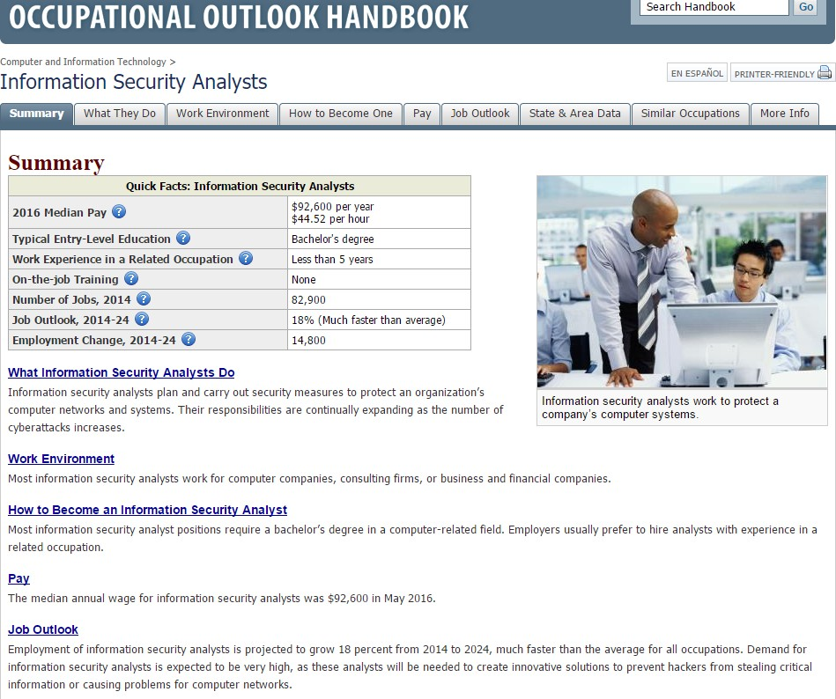

Annotated Resources that relate specifically to the element
College: Learning the Skills To Pay the Bills? (Page One Economics). (n.d.). Retrieved April 28, 2017, from https://www.stlouisfed.org/education/page-one-economics-classroom-edition/college-learning-the- skills-to-pay-the-bills
Lessons: Teaching Human Capital and the Importance of Postsecondary Education. (n.d.). Retrieved April 28, 2017, from https://www.frbatlanta.org/education/publications/extra-credit/2016/spring/lessons- and-activities/high-school/personal-finance/teaching-human-capital.aspx?d=1&s=fre

