EOCT Practice Questions

1. The study of how individuals, firms (businesses), and nations can best allocate their limited resources is called:
A economics B entrepreneurship

2. The act of giving up one thing of value to gain another thing of value is called a/an
A opportunity cost B tradeoff

3. Bill wants a shirt for $45 and a hat for $20. He only has $50. If he buys the shirt, then his opportunity cost will be
A the cost of the shirt B the enjoyment he would have gotten from the hat

4. In every economic system, choices must be made because resources
A are unlimited, but human desires and wants are limited.
B are limited, but human desires and wants are unlimited.

5. The fundamental economic problem in which society does not have enough resources to satisfy the people’s wants
A Externalities B Scarcity

6. Who described economic principles in The Wealth of Nations?
A Milton Friedman B Adam Smith

7. Which of the following is NOT one of the four major factors of production?
A Land B Capital C Demand D Labor

8. The payments for land, labor, capital, and entrepreneurial ability respectively are
A rent, profit, wages, and interest B Rent, wages, interest, and profit

9. Trees, minerals, and the real estate on which a company builds its main manufacturing center are all
A capital B land C Labor D entrepreneurship

10. Following a massive hurricane that hits Georgia’s northern coast, residents have no running water or electricity. As a result, citizens buy up all the flashlights and bottled water in the area faster than producers can resupply them. What problem do people on the Georgia coast now face, regarding flashlights and bottled water?
A excessive regulation B scarcity

11. Which of the following tends to make economics more efficient?
A specialization B government ownership of property

12. Diminishing marginal utility refers to
A the quantity of goods and services for sale in relationship to the price.
B when consumers get more and more of a good, they get less satisfaction, even if the price is low.

13. The extra cost incurred by producing one additional unit of a product is called
A total cost B marginal cost

14. Jamie must make an economic decision. He must choose whether or not to buy a new truck. After considering all the options, he concludes that the marginal costs of the truck are greater than the marginal benefits. In Jamie’s case, buying the truck would be
A a rational economic decision B an irrational economic decision

15. Kim works on an automobile assembly line. Kim’s job illustrates a production process that relies on
A autonomous work groups B division of labor

16. Martha owns her own company. She invests in all the capital goods needed to make her product and sells her goods with the motivation of making huge profits. So long as she does not produce anything illegal, Martha freely chooses what to produce and consumers freely choose whether or not to buy her product. It sounds like Martha’s company operates in a
A command economy B market economy

17. The greater the profit motive in an economic system, the greater the likelihood of
A innovation B equity

18. A command economy is an economic system in which
A the government owns much of the property B profit motive is the main motivation for producers

19. Which of the following is a strength of a market economy?
A opportunity for profit B lots of government regulation to ensure that no one has too little or too much

20. Under capitalism, the means of production are owned by
A Private Citizens and businesses B National and State governments

21. Which of the following has the greatest degree of government involvement in the economy?
A Capitalist system B Communist system

22. All of the following are major disadvantages to communism EXCEPT
A fear of unemployment B few individual freedoms
C little incentive to innovate and produce D inefficient centralized planning

23. The person who wrote the Communist Manifesto and Das Kapital
A John Lenin B Karl Marx

24. In a laissez-Faire system, government
A controls a large number of public goods B has a minimum role in the economy

25. Each of the following is a role of government in capitalism EXCEPT
A controller B provider C regulator D consumer

26. Common ways the government might try to regulate a mixed-market economy include
A deregulation B imposing tariffs or subsidies

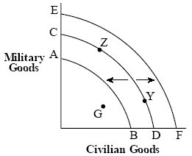
27. If CD represents the current production possibility curve, indicate which two letters you would choose if huge amounts of resources were discovered along with technological innovations in both sectors of the economy.
A Curve AB B Curve EF

28. The rate at which goods and services can be produced is called
A capital investment B productivity

29. If a factory owner uses some of her profits to purchase new machinery, she is investing in
A output returns B capital goods

30. Buying stocks, purchasing new equipment for a business, paying for employees training, and purchasing the latest computers for one’s office are all examples of
A economic outputs B investment

31. Which of the following is an example of investing in human capital?
A paying for an employee’s health insurance and training program
B requiring employees to document what they are doing at work

32. The three major actors in terms of economic activity are
A households, individuals, and the stock market B households, businesses, and the government

33. When factors of production perform tasks that they can do relatively more efficiently than others, it is known as
A capitalization B specialization

34. A market where productive resources are bought and sold is a
A Factor Market B Product Market

35. A good that lasts for more than 3 years is
A Long Lasting Good B Durable Good

36. Microeconomics focuses on
A the overall workings of the whole economy B the individual units that make up the economy

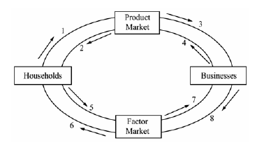

37. The flow of goods and services to consumers is best represented by?
A 8 to 6 B 4 to 2

38. The law of demand states that, other things being equal,
A the higher the price of a good, the lower the quantity demanded
B the higher the price of a good, the lower the quantity supplied

39. All of the following are reasons for changes in demand EXCEPT
A consumers tastes and preferences
B an increase in the supply curve
C the price of substitutes or compliments
D a change in the number of consumers

For the next four questions, decide if a change in demand, a change in quantity demanded, a change in supply, or a change in quantity supplied will occur.

40. Cell phones are partially made from plastic. The price of plastic decreases and cell phone companies can produce more phones.
A Change in demand C Change in supply

41. Tiger Woods is seen wearing a certain brand of sunglasses and sales take a huge jump.
A Change in demand B Change in quantity demanded

42. The price of televisions falls drastically, and people buy more televisions.
A Change in demand B Change in quantity demanded

43. The wage at a local chemical factory increases from $12/hr to $14/hr, and workers work longer hours
A Change in supply B Change in quantity supplied

Use following graph to answer the following two questions
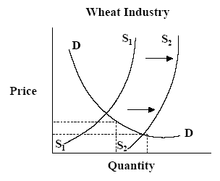
44. Of the following, which situation would cause the shift of the supply curve from S1 to S2?
A The government increases regulation of the wheat industry
B New fertilizers increase the production of wheat

45. What would happen to the equilibrium price and quantity for wheat when the supply curve shifts from S1 to S2?
A Price increases, Quantity decreases B Price decreases, Quantity increases

46. When economists refer to “demand,” they mean which of the following?
A how much consumers will purchase at different prices
B how much sellers will supply at a particular price

47. Which of the following is an attempt by a firm to increase the demand for its product
A the imposition of a price ceiling on the product
B an advertising strategy designed to change consumer tastes and preferences

48. If the demand for any product increases what will happen to the equilibrium quantity for that product?
A Increase B Decrease

49. If the supply for any product decreases what will happen to the equilibrium price for that product?
A Increase B Decrease

Use the following graph to answer the following 3 questions
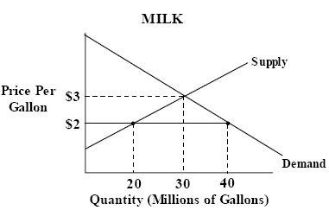

50. If the government set a price ceiling at $2.00. What would be the quantity demanded and the quantity supplied?
Demanded Supplied Demanded Supplied
A 20 40 B 40 20

51. What did the government create when they set the price ceiling for milk at $2.00?
A Surplus B Shortage

52. If the government decides to create to create a price floor for milk at $3.50 what will be created?
A Surplus B Shortage

53. Rent controls that result in a shortage in the marketplace are an example of a
A price ceiling B price floor

54. The minimum wage is a type of
A price floor B price ceiling

55. What would happened to the equilibrium price and quantity of gasoline if a hurricane struck the oil refining regions of the U.S. gulf coast?
A Price increases, Quantity decreases B Price decreases, Quantity decreases

56. Which of the following is NOT a characteristic of a perfectly competitive market?
A The products sold by the firms in the market are the same.
B There are many different buyers and sellers in the market.
C It is difficult for a firm to enter or leave the market.

57. A monopoly is correctly defined as
A A single supplier of a good or service for which there is no close substitute.
B A firm with annual sales over 10 million.

58. What is a business organization where the owner has totally liability for the firm but receives all of the profits?
A Sole Proprietorship B Corporation

59. John, Peter, and Sarah decide to raise funds to expand their restaurant business by offering public stock in the business. What type of business is their company now?
A Corporation D Sole Proprietorship

60. A firm that owns at least four business that produce unrelated products is a?
A Corporation B Conglomerate

61. What business organization is the most profitable for an individual?
A Partnership B Sole Proprietorship

62. Sharon decided to open a dry-cleaning business, taking out a loan from a bank and hiring a helper. What business structure did she use?
A Sole proprietorship B Partnership

63. What is a disadvantage of Sharon’s business structure?
A unlimited liability B double taxation

64. A steel company with manufacturing plants in Pittsburgh, Mexico City, Hong Kong, and Moscow is an example of a
A multinational B conglomerate

65. What is an organization that negotiates for workers and attempts to speak for workers’ rights?
A Labor Union B Credit Union

66. If an airport is built in an area the noise pollution is a?
A Positive Externality B Negative Externality

67. What is the greatest danger of a monopoly?
A It denies consumers the benefit of competition B It will provide for too much competition

68. Highways, flood control projects, national defense, and the criminal justice system are all examples of?
A Private Goods B Public Goods

69. In the US, how are public goods paid for?
B Non-profit organizations collect charitable donations from people
C The government collects tax revenues from individuals and firms

70. What was the first act of Congress to restrict monopolies?
A Clayton Antitrust Act B Sherman Antitrust Act

71. The market structure that has all the conditions of pure competition except that the products are not identical is?
A Oligopoly B Monopolistic Competition

72. A market structure where a few very large firms dominate the market is?
A Oligopoly B Monopolistic Competition

73. Firm X has developed and patented a new mechanical device. As the sole producer of this device, Firm X is a
A technological monopoly B government monopoly

74. A single gas station at an interstate exit far from the next exit is an example of
A geographic monopoly B natural monopoly

75. What is an advantage of a sole proprietorship?
A Unlimited liability B Profit is not shared

76. What is the best market structure for consumers?
A Monopoly B Pure Competition

77. When advertising or other promotional campaigns try to convince buyers that a product is somehow better than another brand it is?
A Non-price competition B Directive Competition

78. Macroeconomics is the study of economics from the standpoint of
A individual economies B the overall economy

79. The most important measure of overall economic performance is:
A Inflation B GDP

80. What four sectors make up GDP?
A C + I + G + Nx B C + B + G + I

81. What would be included in GDP?
A Spending $30,000 to buy a 3-year-old car from the first owners.
B Spending $25,000 to purchase a new car that has never been sold before.

82. Standard of Living is calculated by:
A Dividing GDP by Net Exports B Dividing GDP by population

83. In 2002, Estonia’s government sector was 45 billion, consumer sector was 3 billion, investment sector was 98 billion, and there were 55 billion in imports and 65 billion in exports. What was the GDP for 2002?
A 156 Billion B 266 Billion

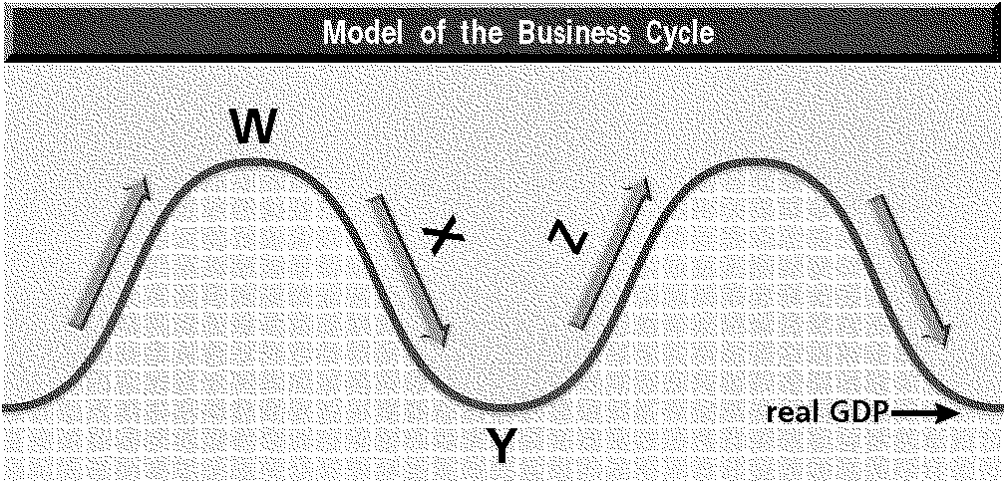

84. Which letter on the graph represents a recession in the business cycle?
A Z B X

85. Which letter on the graph represents expansion in the business cycle?
A W B Z

86. Which of the following would not be considered unemployed?
A a new entrant to the labor force B a newly retired worker

87. Which of the following is a limitation of the unemployment rate:
A Not taking into account the people who have given up looking for a job
B People are considered employed even when they hold a part time job
C Both A & B

88. The natural rate of unemployment in the US is:
A 0% B 4% - 6%

89. This is unemployment caused by workers who are between jobs:
A Structural B Frictional

90. This unemployment occurs when a change in the economy reduces the demand for a specific skills or for a specific type of job:
A Structural B Frictional

91. Inflation is best described as:
C an increase in the general price level D an increase in the price of a single necessity

92. Deflation refers to the situation when?
A the inflation rate decreases B the average of all prices is falling.

93. What is MOST likely to lead to inflation?
A an increase in the cost of production
B an increase in the aggregate supply of goods and services

94. When all sectors of the economy attempt to buy more than the economy can produce what is created?
A Demand pull inflation B Cost push inflation

95. What will be a consequence of inflation?
A The dollar will buy less B Interest rates will fall

96. What type of inflation is taking place when the rate of inflation is 500%?
A Disinflation B Hyper Inflation

97. What would you conclude about an economy characterized by increasing real GDP, low unemployment, and increasing inflationary pressures?
A The economy is in the expansion phase of a business cycle
B The Federal Reserve should expand the money supply.

98. Of the following groups, the one hurt the LEAST by unanticipated inflation is
A workers who have cost-of-living adjustments in their contracts
B banks that have made long term, fixed rate mortgage loans

99. All of the following are key functions of money EXCEPT
A Medium of Exchange B Store of Value
C Creator of Value D Unit of Account

100. Money that has an alternative use as a usable resource is known as?
A Fiat Money B Commodity Money

101. Money that is declared valuable by government decree is known as?
A Fiat Money B Commodity Money

102. By going to Wal-Mart and having the cashier accept your paper money in return for groceries and clothes, which function of money is demonstrated?
A Medium of Exchange B Store of Value

103. The government agency that insures consumer deposits in banks is?
A F.D.I.C. B National Banking System

104. Brandon had $5,000 in his savings account when his bank declared bankruptcy. Which of the following is true?
A Some of Brandon’s savings will be returned to him after the bank’s assets are sold off.
B Brandon’s savings will be protected by the FDIC

105. The formula used to compute the amount of reserves a banking institution must have is called the?
A Discount Rate B Reserve Requirement

106. Debts and obligations to others are known as?
A Liabilities D Assets

107. Liquidity refers to
A the ease of converting investments into cash B the net worth of a bank

108. The expansion or contraction of the money supply to influence the cost and availability of credit is known as
A Fiscal Policy B Monetary Policy

109. A tight money policy
A causes interest rates to increase B encourages economic growth

110. Which of the following is primarily responsible for the control of the money supply?
A the Federal Reserve System B the Federal Deposit Insurance Corporation

111. Open Market Operations
A refers to the Federal Reserve’s monitoring of all bank mergers
B refers to the purchase or sale of government securities by the Federal Reserve

112. If the Fed chairman desires to influence the economy of the U.S. by giving newspaper interviews then he is practicing the policy of?
A Open Market Operations B Moral Suasion

113. If the Fed is practicing an easy money policy then the Fed wants interest rates to?
A Increase B Decrease

114. If the Fed sells securities in an open market operation then the money supply will?
A Increase B Decrease

115. A relatively high tax that raises quite a bit of revenue while trying to stop the usage of a socially undesirable product is known as
A Duty Tax B Sin Tax

116. A tax that imposes the same percentage rate of taxation on everyone, regardless of income is a
A Proportional Tax B Value Added Tax

117. Which of the following is an example of a progressive tax?
A Georgia’s state sales tax B The federal income tax

118. A tax imposed by the United States government designed to provide income for retired persons is?
A Medicare C Social Security

119. Which of the following taxes is the MOST regressive?
A The federal income tax B A sales tax on food

120. What is the total amount of money the Federal government has borrowed from others?
A The Federal budget deficit B The National debt

121. What is the excess of federal expenditures over tax and revenue collections known as?
A The Federal budget deficit B The National debt

122. What is the effect of the National Debt on the economy?
A It stimulates growth through expansion of the money supply
B It slows growth by driving up interest rates and causing the need to raise taxes to offset interest

123. Where does the Federal government receive its largest share of revenues?
A Corporate Income Taxes B Individual Income Taxes

124. What are the tools that are used by government when influencing the economy through fiscal policy?
A Open Market Operations, reserve requirement, discount rate, interest on reserves
B Government Spending and Taxation

125. These are programs that are designed to act on their own to help stabilize the economy.
A The Multiplier Effect B Automatic Stabilizers

126. Under the theory of Keynesian Fiscal Policy, the total output of the economy should grow through
A Increasing in Government Spending B Decreasing the Money Supply

127. In Supply-Side economics, the policies are designed to
A Increase Aggregate Supply B Increase Aggregate Demand

128. The two key tenants of Supply-Side economics are
A Smaller Role of Government and Lower Taxes B Larger Role of Government and Higher Taxes

129. A country’s ability to produce more of a product than another country is known as
A comparative advantage B absolute advantage

130. If a country can produce a product at a lower opportunity cost than another country, then it has a(n)
A comparative advantage B absolute advantage

131. A provision allowing a country to receive the same tariff reduction that the United States negotiates with a third country is called
A most favored nation clause B balance of payments

132. Countries X and Y will NOT trade shoes and wheat if which of the following is true?
A Country Y can produce enough shoes and wheat to satisfy the demand of its public
B The opportunity costs of producing shoes and wheat are the same in both countries

133. What is not true of fixed exchange rates?
A the exchange rate does not change B supply and demand determine currency’s value

134. What will a stronger US dollar potentially lead to?
A Trade Deficit B Trade Surplus

135. What is happening in the economy after 6 consecutive months of declining GDP?
A Recession B Depression

Answers

- A
- B
- B
- B
- B
- B
- C
- B
- B
- B
- A
- B
- B
- B
- B
- B
- A
- A
- A
- A
- B
- A
- B
- B
- A
- B
- B
- B
- B
- B
- A
- B
- B
- A
- B
- B
- B
- A
- B
- C
- A
- B
- B
- B
- B
- A
- B
- A
- A
- B
- B
- A
- A
- A
- A
- C
- A
- A
- A
- B
- B
- A
- A
- A
- A
- B
- A
- B
- C
- B
- B
- A
- A
- A
- B
- B
- A
- B
- B
- A
- B
- B
- A
- B
- B
- B
- C
- B
- B
- A
- C
- B
- A
- A
- A
- B
- A
- A
- C
- B
- A
- A
- A
- B
- B
- A
- A
- B
- A
- A
- B
- B
- B
- B
- B
- A
- B
- C
- B
- B
- A
- B
- B
- B
- B
- A
- A
- A
- B
- A
- A
- B
- B
- A
- A

